Web Browser – History, Concepts, Market

Seminar Paper

from

**Alwin Krycha-Weilinger**

**12016864**

Supervised by

**Prof. Rony G. Flatscher**

**SBWL Business Information Systems**

**Summer Term 2023**

Vienna, 14.06.2023

**Contents**

1 Introduction 1

2 History and Development of Web Browser 2

2.1 WorldWideWeb and Nexus 2

2.2 Mosaic 5

2.3 Netscape Navigator 7

2.4 Internet Explorer 10

2.5 Mozilla Firefox 14

2.6 Opera 16

2.7 Safari 18

2.8 Google Chrome 20

2.9 Microsoft Edge 23

3 Browser Market and Trends 25

3.1 Market Shares of the most used Browsers then and now 25

3.2 Trends for Webbrowser 27

4 Discussion and Conclusion 30

5 References 31

List of Figures

Figure 1: WorldWideWeb Browser   
Berners-Lee, T. (1993, December 13). WorldWideWeb showing many of its functions. <https://upload.wikimedia.org/wikipedia/commons/7/76/WorldWideWeb_FSF_GNU.png>

Figure 2: Mosaic Browser  
NCSA Mosaic Browser. (2019, January 5). National Center for Supercomputing Applications. <https://upload.wikimedia.org/wikipedia/commons/thumb/e/ea/NCSA_Mosaic_Browser_Screenshot.png/1024px-NCSA_Mosaic_Browser_Screenshot.png>

Figure 3: Netscape Navigator  
A screenshot of Netscape Now showing the Welcome to Netscape page. (2018, January 20). Welcome to Netscape. <https://upload.wikimedia.org/wikipedia/en/3/39/Welcome_to_Netscape.gif>

Figure 4: Netscape’s Mascot on IE's logo  
Stracke, J. (1997, October 4). Mozilla stomps IE. <http://home.snafu.de/tilman/mozilla/mozilla-uber-alles.jpg>

Figure 5: Internet Explorer  
Internet Explorer 5 on Windows 98. (2017, February 15). I installed Windows 98 on a VMware Fusion virtual machine and took a screenshot. <https://upload.wikimedia.org/wikipedia/en/0/0e/Internet_Explorer_5_on_Windows_98.png?20170215173446>

Figure 6: Mozilla Firefox  
Mozilla Firefox 1.0. (2005, February 2). Kaszeba. <https://upload.wikimedia.org/wikipedia/commons/3/34/Firefox_1.0.png?20160512163856>

Figure 7: Opera  
Editorial Team. (1995, April 10). Old Version of Opera Browser. <https://www.my-old-version.com/wp-content/uploads/2020/01/Old-Version-Opera-1024x773.png>

Figure 8: Safari  
Safari 4. (2009, June 14). Safari 4 (pictured) was the first version that had entirely passed the Acid3 rendering test. <https://upload.wikimedia.org/wikipedia/commons/3/3e/Safari4_osx.png>

Figure 9: Google Chrome  
Google. (2009, April 29). Google Chrome 1.0 <https://archive.org/download/chrome1.0/google%20chrome%201.PNG>

Figure 10: Microsoft Edge  
Microsoft. (n.d.). Edge. <https://edgestatic-ehf9gbe6gfdfdec4.z01.azurefd.net/shared/cms/lrs1c69a1j/section-images/e2258d06158940118ce733c03dbf26cf.jpg>

Figure 11: Browser Market Shares in May 2023  
Desktop Browser Market Share Worldwide. (2023, June 5). Bar Chart. [https://gs.statcounter.com/browser-market-share/desktop/worldwide/#monthly-202305-202305-bar](https://gs.statcounter.com/browser-market-share/desktop/worldwide/" \l "monthly-202305-202305-bar)

Figure 12: Microsoft Edge’s new AI Text Composer  
MCGH Admin. (2023, February 8). AI, Azure, General, Microsoft Edge, Windows, Windows 10, Windows 11, Windows Insider. https://i0.wp.com/microsoftcaregh.com/wp-content/uploads/2023/02/new-microsoft-edge-experience.jpg?resize=1000%2C563&ssl=1

# Introduction

This seminar paper will give a holistic overview over desktop web browsers - the tools humanity uses to access the Internet. These browsers have come a long way, starting from simple gimmicks to becoming crucial parts of our digital lives. The following pages will start by showing the history and growth of web browsers, beginning with the very first web browser, WorldWideWeb (later renamed Nexus). From there, the paper will cover the advances made by other browsers, such as the Graphical User Interface by Mosaic, the dominance of Netscape Navigator, the unethical actions of the Internet Explorer followed by the independent open-source project Firefox to the ubiquitous browser Chrome.

Furthermore, this seminar paper explores the dynamics of the web browser market and its trends, focusing on the market share of each browser and how these percentages have fluctuated over time. This part will further deepen the knowledge of the reader and allow him to see the big picture of how the web browser market has evolved and where it is heading with its newest developments and trends.

In essence, this seminar paper provides a comprehensive elaboration of web browsers. After reading it, the reader will have developed a profound understanding for the world of web browsers and learned insights about the most important browsers developed until 2023.

# History and Development of Web Browser

In this chapter, the most important web browser will be introduced, and their development, innovations and technical concepts will be explained. Furthermore, relevant historical content will be explained to support the process of understanding the developments made by each browser.

## WorldWideWeb and Nexus

Developed by Tim Berners-Lee in 1990, the WorldWideWeb browser was the first web browser ever. The British computer scientist wanted to create a more efficient method for researchers to share and access information across digital networks (*Berners-Lee*, n.d.).

Before Berners-Lee could even create the first Webbrowser, the foundation of the Internet had to be laid out. In the 1960s, different research departments connected their computers over the ARPANET (Advanced Research Projects Agency Network), which was originally developed by the U.S. Defense Department. Back then, the communication over the ARPANET was not standardized, which made information sharing very difficult. This is why, on January 1st, 1983, the communication protocol “Transfer Control Protocol/Internetwork Protocol”, also called TCP/IP, was established as the standard way to communicate. This milestone for connecting different computers is also considered as the birthdate of the Internet *(A Brief History of the Internet, n.d.).*

In 1989, Tim Berners Lee made his first proposal for the idea of the World Wide Web, a public interconnection of Websites *(A Short History of the Web, 2023) (The World Wide Web Project, n.d.).* Even though the Internet itself already provided different services like file-sharing, email communication or SSH (Secure Shell), a means for sharing information over the World Wide Web had to be developed: the WorldWideWeb Browser *(Wikipedia-Autoren, 2023).* To make this possible, Tim Berners Lee had to invent three new concepts, which are still used to this date:

* HTML

The Hypertext Markup Language is a markup language designed for structuring content on the web and creating web pages. It defines the structure of a webpage and tells the Browser how the contents of a website should be rendered. HTML thus enables users to create and format texts, images, and multimedia elements. The first version of HTML was very simple, but it provided a way for developers to quickly create simple looking web pages and link them together using hyperlinks. An example using an early version of HTML would be the first Webpage ever created at Cern: http://info.cern.ch/hypertext/WWW/TheProject.html. Later versions of HTML, the latest being HTML5, include more sophisticated features. *(Structuring the Web With HTML - Learn Web Development | MDN, 2023) (WebD2: A Brief History of HTML, 2023)*.

* URI

The URI (Uniform Resource Identifier) is a unique identifier for resources on the web, allowing users to locate and access web pages. The most common form of URI is the URL (Uniform Resource Locator), which includes the protocol, domain name, and the specific path to a resource. The concept of URIs was introduced to provide a standardized way of identifying web resources and their locations *(RFC 3986: Uniform Resource Identifier (URI): Generic Syntax, 2005)*.

* HTTP

The Hypertext Transfer Protocol is a communication protocol that enables the exchange of information between web servers and web clients. While the webserver stores the information, HTTP is used by the client in the form of a web browser to connect to the server and retrieve the information. HTTP is a stateless, request-response protocol that offers standardized methods (e.g., GET, POST, PUT, DELETE) to facilitate communication *(Evolution of HTTP - HTTP | MDN, 2023).*

In 1991, Berners-Lee publicly announced the World Wide Web project on the alt.hypertext newsgroup, and the WorldWideWeb browser became available for download. As the first web browser ever, it played a critical role in making the Internet more accessible and user-friendly. Subsequently, the WorldWideWeb browser was renamed Nexus to avoid confusion between the browser itself and the World Wide Web. Although it was eventually surpassed by other web browsers, such as Mosaic, Netscape Navigator, or Internet Explorer, the WorldWideWeb browser's pioneering role in the development of the modern Internet remains highly significant *(Wikipedia contributors, 2023a).*

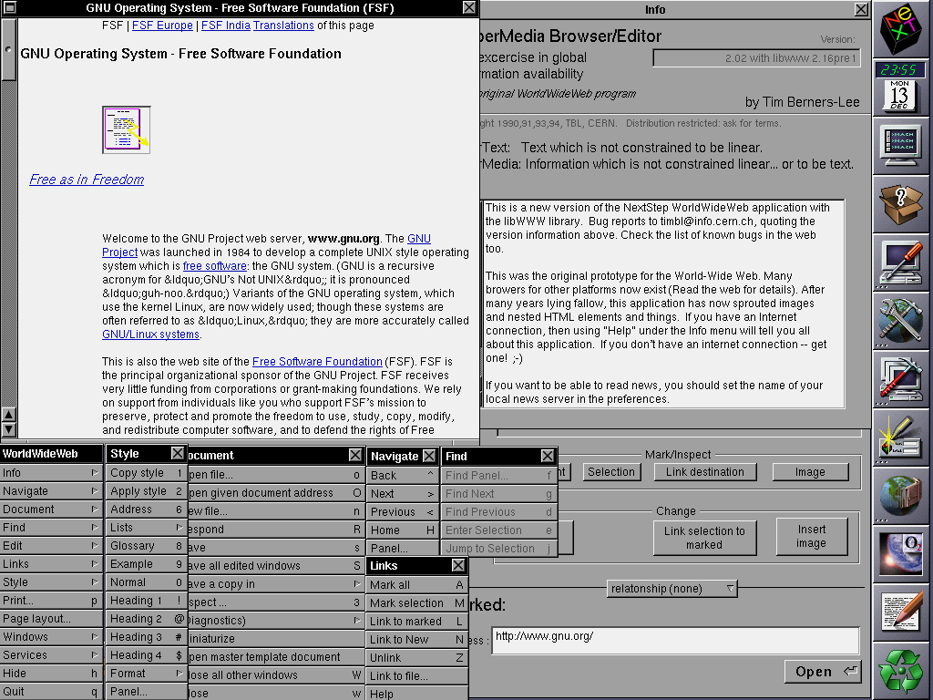

Figure 1: WorldWideWeb

## Mosaic

The Mosaic browser was a revolutionary web browser developed at the National Center for Supercomputing Applications (NCSA) at the University of Illinois, Urbana-Champaign. Developed in 1993 by a team of computer scientists led by Marc Andreessen, Mosaic was the first graphical web browser that allowed users to view text and images on the same page. Like the Nexus Browser, Mosaic was built on top of the two technologies HTML and HTTP and relied on them to render webpages *(Mosaic Web Browser History - NCSA, Marc Andreessen, Eric Bina | LivingInternet, 2020).*

One of the key innovations of Mosaic was its smooth user interface, which was designed to be intuitive and easy to use. Mosaic had a graphical user interface (GUI) that allowed users to interact with web content using a mouse and keyboard. The browser had a toolbar that provided access to common functions, such as navigating back and forward or reloading a page. Additionally, the Mosaic browser was the first one to include clickable hyperlinks and a bookmarking feature. Previous browsers only gave reference numbers and users had to type them in manually *(Staff, 2022).*

Mosaic was implemented using the X Window System, a graphical user interface framework for Unix-based systems. X Window System provided Mosaic with a platform-independent interface for rendering graphics, and it allowed the browser to be run on a wide range of operating systems, including Linux, macOS, and Windows *(Schatz & Hardin, 1994).*

Mosaic's support for inline images, images inserted into a web page, was another notable feature. Before Mosaic, web pages were mostly text-based, and images were displayed as separate files that had to be downloaded and viewed in a separate window. It therefore shifted the World Wide Web from a text-based medium to one that could handle images, and later audio and video. This made web pages more visually appealing and easier to read *(Staff, 2022)*. Furthermore, Mosaic included a feature called “history files”, a predecessor to the modern-day browser history *(Lasar, 2019)*.

Mosaic's impact on the web cannot be overstated. The browser was a key player for the explosive growth of the World Wide Web in the 1990s, and it helped to popularize the idea of a graphical web browser. Mosaic's user interface and features set the standard for web browsers that followed, and many of the features that we take for granted today, such as inline images or bookmarks, were first introduced in Mosaic. It is therefore no wonder that the Mosaic browser won multiple awards such as the InfoWorld Magazine’s 1993 Product of the Year award *(Staff, 2022).*

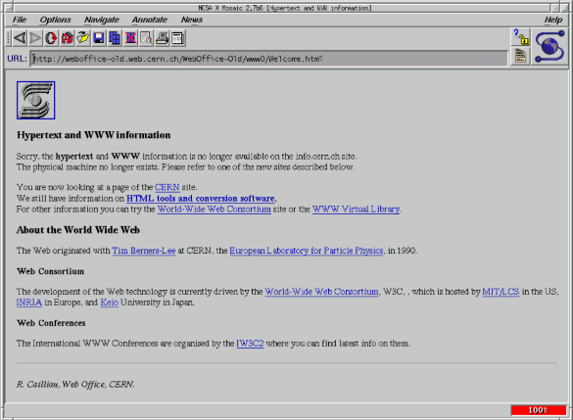

Figure 2: Mosaic

## Netscape Navigator

The historical background of the Netscape Navigator started in mid-1994, when Marc Andreessen and Silicon Graphics founder Jim Clark founded the company “Mosaic Communications”. The first version of the Netscape Navigator was called Mosaic Netscape. As one can guess from the name, the developers of the Netscape browser were originally working on the NCSA Mosaic browser. The company was later renamed to “Netscape Communiations”. The founders realized the potential of the World Wide Web and therefore released the first version of the Netscape Navigator to the general public as a fully-fledged web browser. It quickly gained success due to magazine publishers and Internet Service Providers and soon enjoyed a market share of around 80 percent *(Jowitt, 2016).*

One of the most significant innovations of Netscape Navigator was the introduction of JavaScript, a programming language that allows web developers to create interactive and dynamic web pages. Prior to JavaScript, web pages were largely static and could not respond to user actions in real-time *(Heisler, n.d.).* Created by the Netscape employee Brendan Eich in only 10 days, JavaScript enables developers to create complex applications within a web browser, making it possible to build web-based software. It can create games, animate 2D and 3D graphics and support a vast amount of functionality that could rival desktop applications with minimum effort *(JavaScript Basics - Learn Web Development | MDN, 2023).*

Another key innovation of Netscape Navigator was the introduction of cookies. Netscape tried to help web sites become commercial enterprises and wanted to provide a way to collect information about digital visitors. To do that, cookies were invented *(Singleton, 2000).* Cookies are small text files that are stored by the web browser on a user's computer and are used to store information about that user's interaction with a website.

This information can include login credentials, shopping basket contents, and other user preferences *(Peng & Cisna, 2000).* Cookies made it possible for websites to provide a personalized experience for each user, as well as to track user behavior across multiple sessions *(Using HTTP Cookies - HTTP | MDN, 2023)*. Nevertheless, cookies are often in dispute because they are regularly used in an anti-consumer fashion, especially third party-cookies – cookies created by websites the user is not even visiting. These cookies are being used for advertising and marketing purposes and are often seen as a source of controversy *(Dodt, 2021).*

After the introduction of cookies, Netscape continued to lead the way in web innovation by developing Secure Sockets Layer (SSL) and Hypertext Transfer Protocol Secure (HTTPS). SSL is a cryptographic protocol that is designed to provide communication security over an unsecure network. While the first versions of SSL were very vulnerable to attacks, later versions (called TLS) fixed those vulnerabilities and are still in use *(Wikipedia Contributors, 2023b).* Building on SSL, Netscape combined it with the existing Hypertext Transfer Protocol (HTTP) to create HTTPS, a secure version of the protocol. When using HTTPS, web browsers and servers establish a secure connection through an SSL/TLS certificate, which verifies the authenticity of the data being shared and safeguards it from interference. This stops unauthorized individuals from intercepting or tampering with the data being transmitted. Since HTTPS uses the SSL/TLS protocols, it is also called HTTP over SSL or HTTP over TLS. Even though HTTPS exists since the 1990s, some websites have not adapted to the secure standard in 2023 *(Wikipedia contributors, 2023c).*

The Netscape Navigator web browser was also the first one to introduce the ability to install plug-ins *(Wikipedia contributors, 2023d).* Web browser plug-ins serve as software modules that enhance a browser's functionality, allowing it to process extra content types and offer an enhanced browsing experience to users. These plug-ins, mostly written in the NPAPI (Netscape Plugin Application Programming Interface) operate by integrating seamlessly with the browser, enabling it to handle specific multimedia and interactive features that might not be natively supported. Generally created by third-party developers, users need to install plug-ins separately. Over time, however, built-in support for a range of web standards has been incorporated into modern browsers, reducing the reliance on separate plug-ins *(Plugin - MDN Web Docs Glossary: Definitions of Web-related Terms | MDN, 2022).* A well-known example of a historic plug-in is Adobe Flash Player, to which it’s developer Adobe announced in 2017 to end support in 2020 *(Adobe, 2017).* It's crucial to remember that outdated plug-ins can pose security risks, as they may have vulnerabilities that can be exploited by hackers *(Plugin - MDN Web Docs Glossary: Definitions of Web-related Terms | MDN, 2022).*

Despite its early success, Netscape eventually lost market share to Microsoft's Internet Explorer, which was bundled with the Windows operating systems. Finally, Netscape was acquired by AOL (America Online) in 1998 and was later discontinued in 2008 *(Heisler, n.d.).*

To sum up, the Netscape Navigator was a revolutionary web browser that significantly contributed to the popularization of the World Wide Web during the 1990s. This browser brought forth numerous features and advancements, such as plug-ins and JavaScript, which shaped the way for the browser’s successors and the World Wide Web in general.

## Internet Explorer

The Internet Explorer (IE) was a web browser developed by the Microsoft Corporation in 1995. It was the default web browser for Microsoft Windows operating systems and was one of the most widely used web browsers in the 2000s *(Wikipedia contributors, 2023e).*

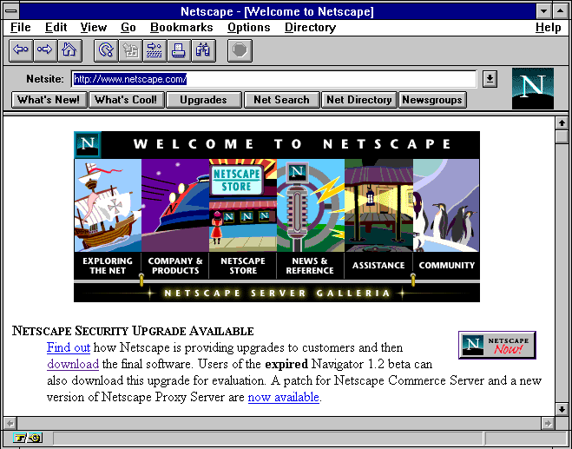

Figure 3: Netscape Navigator

Just like Netscape, the Internet Explorer innovated some of the most important features that most websites could not function without. One of them is the API Document Object Model (DOM), which is used to get access to every part of a website. Developers used to have the ability to only modify certain parts of a webpage using Javascript, but thanks to features that DOM innovated like document.getElementByID or innerHTML, developers were since then able to manipulate every HTML element by assigning it a certain ID. Furthermore, innerHTML was so popular that it was also codified in HTML5 and is widely supported by most browsers *(Zakas, 2012).*

Another core functionality that was innovated by the Internet Explorer and that is still deeply integrated in most Websites is Cascading Style Sheets (CSS). Even though CSS is not commonly associated with the browser due to its historical lag in CSS support, IE played a crucial role in its inception. Cascading Style Sheets is a language used for specifying how documents should be presented to users. It uses parameters like color, font-size, padding or margin, to format and style the HTML elements of Webpages *(What Is CSS? - Learn Web Development | MDN, 2023)*. While Netscape tried to pursue an alternative approach with JavaScript Style Sheets (JSSS), CSS eventually succeeded as the superior innovation – even though it only supported font size, colors, and backgrounds in its first version – since it did not need Javascript to work. Consequently, IE’s pioneering efforts in CSS and its implementation have had a lasting impact on the development and widespread adoption of the styling language *(Zakas, 2012).*

In addition to DOM and CSS, the Internet Explorer was the first web browser to support Asynchronous Javascript and XML (AJAX), a technology to create interactive web applications. AJAX makes it possible to read data from a web server after a web page has loaded, without having to reload the page *(What Is AJAX, 2023)*. Modern sites like Google Maps or Gmail heavily rely on AJAX to work properly *(Techquickie, 2018).*

Although Microsoft’s IE did innovate key features of today’s web browsers, it has been criticized for its anti-competitive behavior in gaining popularity. Especially during the browser wars, a period of intense competition between the Internet Explorer and Netscape Navigator in the 1990s and early 2000s, Microsoft used unlawful tactics to drive out Netscape from the Browser market *(The History of Web Browsers, n.d.).*

During the browser wars, both companies were innovating at an unbelievable speed. The browsers of both companies regularly received updates and copied features from each other. Tensions between the companies started to rise *(The Science Elf, 2017)*. One consequence of the conflicts was, for example, the placement of the IE logo at Netscape's headquarters, to gain attention for the new IE 4.0 release. Netscape’s employees quickly counteracted by putting their mascot on top of Microsoft’s logo and writing down their market share in comparison to Microsoft’s, which was 72 to 18 percent *(Baumgartner, 2016).*

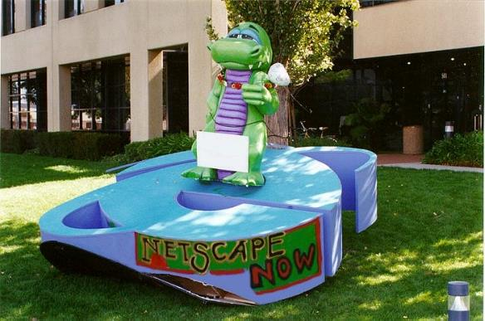

Figure 4: Netscape’s Mascot on IE's logo

Nevertheless, Microsoft had the advantage of controlling the operating system market. Installing Internet Explorer as the default and free option on Microsoft Windows caused many users to switch *(The Science Elf, 2017).* Additionally, Microsoft forced vendors to do that as well and a deviation from that clause would result in losing the Windows license for the vendor, effectively making it the default browser for millions of users. It is rather obvious that businesses started to let go of distributing Netscape Navigator *(The Dude, 2020).* What is more, Windows even had an agreement with Apple in 1997. The agreement stated that the Internet Explorer should be installed as the default browser on macOS for five consecutive years. Therefore, Microsoft’s IE was not only installed on Windows machines, but also on Apple computers *(Microsoft and Apple Affirm Commitment to Build Next Generation Software for Macintosh - Stories, 1997).*

The behavior of Microsoft caused the Government of the United States to file an antitrust lawsuit against them in 1998. The lawsuit stated several anti-consumer actions, for example making it difficult for users to uninstall the Internet Explorer *(Complaint : U.S. V. Microsoft Corp., 2015).*

Although Microsoft’s unlawful and monopolistic tactics were brought up by the Federal Trade Commision and it was very obvious that Microsoft infringed many laws, the trial lasted several years. In 2001, Microsoft was found guilty of antitrust violations by judge Thomas Penfield Jackson and ordered to break up into smaller companies. While the latter ruling was later succesfully challenged by Microsoft, the company was forced to make changes to its business practices and was required to make it easier for users to install other web browsers on the Windows operating system *(CFI, 2020).*

Despite its enormous success, IE eventually lost market share to other web browsers, such as Google Chrome and Mozilla Firefox. The browser was criticized for its poor security and lack of support for modern web standards. Furthermore, Microsoft neglected to further develop the browser, most likely due to their sense of safety from the high market share *(Techquickie, 2018).* Microsoft eventually discontinued and stopped developing security updates for IE in 2016 *(Newman, 2016).*

In conclusion, the Internet Explorer was a groundbreaking web browser that played a key role in the growth of the Internet in the 2000s. The browser introduced several new features and innovations, including integration with Windows, support for DOM, and support for AJAX and CSS. Although IE is no longer in use today, its innovations can still be seen in the modern web browsers that people use today.

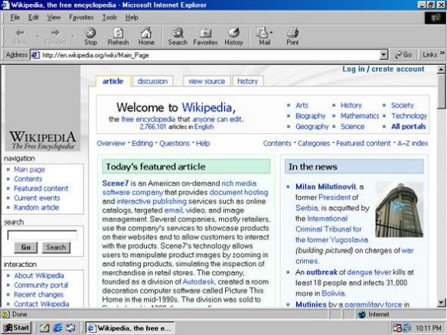

Figure 5: Internet Explorer

## Mozilla Firefox

Due to the browser wars and the antitrust lawsuit against Microsoft, Netscape ultimately decided to make the Netscape web browser open source and call it the Mozilla project. The open codebase created an open community which had soon become larger than any company. People were contributing to the project and consistently added new features and functionality. In 2003, the Mozilla project established the Mozilla Foundation, an independent non-profit organization. Openness, innovation, and opportunity were its official guidelines. Later, in 2004, the first early version of Firefox, Firefox 1.0, was released and received over 100 million downloads in less than a year *(History of the Mozilla Project, n.d.)*. “Firefox essentially became the successor to Netscape, like the Ottoman Empire became the successor to Byzantium” (Shariy, 2023).

In 2004, Firefox innovated the concept of Browser extensions. Until then, only two technologies came near to the functionality of extensions: plug-ins and Browser Helper Objects. While plug-ins represented small executable programs that could be added to the browser, BHOs were used to extend the Internet Explorer with toolbars *(Browser Hijack Objects (BHOs) | Malwarebytes Labs, 2023).* Firefox extensions were the first to popularize the concept of Browser extensions. Their extensibility set Firefox apart from its competitors. Add-ons like UI Themes, Layout resizing options, Mouse Gestures, etc. allowed the user to personalize the browsing experience and add functionality with just a few clicks *(Redaktion, 2004).* In 2023, the major browser vendors each maintain and update their own browser-extension stores and marketplaces. Here, new extensions created by individual developers or companies must undergo strict security checks and can be further distributed to millions of users *(Schiller, 2021).*

In the years since its launch, Mozilla Firefox has remained committed to innovation and user-focused development. The most recent versions of the browser include enhanced privacy controls, an improved user interface, and better performance optimization. In terms of online security and privacy, Firefox remains the best mainstream option. Firefox’s strong reputation for security even made it the code basis for the ultra-privacy-focused Tor browser *(Orgera, 2020).*

From Mosaic to Netscape, from the Mozilla project to Firefox – the browser has consistently demonstrated its adaptability and resilience in the constantly changing digital landscape. Sticking to the core principles of open-source collaboration, the browsers focus on security and privacy makes it an appealing choice to countless users in 2023.

## Opera

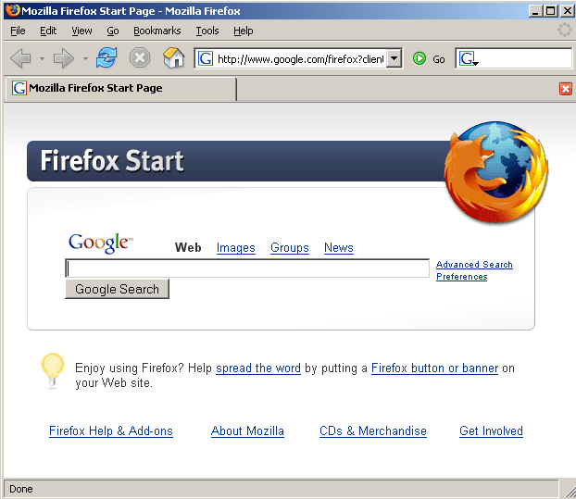

Figure 6: Mozilla Firefox

The Opera Browser was initially developed by Jon Stephenson von Tetzchner and Geir Ivarsoy, while still working at Telenor, in 1994. In 1995, the two developers founded the Opera Software AS and publicly released their browser in 1995 *(Wikipedia contributors, 2023f).* Initially, Opera was launched for corporate use and later for everyone else. With it’s tabbed browsing feature it could have dominated the market and played a major role as a competitor in the browser wars. However, it rather stayed under the radar of most users *(Shariy 2023).*

Nevertheless, tabbed browsing, one of Opera’s innovations, is a feature that every modern web browser supports these days. It is a form of Internet navigation that enables users to open multiple webpages and documents in a single browser window. It is especially handy for users that want to open multiple sites simultaneously, but do not want to have multiple browser windows open. With browser tabs, switching between different webpages is made simple, which is why users still use the feature in 2023, regardless of web browser *(Tabbed Browsing, 2020).*

With its third and fourth version, Opera decided to switch from a paid business model to a free-but-with-ads business model *(Shariy 2023).* Since the browser was coded from scratch and was not based on NCSA Mosaic, Opera always bragged with new features like motion gestures or page zoom. For its small footprint, it includes numerous features with solid support for HTML, CSS, Javascript, DOM, etc *(Wilson, n.d.).*

Opera has also been a pioneer in browser-based data compression technology. With its version 10 from 2009, Opera invented the fast-browsing mode “Opera Turbo”. This functionality allowed users to browse the web more quickly and efficiently. By using proxy-servers, which were offered by opera, the feature compressed webpages by to up to 80 percent before sending it to the client. This helped users, especially with slower Internet connections, to drastically speed up their browsing experience *(Schischka, 2009).*

Furthermore, Opera was one of the first browsers to prioritize adherence to the World Wide Web Consortium's (W3C) web standards, ensuring that websites were displayed consistently across different platforms. This dedication to standards compliance played a significant role in Opera's ability to attract a loyal and passionate user base *(Wilson, n.d.).*

Another key innovation from Opera was the development of the "Speed Dial" feature, which provided users with a customizable grid of frequently visited websites for easy access. This feature, now commonly found in other browsers, greatly enhanced the browsing experience by offering a convenient way to navigate favorite sites *(Reimer, 2007).*

Opera's dedication to user experience, commitment to web standards, and its track record of introducing innovative features made it a long-lasting competitor in the browser market. Even though the team behind the Browser had troubles capturing market shares in the beginning due to the browser wars, the quick and customizable browser has generated a loyal fanbase.

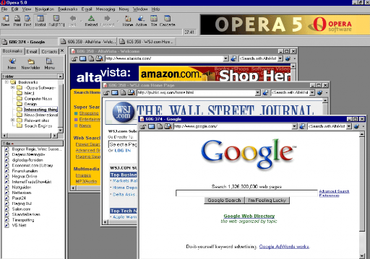

Figure 7: Opera

## Safari

Apple's Safari browser, first introduced in 2003, has become a widely used and respected web browser on both macOS and iOS platforms. Developed in-house by Apple, Safari was designed to offer a seamless browsing experience for users of Apple products, capitalizing on the company's focus on elegant design and smooth functionality. It was developed after the agreement with Windows to install the Internet Explorer as the default browser on Apple computers expired *(Apple Explained, 2018).*

Safari has consistently introduced innovative features that have enhanced the overall browsing experience. One of its early accomplishments was the introduction of the "Reader" mode, which allows users to view articles and web pages in a clean, clutter-free format. This feature has since been adopted by other browsers and remains a popular option for users seeking a more focused and comfortable reading mode for websites *(Apple, 2010).*

Another notable addition Safari made to the Browser-World was Private Browsing. Safari pioneered the concept of Private Browsing with the introduction of its Private Browsing feature in April 2005, as part of the macOS X Tiger (10.4) release. This innovative feature allowed users to surf the Internet without leaving traces of their browsing history, search history, or cookies on their devices. Over time, the private browsing concept gained widespread recognition and adoption, prompting other major web browsers, such as Google Chrome, Mozilla Firefox, and Microsoft Edge, to incorporate similar features into their platforms. Today, private browsing is an essential component of modern web browsers, offering users greater control over their online privacy and enhancing the overall browsing experience *(Trapani, 2013).*

With the launch of the iPhone in 2007, Safari was the first web browser on Apple’s mobile devices. This first mobile version of Safari was designed to provide a browsing experience like the one of the desktop computers but optimized for the smaller screen and touch interface of the iPhone *(Dilger, 2016)*. In 2007, Safari was further offered for the Windows Operating Systems Windows XP and Vista. Nevertheless, it could not generate a sustainable userbase and Apple decided to discontinue to offer Safari for Windows with its release of OS X Mountain Lion in 2012 *(Weis, 2020).*

Recent updates to Safari have brought new features and improvements, including a customizable start page, enhanced tab management, and a new privacy report that offers users insight into the tracking activity that the browser has blocked. The browser's user interface has also been refined to offer a more modern and streamlined look while preserving the intuitive and uncluttered design. Furthermore, since Version 14, Flash is no longer supported *(Porter, 2020).*

In summary, Safari's success as a web browser can be attributed to its focus on user experience and seamless integration with Apple's ecosystem of devices. As the digital landscape evolves, Safari is well-positioned to continue offering users a reliable, stylish, and fast gateway to the World Wide Web.

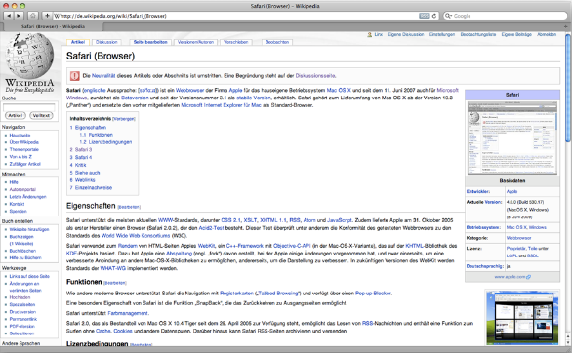

Figure 8: Safari

## Google Chrome

In 2008, Google also wanted to join the browser market and took their turn in developing a web browser for the public. They started working on an open-source project, the Chromium browser, and used parts of the Safari and Firefox Web Browser Engines to develop it *(Little, 2021).* Since Chromium, the basis of Google Chrome, is open source, everybody could theoretically develop their own version of Google Chrome *(Chromium, n.d.)*.

The announcement of Chrome was made public by a blog post on September 1st, 2008. The Browser was launched after an accidental early release of a comic book about it. The comic book presented the features and functionalities of the then-new web browser in a simple manner, making it understandable for anyone interested, even those without a technical background *(Google Chrome, n.d.)*. With Chrome, Google aimed to create a modern platform for web pages and applications. The new Browser featured a simple interface, prioritizing efficient navigation and emphasizing web content. Behind the scenes, Chrome's isolated "sandbox" tabs prevented crashes and enhanced security. This feature is especially useful when one website crashes since the other websites won’t be affected by the crash. Furthermore, Chrome offered improved speed and a powerful JavaScript engine called V8 *(Google, 2008).*

Google Chrome introduced several innovative features that have since become standard in the web browsing experience. One of its most notable innovations was the Omnibox, which combined the address bar and search bar into a single, unified input field. This simplified interface allowed users to quickly navigate to websites or perform searches without the need for multiple input fields *(Google Chrome, n.d.).*

In addition to its focus on speed and simplicity, Google Chrome has also placed a strong emphasis on security and privacy. The browser includes features such as automatic updates or phishing and malware protection, all designed to protect users from potential threats while browsing the Internet. Chrome's Safe Browsing feature, for example, warns users about potentially dangerous websites before they visit them *(Wikipedia contributors, 2023g).*

One of the key selling points of Google Chrome has been its extensive library of extensions, which allow users to personalize and enhance their browsing experience. The Chrome Web Store offers a wide range of add-ons, themes and applications that are tailored to various user needs, from productivity tools to entertainment options. In 2010, the Chrome’s   
extension store already offered more than 8.500 extensions and 1.500 browser themes *(StudySection, 2019).* Nowadays, there are more than 100.000 extensions and around 40.000 themes offered on the Chrome Web Store *(Counting Chrome Extensions – Chrome Web Store Statistics, 2020).*

With the synchronization functionality Google’s Browser made syncing between devices famous. The browser's synchronization capabilities enable users to access their bookmarks, browsing history, and open tabs across multiple devices, providing a consistent browsing experience *(Wikipedia contributors, 2023g).* The feature was originally called “bookmark sync” and the initial version used to only work with synchronizing bookmarks *(Google, 2009).*

In conclusion, Google Chrome's success as a web browser can be attributed to its focus on speed, simplicity, security, and seamless integration across multiple devices. As the digital landscape continues to evolve, Chrome remains well-positioned to adapt and excel, providing users with a reliable, secure, and efficient gateway to the World Wide Web. In 2023, Google Chrome is the most used browser in terms of market share across the globe *(Oberlo, 2023).*

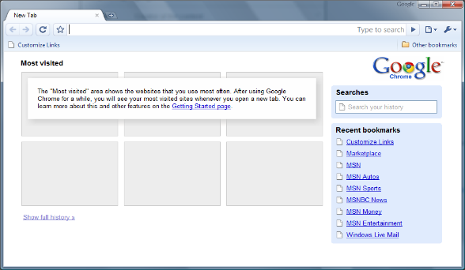

Figure 9: Google Chrome

## Microsoft Edge

Microsoft Edge, initially launched in 2015, is a modern web browser that has emerged as a contender in the competitive browser market. Developed by Microsoft, Edge was designed to replace the aging Internet Explorer and offer a fresh and secure browsing experience for users of the Windows operating system *(Gralla, 2020)*. In Windows 10 Systems, modern webpages will redirect automatically from the Internet Explorer to Microsoft Edge, which further demonstrates that Microsoft Edge replaced the Internet Explorer *(Wesley et al., 2023).* The first version did however fail miserably. It was clunky, filled with features that only a handful of users needed and severely lacked browser extensions *(Gralla, 2020).*

In 2020, Microsoft announced a significant shift in strategy by deciding to adopt the Chromium open-source project as the foundation for a new version of Edge. This transition allowed Edge to leverage the performance, compatibility, and extension support offered by the widely used Chromium engine *(Huc, 2019)*. With the new Chromium engine powering Microsoft Edge, the company also decided to ditch the old “e” logo and replace it with a new one. The new browser further supports business-focused features, such as looking for floor plans, office locations or definitions for company acronyms. It is somewhat comparable to intranet searches but implemented into the browser *(Warren, 2019).*

Privacy and security have also been central to Microsoft Edge's development. The browser offers a pack of features designed to protect user data and maintain online privacy. One of them is called tracking prevention. This tool is used to stop companies from following users from website to website. It is turned on by default and has three levels of blocking – basic, balanced, and strict *(Gralla, 2020)*. Microsoft is regularly improving tracking prevention by implementing new techniques and fine-tuning to adapt to the ever-changing tracking behaviors of different companies *(Microsoft Edge Team, 2019).*

Regular updates to Microsoft Edge brought new features and improvements, such as vertical tabs for better organization or a built-in price comparison tool for online shopping and a screenshot-tool for quick pictures of webpages *(Warren, 2020).* Updates furthermore focus regularly on speed *(Keizer, 2021)* and security performance improvements *(Guenni, 2023).*

In summary, Microsoft Edge's success as a web browser can be attributed to its focus on user experience, commitment to privacy and security, and seamless integration with the broader Microsoft ecosystem.

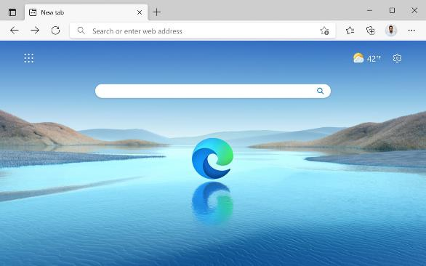

Figure 10: Microsoft Edge

# Browser Market and Trends

This chapter is about the Browser Market and its shareholders. Traditionally, the market share of browsers is being measured through tracking codes installed on various websites, allowing for statistical analysis of webpage visits. However, new modern approaches have emerged, leveraging the power of advertisement-driven measurement *(Callejo et al., 2019).* Thanks to the results of various measurement approaches, one can gain insights into the evolving landscape of the browser market.

## Market Shares of the most used Browsers then and now

The World Wide Web as we know it today has been largely shaped by the emergence and evolution of web browsers. Over time, a few major players have dominated the browser market, shaping user experience and the development of web technologies.

At the commencement of the web and with the first browser ever created by Tim Berners-Lee, the WorldWideWeb Browser was the only web browser to ever hold 100% market share. However, this is due to the fact that it was a relatively small market, since only scientists at CERN had exclusive usage possibilities. Later when Mosaic was released in 1993, it was the first browser to reach a mass audience. It quickly gained popularity due to its graphical interface, which was a novelty at the time. While exact numbers are hard to pin down, it's generally accepted that Mosaic held the majority of the global market share in 1994, significantly diminishing Nexus' prominence *(Neufeld, 2022).*

With its release in 1994, Netscape Navigator, a direct descendant of Mosaic, was the browser that brought the Internet into the mainstream. In 1996, it held an astonishing 90% of the market share. However, the rise of Microsoft's Internet Explorer (IE) soon challenged this dominance *(Neufeld, 2022).*

Microsoft introduced Internet Explorer (IE) in 1995 as a part of the Windows operating system. Due to Microsoft's predominance in the operating system market, IE steadily gained popularity. By 1998, IE surpassed Netscape Navigator to become the most popular web browser in the early 2000s *(Routley, 2020).* At its peak in 2004, the Internet Explorer held a staggering 95% of the market share. However, the rise of competitors like Mozilla Firefox and later Google Chrome marked the beginning of a gradual decline in IE's market share. By 2011, IE had lost its majority stake, and since then further declined *(Desktop Browser Market Share Worldwide | Statcounter Global Stats, 2023).* In 2015, Microsoft released Edge as a replacement for IE. The new browser was initially met with skepticism. However, it has slowly gained a solid userbase due to its tight integration with the Windows Operating System. Nowadays, it holds around 10% of the market share *(Desktop Browser Market Share Worldwide | Statcounter Global Stats, 2023).*

With the new millennium came new challengers. Opera, a browser known for its innovative features like tabbed browsing, managed to capture 3% of the market in 2009. Mozilla Firefox, introduced in 2004, quickly became an alternative to IE. By 2010, the browser had captured 32% of the market share, but never managed to surpass Microsoft’s Internet Explorer as the most used browser worldwide *(Routley, 2020).*

Nevertheless, the most dramatic shift in the browser market came with the introduction of Google Chrome in 2008. By offering a streamlined user experience and superior performance, Chrome was able to rapidly capture the market shares of both Firefox and IE. As of May 2023, Chrome commands a dominant 66% of the global market share, with Safari trailing behind at 13% (see Figure 11) *(Desktop Browser Market Share Worldwide | Statcounter Global Stats, 2023).*

It is worth noting that once a browser becomes popular, it is incredibly difficult to capture back its market share due to factors such as Attitude, Perceived Behavioral Control and Affect. A study conducted by J. Ken Corley and D. Scott Hunsinger has investigated these factors and it can be argued that users stick to a browser once they like it because of a combination of their positive attitude towards the browser, their perception of control over its use, and the positive emotions and sentiments associated with using it *(Corley & Hunsinger, 2012).* As of 2023, it looks like Chrome will continue to be the world’s preferred method of experiencing the Internet. If Chrome’s current trajectory continues, it could become the third major browser to ever surpass a 90% market share *(Desktop Browser Market Share Worldwide | Statcounter Global Stats,* *n.d.)​​.*

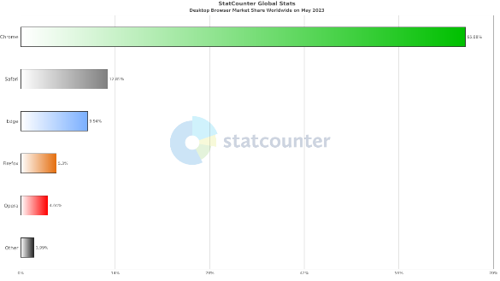

Figure 11: Browser Market Shares in May 2023

## Trends for Webbrowser

The browser market is constantly evolving, and staying updated with the latest trends is essential for users. The following points represent key trends for the browser market in 2023:

* More expensive browsing

The rise of paid browsing services is anticipated, with Google’s plan of blocking ad-blockers in Chrome. This move may encourage free Chrome users to upgrade to premium services like Chrome Enterprise. On the other hand, Mozilla's Firefox plans to share revenues with visited sites instead of charging for browsing, focusing on improving content quality.

* Voice-powered browsers

Voice control is gaining prominence in web browsing, enabling users to control browsers through speech recognition. With the development of voice browsing technology and open standards like W3C's VoiceXML, voice-based browsing could soon become mainstream.

* Instant page loading

As web page sizes continue to grow, browsers are seeking for enhanced loading speed. Faster page loading has become crucial for user experience and can impact factors such as Search Engine Optimization (SEO) and ad performance. Browsers like Opera are using predictive analysis and automation to accelerate page loading.

* AI-enhanced browsing

Just like everything else in 2023, Artificial Intelligence is transforming browsers as well. With tools like TensorFire and Google's AI Experiments, engineers try to apply neural networks and machine learning for browser-based applications. AI in browsers offers benefits such as faster AI operations, improved privacy, and simplified development processes *(Eira, 2023).* Microsoft Edge has also innovated a lot recently in terms of AI. The updated Edge browser features AI capabilities, such as chat summaries and content composition assistance *(Mehdi, 2023).*

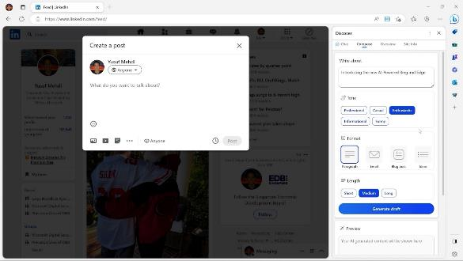

Figure 12: Microsoft Edge’s new AI Text Composer

* Increased privacy

Privacy concerns have led to the development of browser features like Mozilla's Facebook Container and Firefox Monitor. Additionally, while Do Not Track (DNT) features in most browsers have limitations, Firefox and Opera offer browser-based ad-blocking and enhanced privacy options. To enhance privacy and security even further, browser compartmentalization is gaining attention. This approach involves using multiple browsers for different purposes, such as dedicated browsers for web browsing, secure browsing, and accessing online accounts. Browser compartmentalization allows users to maintain anonymity and privacy while using different websites and services *(Eira, 2023).*

These browser trends reflect the continuous efforts to improve user experience, privacy, and efficiency in an evolving digital landscape. Staying informed about these trends will help users adapt to new technologies and make informed choices when it comes to browsing the web.

# Discussion and Conclusion

After reading this paper, the reader probably got the impression, that the desktop web browser market has historically always been dominated by a single entity. From the dominance of Netscape Navigator, the consistent presence of Internet Explorer, to Google Chrome's current dominance, the browser market tends to rather follow a monopolistic character than a diverse one. It seems like the majority of the userbase has a tendency to prefer “if it ain’t broke, don’t fix it” solutions, which makes dominant web browsers stay dominant. It appears as if the browsers with the highest amount of market shares have the power to influence the World Wide Web and capitalize from the Internet the most.

Nevertheless, the existence and innovations of web browsers like Firefox and Opera cannot be understated. Despite the continuous dominance of a single browser, these browsers have continued to introduce innovations, influencing the market in their unique ways. They serve as proof that while market shares may be uneven, the field of innovation is competitive, as different browser providers strive to enhance user experience, implement emerging technologies, and propose new ways of navigating the digital world on a regular basis.

In conclusion, although the browser market demonstrates periods of single-browser dominance, it is the never-ending innovation and competition, even from smaller players, that drive the browser industry forward. Ultimately, this interplay of users, web browsers and the Internet drives forward the development towards an increasingly interconnected and user-centric future in the global exchange of information.

# References

A Brief History of the Internet. (n.d.). <https://www.usg.edu/galileo/skills/unit07/internet07_02.phtml>

A short history of the Web. (2023, May 26). CERN. <https://home.cern/science/computing/birth-web/short-history-web>

Adobe. (2017, July 25). Flash & the Future of Interactive Content. Adobe Blog. <https://blog.adobe.com/en/publish/2017/07/25/adobe-flash-update>

Apple Explained. (2018, May 30). History of Safari [Video]. YouTube. <https://www.youtube.com/watch?v=3dDCXRw56Po>

Apple. (2010, June 7). Apple Releases Safari 5. Apple Newsroom. <https://www.apple.com/newsroom/2010/06/07Apple-Releases-Safari-5/>

Baumgartner, S. (2016, January 27). Tales from the Browser wars: Mozilla stomps Internet Explorer. Medium. <https://medium.com/@ddprrt/tales-from-the-browser-wars-mozilla-stomps-internet-explorer-799035887cb1>

Browser Hijack Objects (BHOs) | Malwarebytes Labs. (n.d.). Malwarebytes. <https://www.malwarebytes.com/blog/threats/browser-hijack-objects-bhos>

Callejo, P., Cuevas, R., & Cuevas, Á. (2019). An Ad-Driven Measurement Technique for Monitoring the Browser Marketplace. IEEE Access, 7, 181339–181347. <https://doi.org/10.1109/access.2019.2959731>

CFI. (2020, August 21). Microsoft Antitrust Case. Corporate Finance Institute. <https://corporatefinanceinstitute.com/resources/management/microsoft-antitrust-case/>

Chromium. (n.d.). <https://www.chromium.org/Home/>

Complaint : U.S. V. Microsoft Corp. (2015, August 14). <https://www.justice.gov/atr/complaint-us-v-microsoft-corp>

Corley, K., & Hunsinger, S. (2012). Google Chrome and the Paradigm Shifts in the Browser Market Among Users. ResearchGate. <https://www.researchgate.net/publication/279466769_Google_Chrome_and_the_Paradigm_Shifts_in_the_Browser_Market_Among_Users>

Counting Chrome Extensions – Chrome Web Store Statistics. (2020, June 29). DebugBear. [https://www.debugbear.com/blog/counting-chrome-extensions#](https://www.debugbear.com/blog/counting-chrome-extensions%23)

Desktop Browser Market Share Worldwide | Statcounter Global Stats. (2023). StatCounter Global Stats. <https://gs.statcounter.com/browser-market-share/desktop/worldwide/>

Dilger, D. E. (2016, January 7). Apple's Safari browser turns 13 years old today. AppleInsider. <https://appleinsider.com/articles/16/01/07/apples-safari-browser-turns-13-years-old-today>

Dodt, C. (2020, July 7). Cookies: An overview of associated privacy and security risks | Infosec Resources. Infosec Resources. <https://resources.infosecinstitute.com/topic/cookies-an-overview-of-associated-privacy-and-security-risks/>

Eira, A. (2023, May 18). 8 Browser Trends for 2022/2023: Latest Predictions You Should Know. Financesonline.com. <https://financesonline.com/browser-trends/>

Evolution of HTTP - HTTP | MDN. (2023, April 10). <https://developer.mozilla.org/en-US/docs/Web/HTTP/Basics_of_HTTP/Evolution_of_HTTP>

Google Chrome. (n.d.). <https://www.google.com/googlebooks/chrome/big_00.html>

Google. (2008, September 1). A fresh take on the browser. Official Google Blog. <https://googleblog.blogspot.com/2008/09/fresh-take-on-browser.html>

Google. (2009, November 2). Bookmark sync and more speed in the latest beta release. Google Chrome Blog. <https://chrome.googleblog.com/2009/11/bookmark-sync-and-more-speed-in-latest.html>

Gralla, P. (2020, January 15). Microsoft’s new Edge browser: Third time’s the charm? Computerworld. <https://www.computerworld.com/article/3513973/microsofts-new-edge-browser-third-times-the-charm.html>

Guenni. (2023, April 7). Edge 112.0.1722.34 with new features. Born’s Tech and Windows World. <https://borncity.com/win/2023/04/07/edge-112-0-1722-34-with-new-features/>

Heisler, Y. (n.d.) In Pictures: A visual history of Netscape Navigator. ARN. <https://www.arnnet.com.au/slideshow/557401/pictures-visual-history-netscape-navigator/>

History of the Mozilla Project. (n.d.). Mozilla. <https://www.mozilla.org/en-US/about/history/>

Huc, M. (2019). Microsoft Edge Chromium will release on January 15. Pureinfotech • Windows 10 & Windows 11 Help for Humans. <https://pureinfotech.com/microsoft-edge-chromium-release-date-january-2020/>

JavaScript basics - Learn web development | MDN. (2023, April 17). [https://developer.mozilla.org/en-US/docs/Learn/Getting_started_with_the_web/JavaScript_basics#supercharging_our_example_website](https://developer.mozilla.org/en-US/docs/Learn/Getting_started_with_the_web/JavaScript_basics%23supercharging_our_example_website)

Jowitt, T. (2016, September 2). Tales In Tech History: Netscape Navigator. Silicon UK. <https://www.silicon.co.uk/workspace/browser/tales-tech-history-netscape-navigator-197105>

Keizer, G. (2021, March 9). What’s in the latest Edge update? Vertical tabs for all, and faster start-ups. Computerworld. <https://www.computerworld.com/article/3586259/whats-in-the-latest-edge-update-rollbacks-and-new-browser-telemetry-policies.html>

Lasar, M. (2019, May 26). Before Netscape: The forgotten Web browsers of the early 1990s. Ars Technica. <https://arstechnica.com/information-technology/2019/05/before-netscape-forgotten-web-browsers-of-the-early-1990s/>

Little, L. (2021, November 5). Google Chrome: Its history and rise to market domination. Android Authority. <https://www.androidauthority.com/google-chrome-history-1025602/>

Mehdi, Y. (2023, February 7). Reinventing search with a new AI-powered Microsoft Bing and Edge, your copilot for the web - The Official Microsoft Blog. The Official Microsoft Blog. <https://blogs.microsoft.com/blog/2023/02/07/reinventing-search-with-a-new-ai-powered-microsoft-bing-and-edge-your-copilot-for-the-web/>

Microsoft and Apple Affirm Commitment To Build Next Generation Software for Macintosh - Stories. (1997, August 6). Stories. <https://news.microsoft.com/1997/08/06/microsoft-and-apple-affirm-commitment-to-build-next-generation-software-for-macintosh/>‌

Microsoft Edge Team. (2019, December 3). Improving Tracking Prevention in Microsoft Edge. Microsoft Edge Blog. [https://blogs.windows.com/msedgedev/2019/12/03/improving-tracking-prevention-microsoft-edge-79/#0xrIt1OMryQDVVLk.97](https://blogs.windows.com/msedgedev/2019/12/03/improving-tracking-prevention-microsoft-edge-79/" \l "0xrIt1OMryQDVVLk.97)

Mosaic Web Browser History - NCSA, Marc Andreessen, Eric Bina | LivingInternet. (2020). LivingInternet. <https://livinginternet.com/w/wi_mosaic.htm>

Neufeld, D. (2022, July 28). Animation: The Rise and Fall of Popular Web Browsers Since 1994. Visual Capitalist. <https://www.visualcapitalist.com/cp/the-rise-and-fall-of-popular-web-browsers-since-1994/>

Newman, L. H. (2016, January 6). Microsoft Is Finally Killing Old Versions of Internet Explorer. Slate Magazine. <https://slate.com/technology/2016/01/microsoft-will-end-support-for-internet-explorer-8-9-and-10.html>

Oberlo (2023). Most Popular Web Browsers in 2023 [Mar ’23 Update] <https://www.oberlo.com/statistics/browser-market-share>

Orgera, S. (2020, July 5). Mozilla's Firefox Web Browser. Lifewire. <https://www.lifewire.com/the-history-of-firefox-446233>

Peng, W., & Cisna, J. (2000). HTTP cookies – a promising technology. Online Information Review, 24(2), 150–153. <https://doi.org/10.1108/14684520010330346>

Plugin - MDN Web Docs Glossary: Definitions of Web-related terms | MDN. (2022, September 9). <https://developer.mozilla.org/en-US/docs/Glossary/Plugin>

Porter, J. (2020, September 17). Safari 14 is now available for macOS Catalina and Mojave. The Verge. <https://www.theverge.com/2020/9/17/21441116/safari-14-macos-catalina-mojave-big-sur-browser-features-improvements-tabs-start-screen>

Redaktion. (2004, December 6). Mozilla Firefox, noch mehr aufgemotzt. DER STANDARD. <https://www.derstandard.at/story/1877173/mozilla-firefox-noch-mehr-aufgemotzt>

Reimer, J. (2007, April 12). Opera releases 9.2 browser, adds “Speed  Dial.” Ars Technica. <https://arstechnica.com/uncategorized/2007/04/opera-releases-9-2-browser-adds-speed-dial/>

RFC 3986: Uniform Resource Identifier (URI): Generic Syntax. (2005, January 25). IETF Datatracker. <https://datatracker.ietf.org/doc/html/rfc3986>

Routley, N. (2020, January 20). Internet Browser Market Share (1996–2019). Visual Capitalist. <https://www.visualcapitalist.com/internet-browser-market-share/>

Schatz, B. R., & Hardin, J. (1994). NCSA Mosaic and the World Wide Web: Global Hypermedia Protocols for the Internet. Science, 265(5174), 895–901. <https://doi.org/10.1126/science.265.5174.895>

Schiller, T. (2021, March 4). A Brief History of Browser Extensibility - Brick by Brick - Medium. Medium. <https://medium.com/brick-by-brick/a-brief-history-of-browser-extensibility-bcfeb4181c9a>

Schischka, B. (2009, March 17). Opera zündet den Turbo. PC-WELT. <https://www.pcwelt.de/article/1092791/bis-zu-80-schneller-surfen-opera-zuendet-den-turbo.html>

Shariy, I. (2023, January 17). How the 'Browser Wars' Changed the Landscape of the Internet. hackernoon.com. <https://hackernoon.com/how-the-browser-wars-changed-the-landscape-of-the-internet>

Singleton, S. (2000, July 11). How Cookie-Gate Crumbles. Cato Institute. <https://www.cato.org/commentary/how-cookie-gate-crumbles>

Staff, H. C. (2022, November 24). NCSA Mosaic Internet Web Browser: The Complete History. History-Computer. <https://history-computer.com/history-of-the-ncsa-mosaic-internet-web-browser/>

Structuring the web with HTML - Learn web development | MDN. (2023, February 23). <https://developer.mozilla.org/en-US/docs/Learn/HTML>

StudySection. (2019, October 31). Brief history of Chrome browser. Blog Posts on Famous People, Innovations and Educational Topics. <https://studysection.com/blog/brief-history-of-chrome-browser/>

Tabbed browsing. (2020, December 31). <https://www.computerhope.com/jargon/t/tabbrows.htm>

Techquickie. (2018, December 26). The Browser That Took Over The World. . .and then DIED [Video]. YouTube. <https://www.youtube.com/watch?v=3Sy5ify-R0w>

The Dude. (2020, June 4). Download: The True Story of the Internet E01 Browser Wars (HD) [Video]. YouTube. <https://www.youtube.com/watch?v=Gh6N1uPjGno>

The History of Web Browser. (n.d.) <https://www.mozilla.org/en-US/firefox/browsers/browser-history/>

The Science Elf. (2017, April 7). Battle of the Browsers (Part 1) [Video]. YouTube. <https://www.youtube.com/watch?v=80wh_-7c4TU>

The World Wide Web project. (n.d.). <http://info.cern.ch/hypertext/WWW/TheProject.html>

Tim Berners-Lee: WorldWideWeb, the first Web client. (n.d.). <https://www.w3.org/People/Berners-Lee/WorldWideWeb.html>

Trapani, G. (2005, May 4). Safari’s private (porn) browsing mode. Lifehacker. <https://lifehacker.com/safaris-private-porn-browsing-mode-102146>

Using HTTP cookies - HTTP | MDN. (2023, April 10). <https://developer.mozilla.org/en-US/docs/Web/HTTP/Cookies?retiredLocale=de>

Warren, T. (2019, November 4). Microsoft’s Edge Chromium browser will launch on January 15th with a new logo. The Verge. <https://www.theverge.com/2019/11/4/20942038/microsoft-edge-chromium-release-date-new-logo-features>

Warren, T. (2020, October 8). Microsoft Edge now has price comparisons and a really useful screenshot tool. The Verge. <https://www.theverge.com/2020/10/8/21507374/microsoft-edge-price-comparisons-screenshot-tool-features>

WebD2: A Brief History of HTML. (2023). <https://www.washington.edu/accesscomputing/webd2/student/unit1/module3/html_history.html>

Weis, O. (2020, February 28). Overview of Safari for Windows: history, pros and cons. Comparium. <https://comparium.app/safari-for-windows.html>

Wesley, D., Barr, A., et al. (2023, February 14). Redirection from Internet Explorer to Microsoft Edge for compatibility with modern web sites. Microsoft Learn. <https://learn.microsoft.com/en-us/deployedge/edge-learnmore-neededge>

What is AJAX. (2023). <https://www.w3schools.com/whatis/whatis_ajax.asp>

What is CSS? - Learn web development | MDN. (2023, February 23). <https://developer.mozilla.org/en-US/docs/Learn/CSS/First_steps/What_is_CSS>

Wikipedia contributors. (2023a). WorldWideWeb. Wikipedia. <https://en.wikipedia.org/wiki/WorldWideWeb>

Wikipedia contributors. (2023b). Transport Layer Security. Wikipedia. <https://en.wikipedia.org/wiki/Transport_Layer_Security‌>

Wikipedia Contributors. (2023c). HTTPS. Wikipedia; Wikimedia Foundation. <https://en.wikipedia.org/wiki/HTTPS>

Wikipedia contributors. (2023d). Netscape (web browser). Wikipedia. <https://en.wikipedia.org/wiki/Netscape_(web_browser)>

Wikipedia contributors. (2023e). Internet Explorer. Wikipedia. <https://en.wikipedia.org/wiki/Internet_Explorer>

Wikipedia contributors. (2023f). Opera (web browser). Wikipedia. <https://en.wikipedia.org/wiki/Opera_(web_browser)>

Wikipedia contributors. (2023g). Google Chrome. Wikipedia. <https://en.wikipedia.org/wiki/Google_Chrome>

Wikipedia-Autoren. (2023). World Wide Web. de.wikipedia.org. <https://de.wikipedia.org/wiki/World_Wide_Web>

Wilson, B. (n.d.). Browser History: Opera. Blooberry.com. <http://www.blooberry.com/indexdot/history/opera.htm>

Zakas, N. C. (2012, August 23). How Internet Explorer Shaped the Internet. Gizmodo. <https://gizmodo.com/how-internet-explorer-shaped-the-internet-5937354>