Roaming and Comparison of Roaming Fees
Seminarpaper

Submitted to
Prof. Rony G. Flatscher
Institut für Wirtschaftsinformatik und Gesellschaft
Wirtschaftsuniversität Wien

from
Ardit Bacaj

Field of Study: Business Informatics
Student ID: 11702367

Table of Contents

Table of Figures IV
List of Tables IV
1 Introduction 1
2 Definition of Roaming 2
2.1 History and Development 2
2.2 Functionality 3
2.2.1 GSM and CDMA 3
2.2.2 Evolution of Mobile Networks 6
2.2.3 Domestic and International Roaming 7
2.2.4 Problems of Roaming Fees 8
3 Roaming Fees 8
3.1 Definition and Calculation of Roaming Fees 8
3.2 Different Types of Roaming Fees 9
3.2.1 Phone-Calls and SMS 9
3.2.2 Data Roaming 10
3.3 Type of Tariffs 10
3.4 Price Difference between Mobile Operators 11
3.5 Data Usage Monitoring 14
3.6 Critics on Roaming Fees 15
4 EU-Roaming Regulation 16
4.1 Roaming before EU-Regulation 16
4.2 Phases of EU-Regulation 18
4.3 Impact on Roaming Fees 19
4.4 Regulations Outside of EU 20
5 Alternatives of Roaming 21
5.1 Wi-Fi 22
5.2 SIM-Cards 23
5.2.1 Local SIM-Cards 23
5.2.2 International SIM-Cards 26
6 Conclusion 27
References 29

Table of Figures
Figure 1: Functionality of GSM 4
Figure 2: CDMA 5
Figure 3: Magenta International Roaming Package 10
Figure 4: A1 International Roaming Packages 11
Figure 5: Drei International Roaming Packages 12
Figure 6: Survey about Roaming Usage 15
Figure 7: T-Mobile Prepaid SIM-Card in USA 23
Figure 8: AT&T prepaid SIM-Cards USA 24
Figure 9: Global eSIM by Airalo 26

List of Tables
Table 1: Roaming in Canada 13

Introduction
Nowadays, mobile devices such as smartphones, tablets and laptops have become very important in our daily lives. We make use of them every day for private, school or even business purposes. Because of mobile networks, it is possible to surf the internet abroad, to make phone calls or send text messages. This technology is called roaming, and is widely used by many travelers, because using your mobile devices abroad has become inevitable. The number of people that travel within the EU varies from country to country. A study of Flash Barometer 468 shows, that 78% of the respondents in Austria traveled to a different EU-country at least once in the last 12 months (Flash Eurobarometer 468, 2018).
The goal of this seminar paper is to compare the roaming fees in different countries, between different mobile operators and analyze possible hidden fees. The transparency of roaming fees made by the mobile operators is going to be examined from a consumer’s point of view. This is intended to clarify possible problems of roaming costs and to find alternatives. Furthermore, the effects of travelers since the introduction of the EU regulation and how travel behavior has changed as a result are discussed. The travel behavior of consumers will be examined for non-EU countries as well.

To start with, the author will go deeper into the meaning of roaming, its history and how roaming has developed. The next chapter is about the roaming charges, how they are made up and what types there are, the price differences in different countries, different mobile operators etc. The next chapter is about the EU roaming regulation. How did it look before this regulation and what has changed with this regulation. The author will also go into regulations outside the EU, how does it differ from regulations in Europe, etc. In the last major chapter, the alternatives to roaming charges are analyzed and evaluated. Finally, there is a conclusion by briefly summarizing the results of this seminar paper.

Definition of Roaming

History and Development
The history of roaming goes back to the 1980s. During the early stage of mobile communication, roaming services did not exist. Using mobile phones was only used within the respective home networks, travelers could therefore not use mobile phones while traveling outside their network coverage area. Consumers had to change the SIM-Card and their phone number when traveling abroad in order to use their mobile phone outside of their country. Mobile phones became more and more popular, hence the need for roaming services.
To solve this problem, companies such as T-Mobile, Vodafone or Orange appeared in the telecommunication market and started to invest in the roaming infrastructure. They began to work together with other mobile operators in different regions. Now travelers were able to use their phone on partner network when traveling outside of their home country. Roaming quickly gained popularity and became a standard feature of mobile phone services and is an essential part of the mobile telecommunication industry.
A key part of the roaming services was the development of the Global System for Mobile Communications (GSM) standard. GSM is a digital cellular technology that allowed the international roaming services between networks that implemented this standard. GSM was first introduced in 1991 and quickly became the standard of mobile telecommunication throughout the world (Data Flair, 2021).

Functionality
Roaming is not always enabled automatically on each device. On many devices the user has to turn on roaming manually. It is also up to the mobile carrier if roaming is activated, this depends on the contract with the mobile carrier whether roaming is activated in the mobile contract or not. When traveling abroad having roaming activated on the mobile phone, the phone automatically searches and connects to a mobile carrier of the country the user is currently staying in. The foreign network will then detect that the user is connected to it and knows the home country and home carrier. If there is a roaming agreement between the foreign and the home network, it will allow the user to make phone calls, send text messages or use the internet. There are different roaming technology standards that are used, the most common are GSM and CDMA.

GSM and CDMA
GSM and CDMA are the most essential roaming technology standards. They transform data from mobile phones into radio waves in order to transmit data.
GSM
GSM stands for Global System for Mobile Communication and is used in many countries. What GSM does, it uses digital communication technologies to transmit data and voice over airwaves, which allows users to make phone calls or use the internet from their mobile phone. GSM is also known as the second-generation standard for mobile networks or telephony. GSM transmits signals using TDMA (Time Division Multiple Access) and FDMA (Frequency Division Multiple Access). It uses three radio frequencies: 900MHz, 1800MHz and 1900MHz. The Original GSM system used the 900MHz band frequency, whereas 1800MHz band frequency is used for additional support of the increase of consumers. The 1900MHz band frequency is only used in the United States of America (Data Flair, 2021).
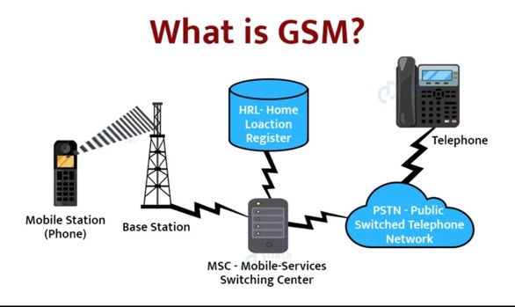
Figure 1: Functionality of GSM
Source: (Data Flair, 2021)
As shown in Figure 1, GSM relies on a network of base stations that communicate with mobile devices via radio waves. The devices connect to the nearest base station and send the signal to the mobile network in order to establish a connection. This connection is used to transmit data, or voice between the device of the sender of the message or call and the recipient of the message/call (Data Flair, 2021).
GSM uses SIM cards (Subscriber Identity Module) that stores information about a user’s identity. A SIM card is needed for data transmission in a GSM system. The GSM system is more adaptable than CDMA because the SIM card can be easily removed and inserted into each device that supports SIM cards. GSM is used by 80% of mobile networks in 210 countries (Data Flair, 2021).

CDMA
Code Division Multiple Access (CDMA) first appeared in the 2G and 3G generations and uses the spread spectrum technology which allows the best use of the available bandwidth. Thanks to the spread spectrum technology, users can send data over the full frequency spectrum anytime and because of that, CDMA is one of the most secure ways of communication. It uses UHF (Ultra High Frequency) with frequencies in the range of 800MHz and up to 1900MHz (Data Flair, 2021).

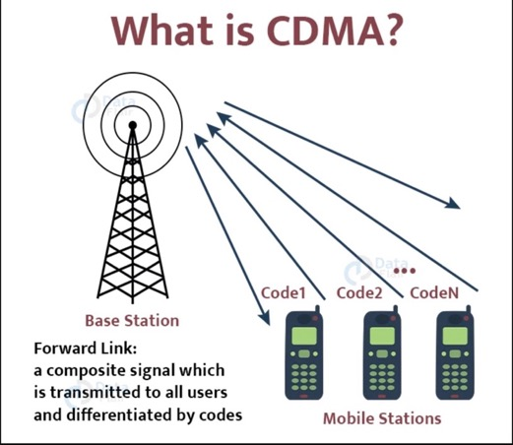
Figure 2: CDMA
Source: (Data Flair, 2021)

Evolution of Mobile Networks
Mobile networks play an important role for providing roaming services. Through the years the technology for mobile networks got better in terms of quality and speed. The generations of mobile network will be briefly discussed and are the following:
- First Generation (1G)
- Second Generation (2G)
  - 2.5G
- Third Generation (3G)
- Fourth Generation (4G)
- Fifth Generation (5G)

First Generation (1G)
The first generation of mobile networks or 1G was introduced in the late 1970s and supported mainly phone calls which was analog based. However, roaming between different operator was not supported and also no compatibility between systems (From 1G to 5G, n.d.).
Second Generation (2G) & 2.5G
The second generation was launched in 1991 under the GSM standard and was a big leap forward. With the launch of 2G, people could send text messages (SMS), multimedia messages (MMS), and picture messages on their phones.
The second and a half generation or 2.5G allowed packet-switched data transmission which where faster than 2G networks. Also, with 2.5G, basic internet browsing and E-Mail services were possible (From 1G to 5G, n.d.).

Third Generation (3G)
3G was introduced in 2001 which offered much faster speeds in data transmission compared to its predecessor. The 3G standard that was used are CMDA and Universal Mobile Telecommunications System (UMTS). 3G enables faster internet speeds, faster and advanced data services, video calling, etc. (From 1G to 5G, n.d.).
Fourth Generation (4G)
The fourth generation was launched in 2009 as the 4G or Long Term Evolution (LTE) standard. 4G offered significant improvements in data speeds, latency, capacity, offered high-speed video streaming and fast web browsing up to 1GBit per second (From 1G to 5G, n.d.).
One problem with 4G was, that switching from 3G to 4G was not as easy as switching from 2G to 3G, because mobile devices needed to be designed in order to support 4G (From 1G to 5G, n.d.).
Fifth Generation (5G)
The fifth generation is the newest generation of mobile networks so far and was introduced in the late 2010s. It can offer even higher speeds, much lower latency up to 10GBit per second (From 1G to 5G, n.d.).

Domestic and International Roaming
In this paper, the author has only discussed roaming outside of the home country. International roaming happens when the user is outside the country and the mobile phone disconnects from its local mobile network and searches for a foreign mobile network. However, in domestic roaming, the mobile phone will disconnect if the phone is outside of the network’s coverage area within its home country and automatically connects to a different domestic carrier. For example, the user is a customer of the internet service provider A1 and is staying in an area without A1 coverage, the phone will then connect to the Magenta coverage in that area. Domestic roaming does not charge the user extra fees, while international roaming typically does but it depends on the user’s mobile carrier and the data usage (Nicolae Bochis, 2022).

Problems of Roaming Fees
There are several problems when it comes to Roaming fees. Often Roaming fees charged by mobile operator are not transparent enough which could lead to tremendously high costs for the users at the end of the month. The lack of transparency in roaming fees and complexity of the charging structure can make it difficult for customers to understand how much they will be charged for using their mobile phones while staying abroad. Especially for people who travel a lot for business purposes this can get very problematic, as well as for students who study abroad.

Roaming Fees

Definition and Calculation of Roaming Fees
When a mobile device with a SIM-Cards inserted is being used outside of its home network, mobile operator applies charges to the customer depending on how much the user has used data or made phone calls within the roaming area. The roaming fees are normally higher than the regular charges. The fees are calculated depending on the service used, SMS, phone calls, mobile data, the visited country, the home network operator etc.
An example of the current roaming fee for a phone call between Austria and Germany would be, that an incoming call from Germany would be free, but an outgoing call would cost 0,09€ per Minute. For data mobile usage the user would be charged 0,02€ (Calculate Roaming Charges - Tellink Traveller SIM, n.d.). However, this calculation was an example for roaming charges within the EU. The charges increase when roaming is used outside the EU. Another example is roaming in USA with an Austrian Sim-Card (for this example, T-Mobile, or Magenta, is used). In this situation the user would get charged 1,99€ per Minute for a phone call or even 15,36€ per MB data that is used (Roaming Übersicht - Magenta, n.d.). The author will focus on the prices between different operators a little bit later during this seminar paper.
So as shown in the example, the calculation of roaming charges do really depend on (mostly) the country that is being visited but also the mobile operator for example Magenta or A1 etc., so each mobile operator charges different roaming prices, which will be later discussed.

Different Types of Roaming Fees
When traveling outside the domestic country, there are different types of roaming fees that the mobile operator can charge a user. It depends what type of communication the user is using. The roaming charges are different for each type of roaming. The different types of roaming are phone-calls, SMS and data roaming.

Phone-Calls and SMS
When it comes to phone-calls, there are outgoing call charges and incoming call charges. When a person makes an outgoing call while staying in a foreign country, the user will get charged in addition to the standard call charges of local calls by the mobile operator.
Incoming call charge is the fee that the user has to pay, while receiving a call during the stay outside of its home country. The fee is also charged more expensive that the call charges that apply to local calls. This is typically cheaper than outgoing calls, but it depends on the tariff.
SMS is a widely used type of communication. When sending text messages (SMS) while roaming, the user is being charged a fee for each sent text message. The fee while roaming is again higher than the fee for sending text messages while being in the user’s home country or home network.

Data Roaming
Data roaming allows a user to access to the internet while staying outside the home network coverage area. The fee will be charged by the mobile carrier for each Megabyte used. For example, user A lives in Austria and has a mobile tariff of Magenta (T-Mobile) and is currently staying in New York, USA. If user A has activated data roaming on his mobile device, it will automatically connect to an American mobile carrier for example Verizon or AT&T. The user will be charged for each Megabyte used which can get very expensive.

Type of Tariffs
Mobile operators offer a high variety of roaming tariffs for different data services. Users should know the different tariffs available in order to select the best package for them. There are several categories, that most tariffs fall into: Standard roaming tariff, Special roaming tariff, Daily roaming bundles and Monthly roaming bundles (SMS Data Roaming Explained, n.d.).
Standard Roaming Tariff: This is a default tariff that a customer would use when there is no specific roaming tariff option activated. In this case, the user is charged according to how many phone-calls the user has made, how many text messages have been sent or how much data has been uploaded or downloaded (SMS Data Roaming Explained, n.d.).
Special Roaming Tariff: The user gets a lower data roaming tariff for a fixed fee (typically monthly). This tariff is aimed at regular use with low to average volume usage (SMS Data Roaming Explained, n.d.).
Daily Roaming Bundles: With this type of bundle, the user pays a fee for a single day of data roaming, up to a specified data usage limit, for a fixed fee. This is ideal for occasional roamer with a high data volume requirement on particular days from time to time (SMS Data Roaming Explained, n.d.).
Monthly Roaming Bundles: With monthly roaming bundles, users get a certain amount of data that can be used within each month while roaming for a fixed monthly fee. This tariff is often subscribed by regular roamer with high data volumes (SMS Data Roaming Explained, n.d.).

Price Difference between Mobile Operators
This chapter is going to focus on the comparison of prices between different countries of Austrians major mobile carriers Magenta, A1 and Drei.
For international roaming there are several package options. Magenta offers a 7-days international roaming package, which include 100 MB data roaming for 5€, 250 MB data for 12€ and 500 MB data for 23€ in over 80 countries as shown in Figure 3 (Magenta Zusatzpaket Datenvolumen, n.d.).
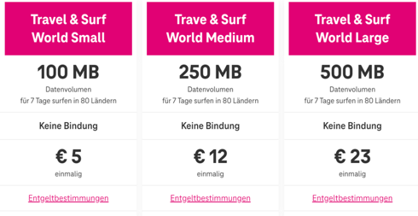
Figure 3: Magenta International Roaming Package
Source: (Magenta Zusatzpaket Datenvolumen, n.d.)
The mobile carrier A1 offers similar roaming packages for international roaming. There are three main packages that are valid for 7 days. As shown in Figure 4, the first offer is 100 MB data, 100 Minutes of phone calls and 100 SMS for 27,90€. The next package includes 500 MB of data, but no phone calls or SMS and costs 27,90€ as well. For 1 GB of data, you pay 34,90€. These international roaming packages are only valid in 55 countries (Roaming Tarife - A1, n.d.).
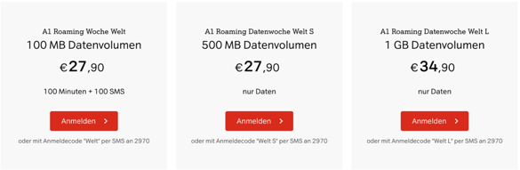
Figure 4: A1 International Roaming Packages
Source: (Roaming Tarife - A1, n.d.)
There are two more roaming packages that include 150 countries outside of the EU that are not included in Figure 4. The “A1 Roaming Welt 250” package includes 250 Minutes, 250 SMS, 250 MMS and 250 MB of data for 149,90€. The “A1 Roaming Welt 100” package includes 100 Minutes, 100 SMS, 100 MMS and 100 MB of data for a price of 79,90€.
Compared to Magenta and A1, the mobile carrier Drei follows a slightly different international roaming package strategy. All three packages offer 500 MB of data but they cost differently. The first package costs 6€ for each of the available country, the second one costs 9€ for each country but consists of a larger amount of available countries and the last roaming package costs 12€ for each country and offers the largest amount of available countries (Roaming – Drei.at, n.d.). Users can choose the suitable package for them.
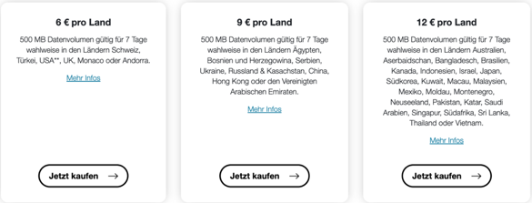
Figure 5: Drei International Roaming Packages
Source: (Roaming – Drei.at, n.d.)
If a user decides not to buy one of the roaming package offers above or something similar to that, they will be charged different, higher prices. The first mobile network carrier that will be presented is Magenta. For example, a user from Austria is currently staying in Canada and decides to turn on his/her mobile phone and activates Roaming with a Magenta SIM-Card inserted, then it will be compared with A1 and Drei as shown in Table 1.

To Austria and inside of Canada | Phone-Call per Minute | Data per MB | SMS | MMS
Magenta | 4,29€ | 15,36€ | 0,45€ | 0,24€
A1 | 4,99€ | 19,90€ | 0,99€ | 0,99€
Drei | 1,99€ | 10,00€ | 0,35€ | 0,84€
Table 1: Roaming in Canada

Table 1 compares the roaming fees of three Austrian mobile carriers: Magenta, A1 and Drei. It compares phone calls from Canada to Austria, mobile data, SMS and MMS services inside of Canada with an Austrian SIM-Card of one of the three mobile carriers (Magenta.at, A1.net, Drei.at, n.D.). As this Table shows, the roaming charges are very high and could easily cost hundreds of Euros, even thousands of Euros for the user. For example, a user surfs through the internet for a couple of hours and consumes 100 MB of data, which is not much data nowadays. With Magenta, the user would be charged 1.536€, with A1 1.990€ and with Drei 1.000€. Compared to Magenta and A1, mobile carrier Drei has significantly lower costs for phone-calls per minute, data per MB and SMS. Drei is the most cost-effective choice for the user in this example with Canada. It is important for the user, to carefully compare roaming charges between different mobile carriers to avoid high charges but choosing a roaming package or a different alternative (will be discussed later in this seminar) will probably be the best choice though.

Data Usage Monitoring
Because of fair use policy, the mobile carrier can monitor and control a user’s roaming behavior over a period of four months. If during this period the user has been abroad longer than at home and has had a higher data usage with roaming than at home, the mobile operator can contact the user and ask for clarification of the current situation and the user has 14 days to explain the current situation.
After the period of 14 days has expired and the user is still spending more time abroad than at home, while continuing to consume more roaming data than the user’s domestic data, the mobile operator is authorized to charge extra fees for the roaming usage. These are the upper limits of the surcharges, excluding VAT (Roaming – Europa.Eu, n.d.):
- 2,2 Cents per Minute for phone calls
- 0,4 Cents per text message (SMS)
- 2 Euro per GB data usage

Tracking a user’s mobile usage abroad could also be helpful for the user in order to prevent extra charges. Some mobile carriers remind the user via notification if the data usage is nearing its limit, this could prevent the user from getting a high bill from its mobile carrier at the end of the month.

Critics on Roaming Fees
Roaming charges have caused many issues to consumers in terms of high charges while using mobile phones outside of their home country. According to a survey conducted by ZDNet, 80 percent of the respondents said that they had received a data-roaming bill that was too expensive, 20 percent of the respondents think that data roaming charges in general were too “high” (David Meyer, 2011). It is not unlikely to receive a bill over hundreds or thousands of Euros. Many travelers are therefore not sure how they should act when traveling abroad. Some users are scared off and turn off roaming in their phone settings or even turn off their mobile phones completely. According to a study of Barometer, around a third of German travelers turn off their mobile device and 20% only turn off roaming in their mobile phone. Around 28% of EU-citizen decide to turn their phone off as shown in Figure 6 (Brandt M, 2014).
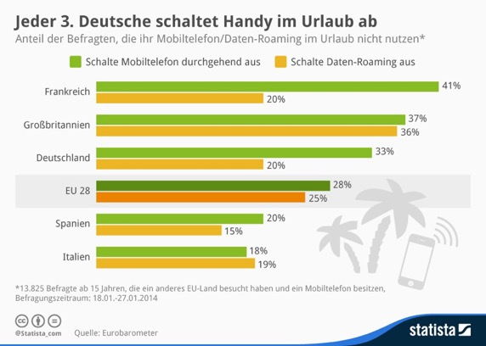
Figure 6: Survey about Roaming Usage
Source: (Brandt M, 2014)

EU-Roaming Regulation
In this chapter, the author wants to discuss how roaming was before the EU-Regulation and how it changed during the phases of implementation of EU-Regulation. During this chapter, the author will go through all phases and then explain the final introduction of the EU-Regulation and “Roaming Like At Home” in 2017. Furthermore, he wants to analyze the impact and what has changed since the implementation of the Regulation.

Roaming before EU-Regulation
International roaming exists since the beginning of the 90s and until 2007 there were no regulations like the EU-Regulation. After the introduction of roaming, the demand in the US and Europe was high because people could use their mobile devices and therefore did not have to call from a phone booth or using a fixed telephone line (Dunnewijk & Hultén, 2007).
But the situation was different back then as users were charged significantly higher prices for using their mobile phone outside of their home country. This applied to all users in Europe. According to an investigation of the European Commission, international roaming calls were four times higher than national calls inside the home country (Grzybowski, L. & Muñoz-Acevedo, A., 2021). People started complaining after they were surprised with a “bill shock” at the end of the month without really knowing how the high charges were calculated and if they were being overcharged or not because there was a lack of transparency in the market.
The International Telecommunications User’s Association (INTUG) analyzed in the year 1999 that the price difference between international calls, which means a call from home to another country, and roaming calls, making a call when the user is traveling outside the home country, is too high and could not be justified. After the complaints, the European Commission was concerned about the high charges and started investigations and concluded that there was a market failure in the International Roaming Services (IRS) wholesale markets. The reason for the market failure was the lack of competition among operators. The European Commission then decided to include this market to the 2003 European Commission recommendation on relevant markets. However, the assessment by the national regulatory authorities (NRAs) and the European Regulation Group (ERG) demonstrated that it was not possible to effectively address the high level of wholesale Union-wide roaming charges. The European Commission therefore imposed a roaming regulation for EEA in 2007 (Spruytte et al., 2017).

Phases of EU-Regulation
In the year 2007, the European Commission introduced a Roaming Regulation (Regulation I) to reduce the costs for outgoing and incoming calls for users who want to travel inside of the EU by setting a price cap. Mobile operators were then forced to obey to this regulation. However, they were still allowed to charge other price tariffs if the user voluntarily chooses and agrees to use such a price tariff.
In June 2009 Regulation II was introduced. The European Commission wanted to continue the price capping strategy and lowering prices for voice calls. With Regulation II the European Commission also introduced data and SMS (for outgoing and incoming SMS) service regulation. A new feature to prevent users from getting “bill shocks” was introduced. After a certain billing amount for data is reached (50€ by default), the mobile operator needed to inform the user that a specific amount of data has been reached. The user could then decide to continue using data services and spend more money on using those services or stop the service (Spruytte et al., 2017).
In 2010, two alternative approaches were mentioned “Roam Like At Home” (RLAH) and “Roam Like A Local”. RLAH means that the operator charges the same price for international (EU and EEA) roaming services like domestic mobile services. RLAL means that the user should pay the price that fits the market of the visited country. However, RLAH is considered as the most straightforward and consumer-friendly option. The Body of European Regulators for Electronic Communications (BEREC) also mentioned in 2011, that RLAH was the better and transparent option, but it was not yet ready and suitable for the year 2012. In the year 2012 the European Commission decided to introduce Regulation III, which included lowering again the existing price caps and adding retail caps for data services (Spruytte et al., 2017).
In 2014, the EU Parliament endorsed the RLAH initiative and was hoping to implement this in 2015. However, the deadline exceeded and RLAH was still not implemented because the member states could not agree on this. Finally, after long discussions the deadline of the reduction-to-zero strategy is postponed to 2017, assuming that the wholesale market is reformed by that date (Spruytte et al., 2017).
On June 15th 2017, the RLAH Regulation came into force, so this means that every traveler who has the EU Roaming option activated in the mobile tariff, the traveler is now able to use mobile data across EU and EEA countries without having to be worried about extra charges. For example, as an Austrian traveler with a Magenta tariff including EU Roaming, the traveler would be able to travel to Germany or Spain for example and use the mobile data services just like being in Austria. But as mentioned, the tariff should include EU Roaming and this could be different depending on what mobile operator you choose. There are many options like 40GB data in the home country and 20GB of the 40GB can be used in the EU.

Impact on Roaming Fees
The implementation of the Roaming regulation has had a significant impact on consumers within the European Union. One major advantage and impact on consumers are the reduction of costs. Due to Roaming Like At Home (RLAH) travelers technically do not have to pay any surcharges for mobile data (if the EU-Roaming package is included in the mobile tariff) when they travel to a different country inside of the EU and EEA. This makes traveling much easier and consumers do not have to worry about “bill shocks” when they receive their monthly bill, in best case they do not pay anything additional to the existing mobile tariff contract. The uncomplicated use of mobile data is not the only benefit that travelers and consumers have, they also benefit from making phone calls or sending text messages. The surcharges for those services have significantly dropped since the introduction of the EU-Regulation. For example, a consumer with an Austrian SIM-Card from Magenta is currently staying in Germany would only have to pay 0,0021€ per Minute when he or she makes a phone call to Austria, sending an SMS to Austria would be charged with 0,0048€. Receiving phone calls or text messages from Austria would be charged nothing by Magenta (Roaming Übersicht - günstig im Ausland telefonieren, n.d.).
Another aspect that has been positively influenced by the EU-Regulation is the increased transparency. Consumers must be informed about roaming charges from their mobile carrier when they travel abroad. The information is sent via SMS to the consumer with all the information of the charges for phone calls and text messages as well as mobile data charges if the amount of the tariffs mobile data is exceeded. The user is also informed by their mobile carrier via SMS when they have reached 80% and 100% of their data allowance. Now users are warned when they reach the limit and can therefore be more cautious with the data usage to prevent exceeding their mobile data volume.

Regulations Outside of EU
Travelling outside of the EU and EEA is different for the European consumer because EU-Regulations do not apply for countries outside of the EU, such as non-EU European countries and international destinations. High Roaming fees can still be charged. Other continents have implemented regulations too, but they are different from the EU-Regulation, which for example allows a consumer to use data in all EU- and EEA-Countries.
In North America there is the “North American Numbering Plan” or NANP. which contains several countries of North America like USA, Canada, and many Caribbean countries. NANP focuses on assigning telephone numbers in a standardized way across North America. The advantage of NANP is that callers do not have to use international dialing codes (North American Numbering Plan General Management and Oversight, n.d.). However, NANP does not directly regulate roaming services like the EU-Regulation. Each country in North America such as USA, Canada or Mexico has its own roaming regulation. For example, in USA there is the “Federal Communications Commission” (FCC), which is an independent U.S. government regulatory agency that focuses on regulating communications by radio, television, wire, satellite, and cable. With the implementation of FCC, consumers have the opportunity to access to voice, text, and data services when they travel outside of their home network’s coverage area. FCC has also set guidelines to prevent users from getting “bill shocks” and high costs (Roaming for Mobile Wireless Services, n.d.).
In other continents outside the European Union, there are no similar standardized Regulations which offer price caps for travelling multiple countries within a specific area. Instead, every country has implemented its own regulations and own rules regarding roaming and charges, like FCC in the U.S and so on.

Alternatives of Roaming
To make sure a customer will not receive any additional roaming fees, a good approach is to look for any alternatives. As mentioned, roaming fees can be charged when a user is traveling abroad and uses his/her phone with the home network’s SIM-Card. So, using a different SIM-Card for roaming is a good alternative. There are a couple of alternatives for travelers, especially when travelling outside of EU and EEA countries. The alternatives are the use of Wireless networks and other SIM-Card options, which will be further discussed in this chapter.

Wi-Fi
Wi-Fi or WLAN is a wireless technology that connects mobile devices to the internet via radio waves that is sent by a wireless router. Nowadays, every mobile phone or devices supports Wi-Fi, which makes it easy for users to use the internet just by connecting to it.
So, if a user decides to travel without using a SIM-Card in order to save additional costs, using Wi-Fi is a good option. A big advantage of WIFI is that in most cases it’s free. Travelers can easily connect to a Wi-Fi of their hotel, the restaurant, or just public wireless spots. It always depends on the country the user wants to visit, some countries offer more wireless opportunities and some countries offer less.
A disadvantage of only using wireless networks when travelling is the dependency of Wi-Fi. When there is no Wi-Fi signal nearby, the user will not be able to use the internet to stay connected with family and friends, this is a risk the user has to take because the Wi-Fi coverage area is limited. Another downside is, the user cannot call someone on their phone number directly but has to use WhatsApp or any other app that supports phone calls via internet. Another problem that could occur is low quality of the Wi-Fi. It is not guaranteed that the internet to which you are connected to is stable and has a good quality. If you are sitting in a Café and you have and important online meeting, there might be a chance that the connection will not work well because wireless in Café are used by many people simultaneously and can therefore lead to connection problems. Security risks should also be considered because public Wi-Fis may be unsecured which could lead to hacking or data theft and the user should be aware of those risks.
Another method is the use of Mobile Hotspots. Mobile Hotspots can be directly activated on someone’s mobile phone if the user has a valid SIM-Card inserted. With this method, the phone can act as a wireless router and provide other people with internet. This is a good idea if you decide to visit family or a friend abroad and do not want to use roaming services, then the family member or friend can easily activate mobile hotspot on the phone an provide internet connection to others.

SIM-Cards
If relying on Wi-Fi networks and their limited coverage areas is not sufficient enough for the user, there are several SIM-Card options available that can be bought in order to use them abroad without needing the own home network’s SIM-Card. These options can prevent the user from getting high roaming charges at the end of the month because only prepaid SIM-Cards options are used. Users might have less worries about “bill shocks” because this cannot occur. Also, buying SIM-Cards specifically for travelling does not require to change the current mobile tariff or add any additional roaming packages. The SIM-Cards options are Local and International SIM-Cards.

Local SIM-Cards
When a user decides to purchase a local SIM-Card in the country he or she is visiting, the user can use the local mobile network at local prices. This has the advantage, that users will not be charged any surcharges because of their stay in the foreign country. Usually, local SIM-Cards for travelers are prepaid, so if their limit has been exceeded, the users do not get any extra charges but also they are not able to make any phone calls, send text messages or access to the internet.
For example, an Austrian user wants to visit the United States of America for 3 Weeks and decided to go with a local U.S. SIM-Card. The Austrian has several options, but in this case only T-Mobile and AT&T will be analyzed.
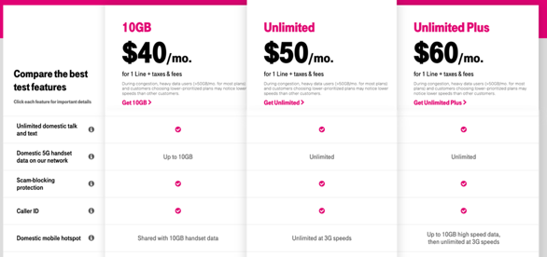
Figure 7: T-Mobile Prepaid SIM-Card in USA
Source: (Compare Our Best Prepaid Phone Plans | T-Mobile Prepaid, n.d.)
T-Mobile USA offers three types of local prepaid SIM-Cards. As shown in Figure 7 the cheapest option called “10GB” costs 40 Dollars for one month and as the name already says, it offers 10 GB of data as well as unlimited voice and text within USA. The second option called “Unlimited” costs 50 Dollars but offers unlimited data compared to the previous offer. And the last prepaid option is called “Unlimited Plus”, the price is 60 Dollars and the difference to the previous options is, that it offers 10 GB high speed internet for domestic mobile hotspot whereas the other options only offer 3G speeds. Note that the prices do not include taxes and fees, these are going to be charged additionally during the purchase.
The other U.S. mobile carrier is AT&T and is one of the largest mobile networks in USA. They offer three prepaid plans as well.
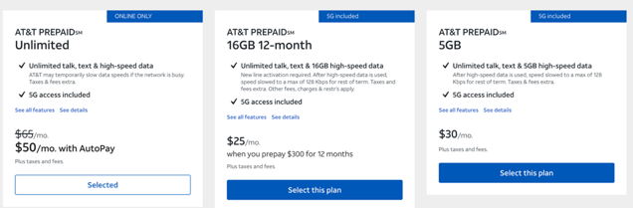
Figure 8: AT&T prepaid SIM-Cards USA
Source: (Shop WIRELESS, n.d.)
AT&T offers several prepaid plans for tourists. As shown in Figure 8, there is the option to buy “Unlimited” data, voice and text for 65 Dollars (plus taxes and fees), the same prepaid plan will cost 50 Dollars if the user decides to activate “AutoPay”, which automatically tops up the SIM-Card but in this case for the Austrian traveler, the AutoPay option would not be necessary. Another option is 16GB for 12 months which has to be prepaid for 12 months, this would only make sense if a user wants to stay in the U.S. for one year. If 5GB is enough for the user, the third option is suitable because it costs 30 Dollars and offers 5GB. There are two more prepaid plans which are not shown in Figure 8 which contain 15GB at the price of 40 Dollars and a 3-month package with 8GB per month which costs 99 Dollars in total.
These were just examples of local SIM-Cards in USA, there are several more offers by different mobile carriers which would be too much to list them all.
For foreign travelers outside of the EU who want to visit European countries, it is suggested to buy a local SIM-Card in the first EU-Country that they visited which has the EU-Roaming package included. With this approach, the user is then given the opportunity to travel across the EU-Countries without having to buy a new SIM-Card for each European destination.

International SIM-Cards
International SIM-Cards, also called global SIM or travel SIM-Cards, are very helpful for people who want to travel to more than one country. They are designed to be used for multiple countries or regions. This is a big difference to the local SIM-Cards, because local SIM-Cards are only limited to that specific country. International SIM-Cards are much more cost efficient than using roaming services and often offer competitive rates for data, calls and SMS.
International SIM-Cards are much more convenient than buying local SIM-Cards for people who travel a lot because they have one SIM-Card that works for multiple countries and therefore do not need to buy and switch between SIM-Cards in each country they visit making it easier for users to stay connected and manage their communication during their travels.
International SIM-Cards are not only offered as physical SIM-Cards, but also as eSIM. The eSIM stands for embedded SIM-Cards and is a digital SIM-Card that is integrated into a device. The big difference and advantage compared to a traditional physical SIM-Card is, that with an eSIM you do not insert any SIM-Card to the device. The eSIM is built into the device an can be activated remotely with the mobile network’s information.
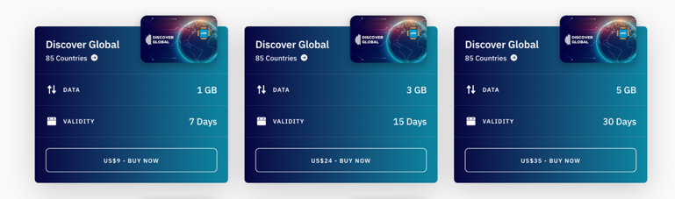
There are many International SIM-Card provider. One provider called “Airalo” offers a global eSIM package which is shown in Figure 9.
Figure 9: Global eSIM by Airalo
Source: (Local and Regional ESIMs for Travellers, n.d.)
Airalo offers several global eSIM packages that include 85 countries such as some European countries, USA, Canada and many more countries. The first package is only valid for 7 days and offers 1 GB of data. The second package include 3 GB of data and has a validity of 15 days. The third option offers 5 GB of data and is valid for 30 days, probably the most suitable for users who want to travel between 2-4 weeks. However, Airalo eSIM-Cards only offer data services (Local and Regional ESIMs for Travellers, n.d.).

Conclusion
The seminar paper discussed the issue of roaming fees and how roaming fees are calculated, what the roaming charges of different mobile operators are and what alternatives there can be in order to bypass or to minimize those charges while staying connected abroad. The internet has changed the world and therefore staying connected abroad has become inevitable for many people. Thanks to roaming, people are able to travel all over the world and can still use their mobile phone to make calls, send messages or use the internet with their home network’s SIM-Card. However, roaming charges can easily get very high, and this has been discussed during the paper with an example how quickly the costs can add up and cause a “bill shock” at the end of the month.
One important aspect that has been discussed during this paper is the EU-Roaming regulation, which has had a significant influence on roaming charges within the European Union. This paper briefly went through all the different stages of the roaming regulation and how it has improved over the years. It has also been discussed if there are similar regulations outside of Europe and how other continents have handled the roaming issue. Lastly, the author described the different alternatives of roaming and how the roaming prices can be minimized during a stay abroad.
This paper highlighted the importance of roaming fees and how users have to be aware of high roaming charges, what they have to keep in mind when they want to travel and what the possible alternatives are. Travelers should be informed about the latest regulations and tariffs when travelling abroad to ensure a cost-effective mobile experience. The EU-Regulation has played a significant role in reducing the roaming costs for travelers of EU-Countries, which could be an example for other regions to follow.

References
Flash Eurobarometer 468: The end of roaming charges one year later (v1.00). (2018). [Data set]. European Commission, Directorate-General for Communication. http://data.europa.eu/88u/dataset/S2192_468_ENG
Brandt, M. (2014). Jeder 3. Deutsche schaltet Handy im Urlaub ab [Digital Image]. Retrieved May 11, 2023, from https://de.statista.com/infografik/1915/nutzung-von-mobiltelefonen-und-daten-roaming-im-urlaub/
Grzybowski, L./ Muñoz-Acevedo, A. (2021). Impact of Roaming Regulation on Revenues and Prices of Mobile Operators in the EU
Calculate Roaming Charges—Tellink Traveller SIM. (n.d.). Retrieved June 9, 2023, from https://www.tellinkroaming.com/calculate-roaming-charges?roaming_in=2-AUSTRIA&destination=22-GERMANY-mobile
Compare Our Best Prepaid Phone Plans | T-Mobile Prepaid. (n.d.). Retrieved June 5, 2023, from https://prepaid.t-mobile.com/prepaid-plans
Data Flair. (2021, December 4). CDMA vs GSM - Difference Between GSM and CDMA. DataFlair. https://data-flair.training/blogs/cdma-vs-gsm/
David Meyer. (2011, March 28). Why data roaming costs too much. ZDNET. https://www.zdnet.com/article/why-data-roaming-costs-too-much/
Dunnewijk, T., & Hultén, S. (2007). A brief history of mobile communication in Europe. Telematics and Informatics, 24(3), 164–179.
From 1G to 5G: A Brief History of the Evolution of Mobile Standards. (n.d.). Retrieved June 8, 2023, from https://www.brainbridge.be/en/blog/1g-5g-brief-history-evolution-mobile-standards
Local and regional eSIMs for travellers. (n.d.). Airalo. Retrieved June 7, 2023, from https://www.airalo.com/global-esim
Magenta Zusatzpaket Datenvolumen. (n.d.). Retrieved June 9, 2023, from https://www.magenta.at/handytarife/zusatzpakete/travel-surf
Nicolae Bochis. (2022, November 28). What Is Data Roaming (and How To Avoid Roaming Charges). Online Tech Tips. https://www.online-tech-tips.com/smartphones/what-is-data-roaming-and-how-does-it-work/
North American Numbering Plan General Management and Oversight. (n.d.). Retrieved June 1, 2023, from https://www.fcc.gov/north-american-numbering-plan-general-management-and-oversight
Roaming – Drei.at. (n.d.). Retrieved June 9, 2023, from https://www.drei.at/de/info/roaming/roamingtickets/
Roaming for Mobile Wireless Services. (n.d.). Retrieved June 1, 2023, from https://www.fcc.gov/wireless/bureau-divisions/competition-infrastructure-policy-division/roaming-mobile-wireless
Roaming Tarife—A1. (n.d.). A1.net. Retrieved June 9, 2023, from https://www.a1.net/handys-tarife/zusatzoptionen/roaming-tarife
Roaming Übersicht—Günstig im Ausland telefonieren. (n.d.). Retrieved May 31, 2023, from https://www.magenta.at/hilfe-service/roaming/roamingfinder
Roaming Übersicht—Magenta. (n.d.). Retrieved June 9, 2023, from https://www.magenta.at/hilfe-service/roaming/roamingfinder
Roaming: Using a mobile phone in the EU. (n.d.). Your Europe. Retrieved May 14, 2023, from https://europa.eu/youreurope/citizens/consumers/internet-telecoms/mobile-roaming-costs/index_en.htm
Shop WIRELESS. (n.d.). Retrieved June 5, 2023, from https://www.att.com/buy/wireless/prepaid/plans
SMS Data roaming explained. (n.d.). Retrieved June 9, 2023, from https://www.gsma.com/aboutus/wp-content/uploads/2012/03/smsdataroamingexplained.pdf
Spruytte, J., Van der Wee, M., de Regt, M., Verbrugge, S., & Colle, D. (2017). International roaming in the EU: Current overview, challenges, opportunities and solutions. Telecommunications Policy, 41(9), 717–730. https://doi.org/10.1016/j.telpol.2017.01.009

