Vienna University of Economics and Business

Seminar Paper

**Webbrowser: History, Concepts, Market** _____________________________________________

Author: Peter Gruber

Matriculation Number: h01550637  
Seminar aus BIS (Schiseminar) - 0082  
Term: WS22/23  
  
Submitted on 15th of December 2022

Instructor: ao.Univ.Prof. Mag. Dr. Rony G. Flatscher

# Declaration of Authorship

I assure:

* to have individually written, to not have used any other sources or tools than referenced and to not have used any other unauthorized tools for the writing of this seminar paper.
* to never have submitted this seminar paper topic to an advisor neither in this, nor in any foreign country.
* that this seminar paper matches the seminar paper reviewed by the advisor.

Date: December 15th, 2022

Signature Peter Gruber:

Table of Content

2 Introduction 1

3 Evolution of Web Browsers 2

3.1 History of Web Browsers 2

3.1.1WorldWideWeb / Nexus 3

3.1.2Line Mode Browser 4

3.1.3Lynx 4

3.1.4Mosaic 5

3.1.5Netscape 6

3.1.6Internet Explorer 7

3.1.7Firefox 9

3.1.8Safari 10

3.1.9Chrome 11

3.1.10Edge 12

3.2 World Wide Web Consortium (W3C) 13

3.3 Acid Tests 14

3.4 Privacy 17

4 Market 18

4.1 Market Share 19

4.2 Why do Mayor Players have Unique Web Browsers? 25

4.3 Revenue Streams 25

5 Future Outlook 25

Table of Figures

Figure 1 WorldWideWeb web browser (ethz) 3

Figure 2 Lynx web browser (lynx) 5

Figure 3 Mosaic web browser (ncsa) 5

Figure 4 Netscape Navigator web browser (webdesignmuseum) 6

Figure 5 Internet Explorer (Webdesignmuseum, webdesignmuseum, 2022) 8

Figure 6 Firefox (webdesignmuseum) 9

Figure 7 Safari (appleinsider) 10

Figure 8 Chrome desktop and mobile (google) 12

Figure 9 Edge (windows) 13

Figure 10 Passed Acid1 Test (w3.org) 15

Figure 11 Passed Acid 2 test (acid2) 16

Figure 12 Passed Acid3 test (acid3) 17

Figure 13 Desktop Market Share 10 years (statcounter) 20

Figure 14 Mobile Market Share 10 years (statcounter) 21

Figure 15 Combined Market Share 10 years (statcounter) 22

Figure 16 Desktop vs Mobile vs Table Market Share 10 years (statcounter) 22

Figure 17 Market Share Europe 2022 (statcounter) 23

Figure 18 Market Share North America 2022 (Statcounter, statcounter, 2022) 23

Figure 19 Market Share Asia 2022 (statcounter) 24

Figure 20 Market Share Africa 2022 (statcounter) 24

List of abbreviations

# Introduction

Nowadays web browsers are needed almost everywhere, many applications are built to be accessed with a web browser and information is accessible everywhere, every time through web browsers on smart phones. The evolution of web browsers started in the early 90s with the invention of the first web browser. This was the starting point of a rapidly changing technology which enabled not-tech-savvy people to access the internet.

The choice of web browsers was limited throughout the last three decades because of always one web browser being dominant. The dominant web browser changed through the years because whenever a browser was on the top another one with better technology made its way. There were also not consumer friendly decisions to limit their choice in web browsers by manufacturers of operating systems. Still even that couldn’t hinder innovation in web browsers.

An organization the W3C was made to create standards for web browsers to enable web developers to build their web pages based on those standards so that those pages would be displayed the same in every web browser. Over the years the W3C published many standards which build the core of web browsers and pages. There was also criticism about some standards published by the W3C and the growing influence from big companies on the decisions.

Privacy issues are a rising concern in peoples and law makers minds, which shifted the development to more privacy friendly web browsers. Through these developments the easiest way to collect data from users was made harder. This had the effect that companies which collected and used this data had to find more creative ways to get the same or more data from users. The battle for privacy on the internet is an ongoing one, because although more and more people are concerned about the collected data the majority of the users is not aware of this and therefore doesn’t care.

The market of web browser is currently dominated by one vendor, but there are three other which together are the four major web browsers used. The market share of the different web browsers is similar over the world in the way that everywhere is the same dominant web browser. But the composition of the less used web browsers is different around the world.

The manufacturers of the four major web browsers have all angels why they develop and maintain an own web browser. They also have different revenue streams through which the finance the development and maintenance of the web browser as well as their business.

The future of web browsers lays in the mobile world, the trend from the last years will only go further and the majority of web browser will be on mobile devices. This will focus the development even more in this direction, with a mobile-first focus from web browsers and web developers. The fight for privacy on the internet will also go on, there were already great starts by law makers but there needs to be more. Because every year more and more of our lives is spent online which makes the data collected even more worth to companies and other entities.

Currently there are wrong discussion about disabling end-to-end encryption under the smokescreen of the justified fight against child pornography. But the effects will be much greater and data from users will be even more prone for attacks. The privacy of users has to get the highest priority.

# Evolution of Web Browsers

Web browsers have undergone a rapid development during the last three decades after the release of the worldwideweb browser. There were many different developers with different ideas on how a web browser must function. It wasn’t until a few years after the first web browser, that big players entered the market, the first one was Microsoft. This market entry was also the spark which ignited the browser wars. Microsoft was followed by Apple and finally Google, with their own web browsers.

To make it possible to provide consistent web pages in every web browser, the World Wide Web Consortium (W3C) was founded, to create recommendations for technical specifications which should be implemented in every web browser. Due to the fact that those standards are only recommendations, the web browser developers do not always implement them fully or at all. In the late 90s this has led to users having to decide which web browser to use as they were incompatible.

## History of Web Browsers

The history of web browsers has been marked with rapid development and innovation, with competition between multiple organizations and technologies. The continued evolution of web browsers has played a major role in the use of the internet today. The following list of web browsers is just a small overview over the most important ones in the past three decades, but it is by no means a full list of all browsers developed and released during this time.

### WorldWideWeb / Nexus

The first web browser, WorldWideWeb, was developed by Tim Berners-Lee in 1990, who was working at CERN at that time. After the initial development from Tim Berners-Lee, several others were included in the team to work on the WorldWideWeb web browser. The web browser was only working on NeXT computers because it depended on the proprietary software from those computers.

In the beginning the web browser was capable of displaying only text, images had to be downloaded to be viewed, as there were no means to display them in the browser. This was until a change in the used NeXTSTEP’s text class, which later also supported images. The WorldWideWeb web browser was a What-you-see-is-what-you-get (WYSIWYG) editor.

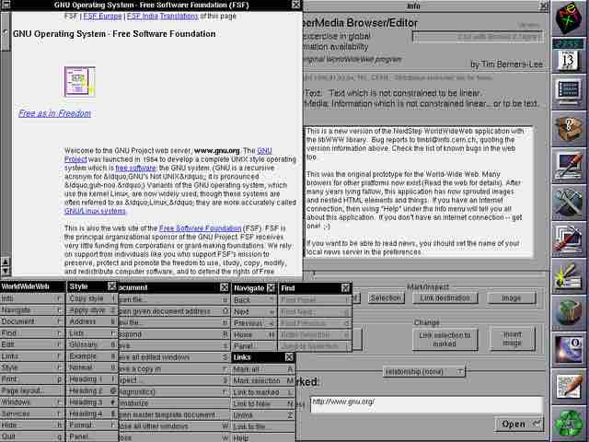

Figure 1 WorldWideWeb web browser (ethz)

In the release of a new version in 1994, the name of the web browser was changed to Nexus, to avoid confusion with the already growing world wide web itself. Later in the same year the web browser was discontinued, and the source code was released into the public domain.

### Line Mode Browser

In the same year the WorldWideWeb web browser was developed, the development of the Line Mode Browser was done by some of the same members of the original WorldWideWeb team. The Line Mode Browser had the goal to be used on any operating system. For this the user interface had to be as simple as possible, which resulted in a line-by-line interface.

After the main developer at that time, Nicola Pellow, started the development on the MacWWW web browser, soon after the source code of the Line Mode Browser, became public domain. Shortly after the responsibility was put into the hands of the newly created W3C. The last release of the Line Mode Browser was in 1995, after which it was fully integrated into the libwww.

During the first years after its release, it was a popular web browser since it was supported on every operating system. But due to its nature of only displaying line by line text, it was soon displaced by web browsers which were capable of displaying far more than just text. It’s function as a text-only browser was superseded by the Lynx web browser.

### Lynx

The Lynx web browser was developed from another team then the Line Mode Browser but superseded the later one after a brief period. Lynx is currently the oldest web browser still maintained, although it is still featuring a text only experience. Other non-text content can be opened in external software, but not in the web browser itself. Due to its nature of only rendering text, it is considered fast, especially when using older hardware or a slow internet connection.

This makes it also a web browser which is used by visually impaired people, because text-to-speech software can work good with just text output and if correctly used the alt attribute from images.

Ein Bild, das Text enthält.

Figure 2 Lynx web browser (lynx)

Since there are no images or other objects than text to be loaded and no JavaScript support, a lot of the currently used tracking methods are not working. But it can still not be considered completely privacy safe since it supports browser histories.

### Mosaic

The Mosaic web browser was originally developed for the Unix’s X Window System. Shortly after the initial release ports for Microsoft Windows and Macintosh were released.

Ein Bild, das Text enthält.

Figure 3 Mosaic web browser (ncsa)

Mosaic web browser was the first to be easy to install by ordinary people and to display images on the same page and not in another window. Those things made it the first web browser appealing for the masses, which initiated the start of the internet boom. The Mosaic web browser achieved a huge market share of over 50%, which unfortunately for Mosaic was swiftly changed when the Netscape web browser was released, which was superior for the users.

### Netscape

The Netscape Navigator web browser was developed by one of the former developers from Mosaic web browser, Marc Andreessen. The early intention of Netscape Navigator was to be available for non-commercial users free of charge, which changed after two months. The free use was only available for academic and non-profit organizations. After a year the decision was reversed, so that Netscape Navigator was free to use, not only for academic and non-profit organizations, but for all non-commercial uses.

Ein Bild, das Text enthält.

Figure 4 Netscape Navigator web browser (webdesignmuseum)

The Netscape Navigator web browser was soon the standard web browser, with a peak market share of 86%. One of the reasons for this success, was the implementation of on-the-fly display. This means that web pages are displayed as there were loaded and not after all the elements were loaded. During the early days of the internet this was especially useful for users, as they were using slow connections, which meant in other web browsers to maybe wait minutes until the web page was displayed. Which was different in Netscape Navigator, were the already could read the text of the web page after a few seconds and when the images were loaded the would be displayed immediately.

The developers of the Netscape Navigator web browser always tried to be ahead of the competition. They implemented lots of new technology, like HTTP cookies and JavaScript. Those developments were not without criticism, like that bypass standards from the W3C or that the make it possible to invade the privacy of the users. One of those new technologies, was their own implementation of a Cascading Style Sheet technology called JavaScript Style Sheets. This technology was not adopted by web page developers, which had the effect that the developers from Netscape had to implement a Cascading Style Sheet to JavaScript Style Sheets converter, which only worked when JavaScript was enabled.

This was one of the reasons they quickly lost market share to the Microsoft Internet Explorer, because the design from Netscape was viewed as dated compared to it. The other, bigger reason for the decline of Netscape was that Microsoft’s Internet Explorer was bundled with Microsoft Windows and later in the 90s it was also the default web browser in Mac OS. At the end of the 90s Netscape developed but not incorporated the Gecko engine, which became the basis of Firefox.

### Internet Explorer

The first Internet Explorer version was developed on the basis of the Mosaic web browser in 1995. The licensing worked in a way that Microsoft paid a fixed amount plus a percentage of the revenue. For the first two version of Internet Explorer which were sold to the users, this was a good for Spyglass, the license owner. But this changed with version 3, which was bundled in Windows 95 and additionally released free of charge.

Due to this there was no revenue from which a percentage could be paid, so Spyglass was left with only the fixed amount. Still, Microsoft had to settle with Spyglass after they threatened to start a contractual audit.

Ein Bild, das Text enthält.

Figure 5 Internet Explorer (Webdesignmuseum, webdesignmuseum, 2022)

It wasn’t until the next version, version 4 that Internet Explorer overtook Netscape and set the bar higher. During this time, the US Department of Justice brought up a legal case against Microsoft for breaking a consent decree with bundling Internet Explorer with Windows and rewarding OEM partners for including Internet Explorer and no web browser else.

Microsoft argued that this was all in the interest of the consumer and that without Internet Explorer, Windows would not function correctly. Due to basic functions like Windows Update and Windows help relying on libraries installed with Internet Explorer this was partly true. This changed with the release of Windows Vista, where all the functions were also usable without Internet Explorer installed.

Until 2005 Internet Explorer was the dominant web browser, this slightly changed with their end of support for the Macintosh version and the release of Firefox. During the following years, Internet Explorer lost a lot of market share to Firefox, which was the more performant web browser after the Firefox version 3 release.

With the release of Google Chrome, this decline of market share started to accelerate until in 2012 Internet Explorer was not the most used web browser anymore. The development of Internet Explorer continued until 2014, when Microsoft Edge was announced.

The newest release of Internet Explorer 11 reached end of support in summer 2022 for consumer versions and is now only redirecting to Edge. Internet Explorer 11 on enterprise system will be supported until their respective end of support dates. Even older versions of Internet Explorer are still supported, Internet Explorer 7 is still supported until October 2023 and Internet Explorer 9 even until January 2024.

### Firefox

The Firefox web browser was developed by the Mozilla Foundation as an experiment which intended to replace the Mozilla suite with the Mozilla browser. It was developed using the Gecko engine which was first introduced by Netscape. Firefox is a free and open-source web browser.

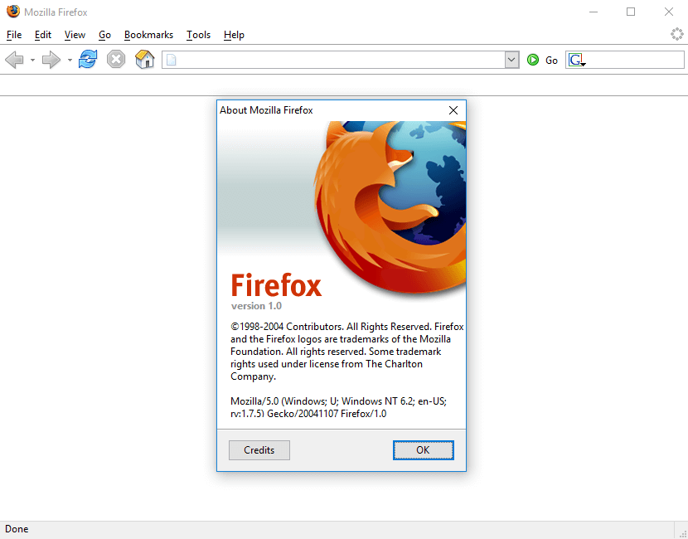

Figure 6 Firefox (webdesignmuseum)

The first release of version 1 was after multiple versions which were tested beforehand and achieved great response from the testers. During this testing phase it achieved better performance and security than the Internet Explorer 6.

Firefox added features such as an integrated pop-up blocker, which was a big issue at that time, which made the web browser popular. Another feature was tabbed browsing, which although already available in other web browsers, Firefox made it available to more users.

During its lifetime Firefox has went through multiple major graphical redesigns and a big technological redesign with project Quantum in 2017.

Project Quantum had the goal to make Firefox more competitive again versus the Google Chrome web browser, which had taken a huge part of the market. Through this changes Firefox now distributes the tabs over four processes, which decreased the memory consumption drastically. The processes count can be changed manually which allows for more than four processes on better hardware.

### Safari

Safari was only developed after Microsoft discontinued the Internet Explorer for Mac. Safari was developed with the Apple’s WebKit engine. The first version of Safari was pre-installed with Mac OS X and Internet Explorer remained as an alternative web browser.

Ein Bild, das Text enthält.

Figure 7 Safari (appleinsider)

Safari 2 was the first version of Safari which was the only pre-installed web browser in Mac OS X, which ended the Internet Explorer for Mac era. This version of Safari was the first web browser to pass the Acid2 test, which was designed to test web browsers on their following of the specifications from the W3C.

Safari 3 was the first version available on both Mac OS X and iOS, displaying full desktop web pages on both. Safari was then also released as a Windows version, which was the fastest web browser on Windows at that time.

Safari 5 was the last version released for Windows as well. It featured DNS prefetching which made it load up web pages even faster than before.

Safari 11 was the first version to implement Intelligent Tracking Prevention, which limited cookies and website data to prevent cross-site tracking.

The biggest criticism about Apple and Safari is the forced use of WebKit, for every other browser available, which makes it impossible for users to install browser extensions which are not supported by WebKit.

### Chrome

Development for Google Chrome started in 2006 and the first version was released in 2008. Up until 2013 Chrome used Apple’s WebKit engine, then they created their own engine called Blink, which is built on the WebCore components from WebKit.

Chrome implemented multithreading, which increased the performance over other web browsers drastically. Over the years it was released for MacOs, iOs and Android as well as Google’s own operating system ChromeOS.

Ein Bild, das Text, Monitor, Screenshot, drinnen enthält.

Figure 8 Chrome desktop and mobile (google)

When Chrome was released, Google also released a large part of its source code as an open-source project called Chromium. Chromium lacks automatic updates, API keys for Google Services and other licensed applications.

The Chromium codebase is widely used, the most prominent users are Microsoft Edge and Opera.

Right from the beginning Chrome sparked concerns about privacy, with their initial Terms of Service release which stated that all content transferred via Chrome, belongs to Google. They quickly turned around and removed this passage, but still the seed of doubt was there. Over the years the concerns were always there, because of non-optional tracking mechanisms in Chrome.

Since Google’s business lies in advertising most of the cookies saved are produced by Google itself, to collect data. In 2021 Alphabet announced that it plans to discontinue cookies and replace them with FLoc technology. After criticism from other web browser distributors, Alphabet announced that FLoC is not going to be released and replaced by another technology called Topics API.

### Edge

The Edge web browser is the successor if the Internet Explorer. Initially it was built in 2014 using Microsoft’s EdgeHTML engine and it was released in 2015. This legacy Edge was only developed for three years, after which Microsoft decided to build a Chromium based Edge browser, with extension made by Microsoft.

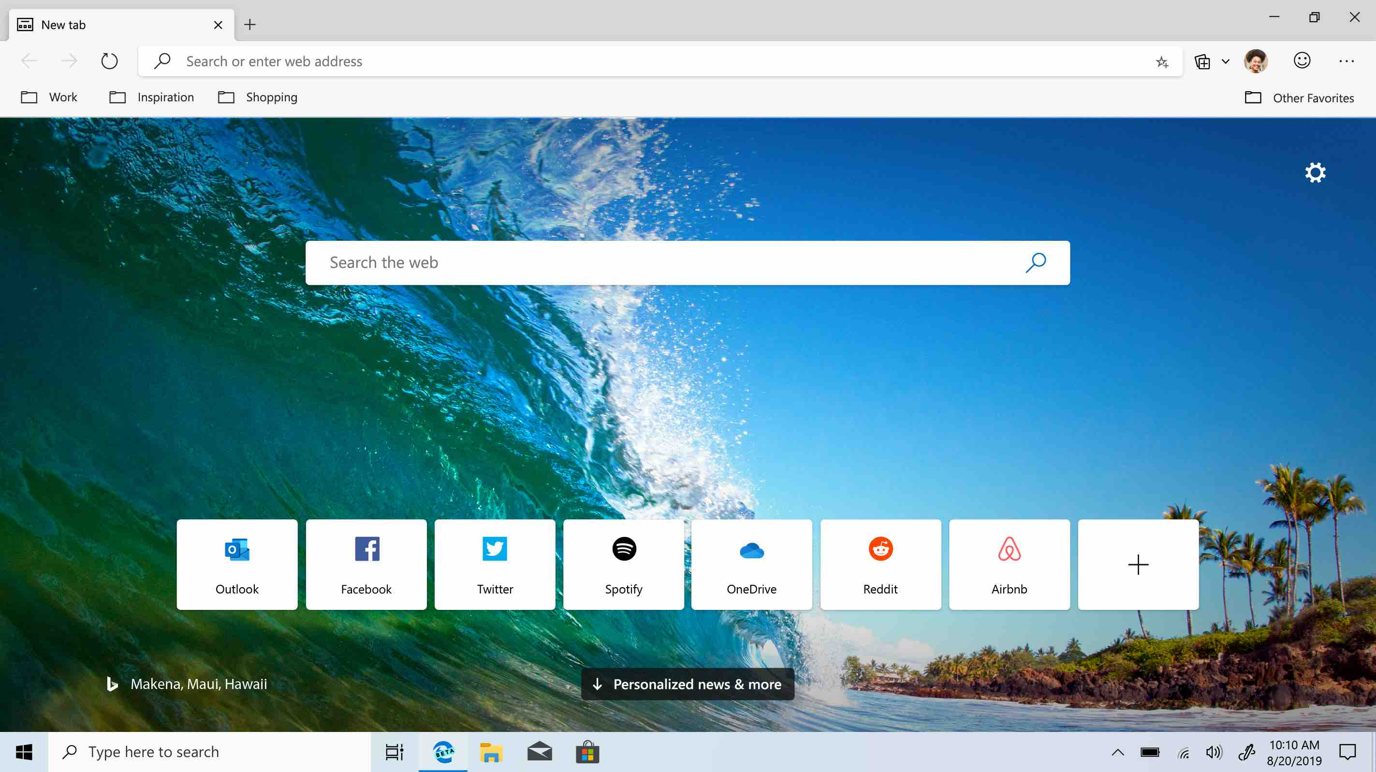

Figure 9 Edge (windows)

It features an Internet Explorer mode which can be used to fix compatibility issue on older web pages, which was needed because many organizations still have legacy system running which are only displayed correctly in Internet Explorer.

## World Wide Web Consortium (W3C)

The World Wide Web Consortium is an international organization that develops standards for the World Wide Web. The W3C was founded in 1994 by Tim Berners-Lee, the inventor of the World Wide Web, and is made up of member organizations that represent a broad range of stakeholders, including web developers, user-agent vendors, content creators, and researchers.

Through the standards developed by the W3C a consistent level of technology and quality should be available in web browsers. When web browsers comply with those standards, developers can use these standards to build applications which are going to work regardless of the user’s browser choice.

Over the years the W3C defined multiple standards, a few of them are HTML, CSS, XML, DOM, SOAP, and Web Content Accessibility Guidelines. In 2017 the W3C published a standard for Encrypted Media Extensions, which entailed lots of criticism as it stands against open-source web browsers, and there are concerns about privacy and security.

The standard specifies the communication between web browser and Content Decryption Module. It is used to play HTML5 digital rights management protected content, without using Adobe Flash or applications. The Content Decryption Module is the part which limits open-source web browsers, since there is no module which is licensed without paying a per-browser fee.

The Encrypted Media Extensions interface has been implemented in all the major web browsers, although Firefox goes a slightly different way in which it handles the Content Decryption Module. Firefox loads the Content Decryption Module in a sandbox, which hinders the ability von the Content Decryption Module to track the user. In Firefox it is also always possible to disable the functionality.

This standard also showed the huge impact large organizations have on the W3C and its members. There was a huge opposition to this standard, but all the objections were overridden by the director although the W3C should work in consensus.

Currently the W3C faces a challenge regarding the dominance of Google Chrome. Through the massive amounts of users which Chrome has, and the money Google can use to develop their web browser, they can control in which direction the web goes.

This was also shown when the four big browser vendors, started the Web Hypertext Application Technology Working Group (WHATWG). This group developed the standard what would later become HTML5, after they disagreed with the W3C about the future of web development. After the major browser vendors supported HTML5, the W3C approved it too, which already shows the pressure they were under.

Both organizations had come to an agreement after a fallout about the new DOM standard, that only the WHATWG will publish standards about HTML and DOM. This gives the four big browser vendors, complete control over the further development of the web.

## Acid Tests

The Acid tests were created to check their conformity with the standards issued by the W3C. The tests were useful for developers to see whether a web browser supports all the standards or not. But for not tech-savvy users the tests were not important, for them if a web page wasn’t working in one browser they used another one and if this also didn’t work, the conclusion for them was that the web page was broken.

The first acid test was released in 1998 and in took until 2008 for every major web browser to pass this test. Although by that time it was merely relevant anymore.

Figure 10 Passed Acid1 Test (w3.org)

This version tests different features against one reference image, so naturally all the line-by-line web browsers at that time didn’t fulfil the W3C standards.

The acid 2 test was released in 2005 and tested web browser for HTML conformity with the main focus on CSS, as it was not correctly implemented in the dominant browser at that time, Internet Explorer. Internet Explorer often rendered web pages different than other web browsers, so it was more development needed from web developers to get their pages working outside the W3C standard in Internet Explorer. The acid 2 test was meant as a challenge for Microsoft to make Internet Explorer comply with the defined standards. This challenge was successfully mastered by Microsoft with the release of Internet Explorer 8, at that time all the major web browsers passed the acid 2 test.

Figure 11 Passed Acid 2 test (acid2)

At the release of the test every web browser failed it, but nowadays every major web browser passes the test, even mobile web browsers. This is interesting since most of the standards tested are from before the year 2000 with only CSS being new.

The currently last test acid3 was released in 2008 and focused on the conformity of standards regarding the interactivity of web browsers. Like with acid2 when the test was written, no web browser was able to pass it. The test had to be rewritten in 2011 because some at the initial release discussed standards were not codified and since not implemented by web browser vendors.

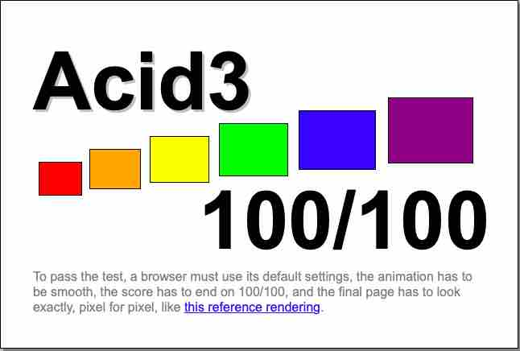

Figure 12 Passed Acid3 test (acid3)

Since the rewritten release in 2011 a lot of the specifications have changed, so that by 2017 the test didn’t reflect the specified standard anymore. As a result, the latest versions of the major web browsers don’t pass the test. The author of the test acknowledges that the test no longer reflects the standards it’s supposed to test (Hickson, 2022).

Originally there was an acid4 test planned and it was already in development, but there is no planned release available which makes it uncertain if there will ever be an acid4 test. Because of this the acid tests have become more or less obsolete in the current web browser environment at least that’s what can be thought but as there has only been a new test for only html5, the acid3 test still has validity.

The html5 test only checks the conformity of the web browser with the html5 standard but no other W3C standards. The combination of both tests can cover a lot of the standards from the W3C and the Mozilla Foundation.

## Privacy

# Market

Today’s web browser market is split between only a handful of web browsers, with one of them, Google Chrome currently dominating the market. The history of web browsers repeats itself over and over, in the last three decades there was always one web browser which dominated the market and other smaller ones. This led to the fact that web developers often focus on the currently dominating web browser with their optimizations, which further limits the choice users have. This is the biggest problem with one browser dominating like this, users are often forced to use this browser as otherwise some web pages might not be fully available to them.

The fact that there is only a limited viable choice of web browsers is in some cases wanted by the organization behind the operating system. As it is the case with Apple’s MacOS and iOS which both only allow web browser developed with their own WebKit engine. Apple limits with this restriction the possibilities of the web browser developers and due to this also the availability of niche web browsers in their ecosystem.

Another thing which limits the choice is the fact that not every web browser implements the specified standards exactly the same which leads to web pages behaving different in different web browsers. This is caused due to the not binding specifications which leaves the developers of the web browsers room to only implement some or no parts of a specification without repercussions. This can only work with web browser which are used by a large share of the market, because otherwise the web page developers would have no incentive to design their web pages away from the specified standard.

There is also the interest in the user data which is collected through the use of the web browser. Web browsers have more ways to collect data on their users than web pages, because they don’t rely on tracking of the user since they always know what the user is doing in its environment. The user data can be used in multiple ways, the most common one is advertising. In case of Google Chrome advertising revenue makes the biggest part of their revenue. Due to the massive amount of collected data Google can offer firms or individuals who want to advertise through their services a narrow audience which according to the collected data is interested in the advertised topic.

But not only organizations are interested in the data collected from users, also governments are interested in it. May it be for legitimate reasons but mostly it’s an extreme violation of privacy when government organizations can access all the data collected which doesn’t even have to have anything to do with the crime they are investigating. Or in other cases of authoritarian countries where the government wants to control everything a user does on the web.

The market currently consists of only web browsers which are free of cost, either through being available to download or already bundled with a specific operating system. This was not always the case, there were times when some web browsers were only available for a fee.

## Market Share

Currently the market is divided into two categories, desktop and mobile web browsers, with the majority of users on mobile web browsers. The desktop market is shared amongst one big and three smaller web browsers, in case of usage numbers but the organizations behind them are big. The mobile market is in the hand of two web browsers which are also the two most used browsers in the desktop category.

There are multiple ways to determine the usage numbers of web browsers each organization had different ways. Since a few years there seems only one organization left which collects this data and provides it.

The measuring of the market share of web browsers is not without criticism because of the fact that every counting method has its pros and cons. Applications which collect and analyze this data try their best to create a true picture of the market situation through acknowledging those concerns and mitigating them as far as possible.

Statcounter measures the usage of browser with page views and not unique users. Their reasoning for it is that when a user clicks a page one time at a day with one browser and multiple times with another browser, if only counted unique visitors both counts would be 1. In their eyes this doesn’t reflect the truth, which is why they count every page view (Statcounter, statcounter, 2022). There are also other aspects which make it difficult to take unique users as a measure, since a common way to track a single user would be through cookies. So, if a web browser doesn’t allow cookies, it would render this method to count wrong, since every page view would be a unique user without a way to define a unique user. This would give web browsers with blocked cookies more usage share than it really has. Statcounter also tries to minimize the impact bots have on the usage data and filters them out.

Some web browsers also provide a pre rendering ability which preloads web pages of links on the currently viewed page, as they might be a future view from the user and the loading speed is optimized this way. This behavior is partly filtered out through a specific API header, but in Safari’s “Top Sites” and Opera’s “Speed dial” features there is currently no way to filter out their traffic.

Statcounter provides all the collected data free of charge under a Creative Commons Attribution-Share Alike 3.0 Unported License. The data can be displayed in various different ways on their web page, to make it accessible for everyone.

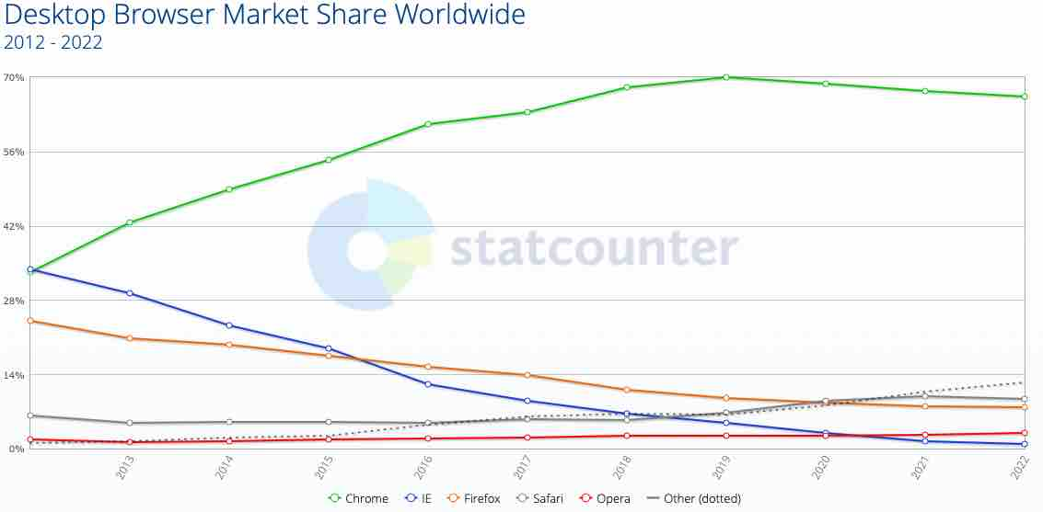

Figure 13 Desktop Market Share 10 years (statcounter)

Figure 13 shows rapid growth of Google Chrome over the last ten years and the steady decline of Internet Explorer. Although in the last years there was a small decline in usage of Google Chrome which is due to other Chromium base web browsers like Microsoft Edge. It is also displayed that over the last ten years the other big players in the market had a decline in usage like Firefox or are almost unchanged over time like Safari and Opera.

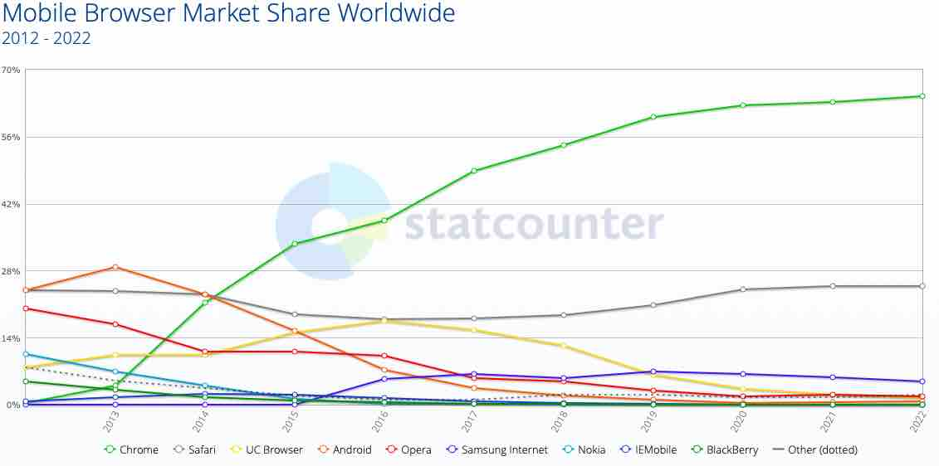

Figure 14 Mobile Market Share 10 years (statcounter)

Figure 14 shows a similar trend considering Google Chrome like in the desktop web browser figure. The biggest difference in market share between desktop and mobile is that the mobile market, although there is a dominant vendor, is more diversified. At the beginning of the smartphone era, every manufacturer decided to create their own web browser for their phones. This led to multiple web browsers which disappeared with the end of life from their smartphones. Prominent examples which can be seen in the figure are Nokia and Blackberry as well as IEMobile. In the mobile market Safari is the biggest competitor in market share to Google Chrome. This is due to the fact that until now Apple doesn’t allow different web engines than their own WebKit Which makes every web browser on iOS similar since they are limited in their features with what WebKit offers them. Samsung internet still exists but mainly because it is pre-installed on Samsung smartphones.

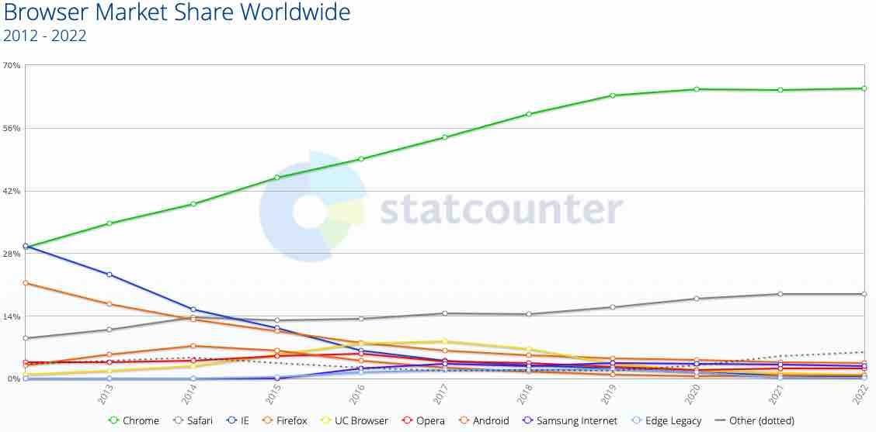

Figure 15 Combined Market Share 10 years (statcounter)

Figure 15 shows that combining all the different platforms it is visible that the mobile market is a big factor in market share. Which will only continue in the following years since more and more people only have a smartphone or a tablet and no desktop computer.

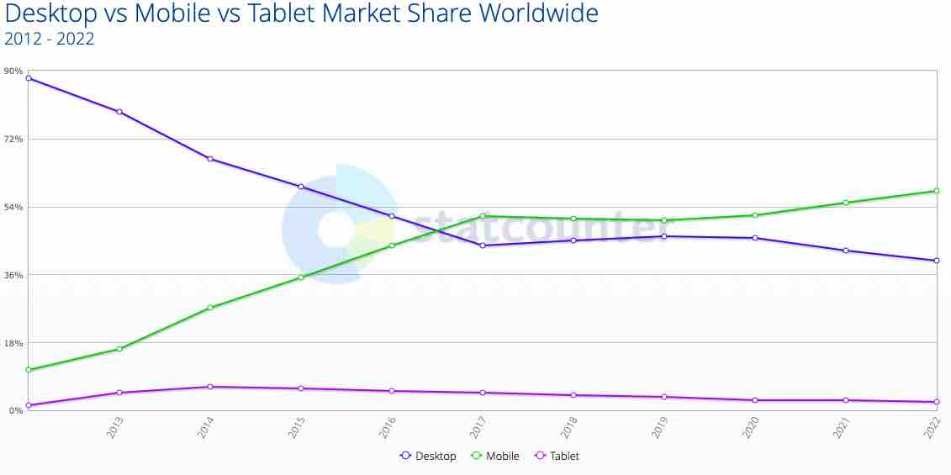

Figure 16 Desktop vs Mobile vs Table Market Share 10 years (statcounter)

Since Statcounter collects all the device data, it can also show a clear picture on how the market share is developing considering desktop and mobile web browsers. The first time mobile web browsers overtook desktop browsers was in 2016. Would be tablets counted together with mobile web browsers it would have been slightly earlier. For a few years now more than half the page views are through mobile web browsers.

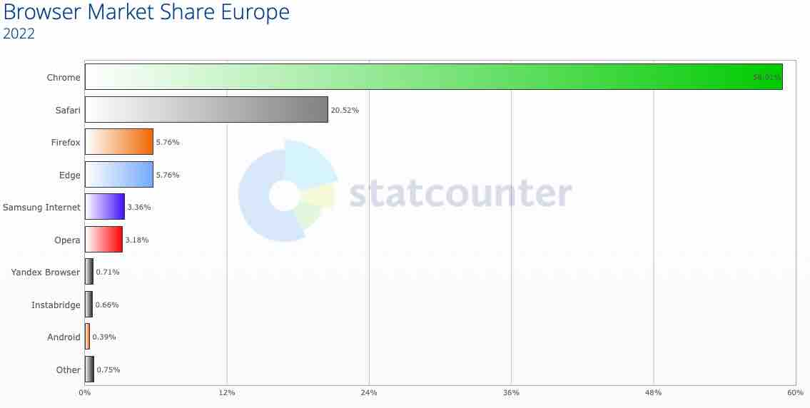

Figure 17 Market Share Europe 2022 (statcounter)

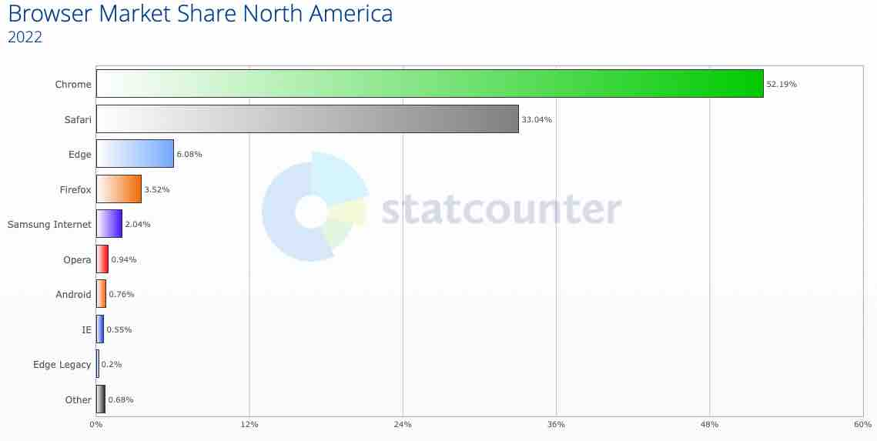

Figure 18 Market Share North America 2022 (Statcounter, statcounter, 2022)

Comparing Figures 17 and 18 shows a bit different situation in web browser market share between Europe and North America. The huge difference in market share for Chrome and Safari is due to the much higher share of iPhones in North America compared to Europe. This leads also to a smaller market share of Samsung Internet in North America. Chrome is still the dominant browser in both regions although the trend points in the direction that Safari might further catch up to Chrome in North America. In Europe is no such trend visible.

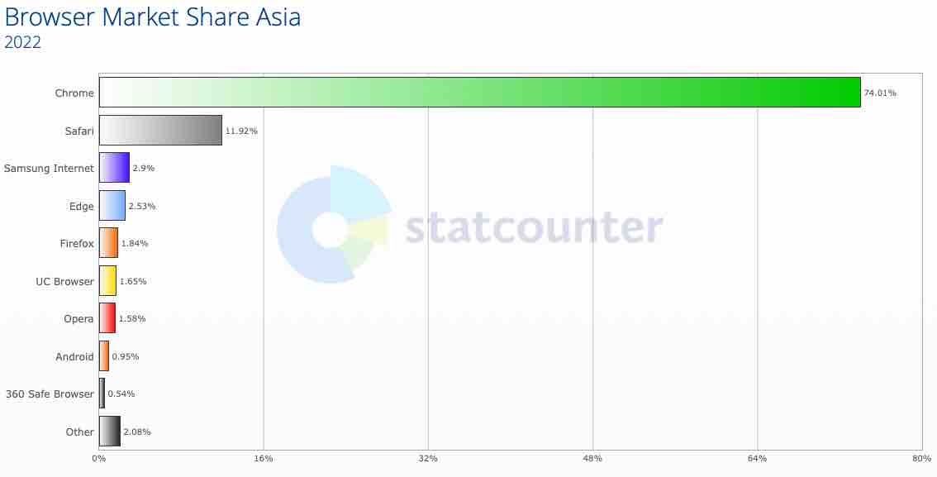

Figure 19 Market Share Asia 2022 (statcounter)

The figure for the Asia region is similar but also not similar, it shows that Chrome is also the dominant web browser. But the only other significant web browser is Safari while all the other ones are just niche web browsers in Asia.

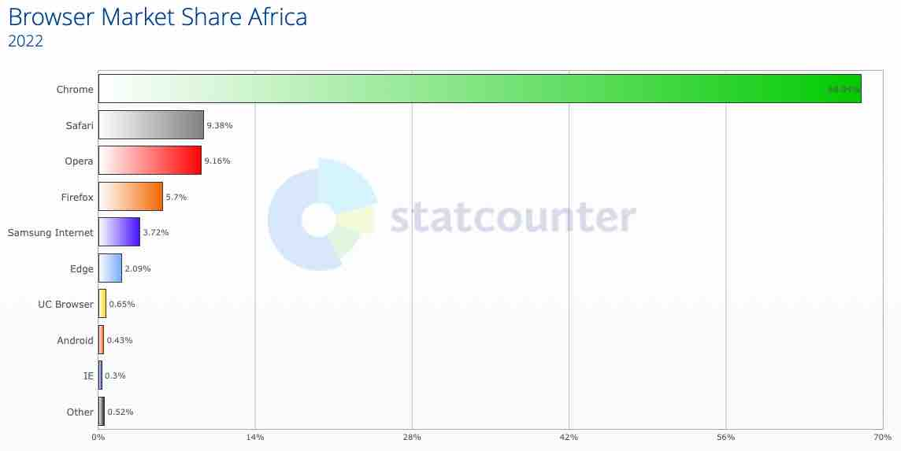

Figure 20 Market Share Africa 2022 (statcounter)

The figure for Africa is interesting in a way that Chrome is more dominant than in every other region and also the fact that Opera is a bigger player in this Region. Opera is used in Africa in form of the Opera Mini web browser, which features faster connection and free limited monthly data. Opera makes this possible through cooperation with telecom providers in different African states, to provide the people with internet access through a fast and easy to use web browser combined with sponsored monthly data (Opera).

## Why do Mayor Players have Unique Web Browsers?

## Revenue Streams

# Future Outlook

# References

*acid2*. (2022, 12 15). Retrieved from acid2: http://acid2.acidtests.org/#top

*acid3*. (2022, 12 15). Retrieved from acid3: http://acid3.acidtests.org

Appleinsider. (2022, 12 15). *appleinsider*. Retrieved from appleinsider: https://photos5.appleinsider.com/archive/leopard-preview-safari-16.jpg

Berners-Lee, T. (n.d.). *ethz*. Retrieved from ethz: http://gnu.ethz.ch/www.levenez.com/firstbrowser.png

Google. (2022, 12 15). *google*. Retrieved from google: https://www.google.com/chrome/static/images/home-experiment/hero-img_desktop.png

Hickson, I. (2022, 12 15). *acidtests.org*. Retrieved from acidtests.org: https://web.archive.org/web/20090927024208/http://www.acidtests.org/

Lynx. (2022, 12 15). *lynx*. Retrieved from lynx: https://lynx.browser.org

Microsoft. (2022, 12 15). *windows*. Retrieved from windows: https://blogs.windows.com/wp-content/uploads/prod/sites/2/2019/08/4cac7883632a1fb69454aba7b0b0c3ac.png

NCSA. (2022, 12 15). *ncsa*. Retrieved from ncsa: http://www.ncsa.illinois.edu/research/project-highlights/ncsa-mosaic/

Opera. (2022, 12 15). *Opera*. Retrieved from Opera: https://press.opera.com/2021/12/16/opera-celebrates-15-years-of-connecting-africa/

Statcounter. (2022, 12 15). *statcounter*. Retrieved from statcounter: https://gs.statcounter.com/faq#methodology

Statcounter. (2022, 12 15). *statcounter*. Retrieved from statcounter: https://gs.statcounter.com/browser-market-share/desktop/worldwide/#yearly-2012-2022

Statcounter. (2022, 12 15). *statcounter*. Retrieved from statcounter: https://gs.statcounter.com/browser-market-share/mobile/worldwide#yearly-2012-2022

Statcounter. (2022, 12 15). *statcounter*. Retrieved from statcounter: https://gs.statcounter.com/browser-market-share#yearly-2012-2022

Statcounter. (2022, 12 15). *statcounter*. Retrieved from statcounter: https://gs.statcounter.com/platform-market-share/desktop-mobile-tablet#yearly-2012-2022

Statcounter. (2022, 12 15). *statcounter*. Retrieved from statcounter: https://gs.statcounter.com/browser-market-share/all/europe/#yearly-2022-2022-bar

Statcounter. (2022, 12 15). *statcounter*. Retrieved from statcounter: https://gs.statcounter.com/browser-market-share/all/north-america/#yearly-2022-2022-bar

Statcounter. (2022, 12 15). *statcounter*. Retrieved from statcounter: https://gs.statcounter.com/browser-market-share/all/asia/#yearly-2022-2022-bar

Statcounter. (2022, 12 15). *statcounter*. Retrieved from statcounter: https://gs.statcounter.com/browser-market-share/all/africa/#yearly-2022-2022-bar

*w3.org*. (2022, 12 15). Retrieved from w3.org: http://www.w3.org/Style/CSS/Test/CSS1/current/test5526c.htm

webdesignmuseum. (2022, 12 15). *webdesignmuseum*. Retrieved from webdesignmuseum: https://www.webdesignmuseum.org/uploaded/old-software/web-browsers/netscape-navigator/netscape-navigator-2-01-preview.png

Webdesignmuseum. (2022, 12 15). *webdesignmuseum*. Retrieved from webdesignmuseum: https://www.webdesignmuseum.org/old-software/web-browsers/internet-explorer-1-0#&gid=1&pid=1

Webdesignmuseum. (2022, 12 15). *webdesignmuseum*. Retrieved from webdesignmuseum: https://www.webdesignmuseum.org/web-design-history/mozilla-firefox-1-0-2004#&gid=1&pid=1