Wirtschaftsuniversität Wien



Seminar paper on

**Comparison and Critical Comparison of Charges for Roaming (cost based, value based or arbitrary prices).**

__________________________________________________

Edin Hadžimehmedović  
Matriculation number: h0152749

Seminar: Comparison and Critical Comparison of Charges for Roaming (cost based, value based or

arbitrary prices).  
Semester: SS22

Course: SBWL Vertiefungskurs V – Business Information Systems

Submission date: 26.05.2022

Mentoring professor: Prof. Dr. Rony G. Flatscher

Declaration of Authenticity

I declare that I completed the Seminar paper independently and used only these materials that are listed. All materials used, from published as well as unpublished sources, whether directly quoted or paraphrased, are duly reported.

Furthermore, I declare that the Seminar paper, or any abridgment of it, was not used for any other evaluation seeking purpose.

Vienna, 29.05.2022 Signature: Edin Hadzimehmedovic

Table of Content

1. Introduction 1

2. Mobile Telecommunications 2

3. Roaming 3

3.1. Definition 3

3.2. Beginnings 4

3.3. Development 5

4. Pricing Strategies 8

4.1. Cost-Based 8

4.2. Value-Based 9

4.3. Arbitrary Pricing 9

5. Roaming service and market structure 10

5.1. Technology 10

5.2. Supply and demand conditions 14

5.2.1. Retail Level - Demand conditions 14

5.2.2. Retail Level - Supply Conditions 15

5.2.3. Wholesale Level - Supply Conditions 16

5.2.4. Wholesale Level - Demand Conditions 17

6. Composition of Costs and Pricing 18

6.1. Roaming Agreements 18

6.2. Europe Roaming Charges 20

6.3. Cost factors for roaming charges 23

6.4. EU Roaming Regulations 2007-2017 26

7. Conclusion 29

8. Publication bibliography 31

# List of Figures

Figure 1: Mobile Telephone Subscriptions 2000-2018 development 2

Figure 2: The Evolution 1G to 5G 7

Figure 3. Situation 1: Caller and a callee are in a visited country 12

Figure 4. Situation 2: Caller is in a visited country and a callee in a home country 13

Figure 5. Situation 3: Caller is in a visited country and a callee in a third country 14

Figure 6. Comparison of Local and Roaming Voice Call Rates in 1999 (€) 23

Figure 7. Prices of local and roaming calls 25

Figure 8. EEA Average wholesale price per minute for wholesale voice calls 26

Figure 9. EEA Average wholesale price per SMS 27

Figure 10. EEA Average wholesale data price per MB 27

Figure 11. Glide Path of EU Tariff Caps for Voice Roaming, 2007-2017 29

# List of Tables

Table 1 24

Table 2 255

# Introduction

To use your mobile phone anywhere in the world is very pleasant and usable feature, however, sometimes it could become a nightmare. There is significant number of users whose vacation or a business trip turned into a big problem after receiving a monthly invoice and seeing, under position roaming, an amount that is multiple times higher than expected. According to a newspaper report from lower Austria, one subscriber who was in Turkey for vocation received a bill in the amount of 22.000€ for consuming around 1.4Gb volume of data which means that one-megabyte costs around 15€.

Applying quantitative content analysis as a research method, in this paper, I´ll try to answer two questions. First, how roaming prices are being formatted and second, what pricing strategy is being pursued?

As a result of broad interest for the use of mobile technology, the industry of mobile networks, applications and devices increased dramatically over time.

Since the 1920s when the first form of mobile telephony was experimented with in the USA, people have found this type of communication extremely attractive and efficient. However, like any technology, mobile telephony and networks have had their downsides and needed updates in order to give customers the best experience.

For the most part, people have been having issues with high rates of roaming telephony costs. Although business people are the majority of roaming users worldwide (they are not necessarily focused on the cost of a business phone call abroad), there are still certain issues that need space for discussion.

Covering the development of roaming cost rates, arbitrary costs and value cost transparency toward the end customer, this paper, hopefully, shines light on important matters as well as offering applicable solutions.

# Mobile Telecommunications

Mobile radio technology includes procedures of processing and transmission of radio signals and components for the operation of a mobile radio network. It is used for mobile communication using stationary or mobile end devices. Interconnected base stations form a network that enables constant connected to the mobile network.

The success and the broad interest in the use of mobile radio technology was the constant accessibility and availability of a mobile radio network. As a result, mobility increased dramatically and interest in mobile applications and services increased just as much. (See Figure 1). Although mobile radio technologies were primarily developed for the transmission of voice, the strongest service in mobile radio today is the data services.

With GSM service it was SMS, with UMTS mobile Internet and with LTE service, it is the DSL-to-go feeling.

At least in Europe, GSM is the basic technology with almost 100% network coverage. UMTS is the basic technology for fast mobile Internet access. It is being replaced by LTE due to the steadily increasing need for fast mobile Internet (Schnabel 2012)

Figure 1: Mobile Telephone Subscriptions 2000-2018 development (Data Source: <https://databank.worldbank.org/source/millennium-development-goals/Series/IT.CEL.SETS.P2>)

# Roaming

## 

## Definition

Roaming refers to a mobile communication service that gives a mobile telephone customer an ability to make and receive voice calls, send and receive data and use other services, when staying outside of a network coverage of his home telecommunication operator and using a network of visited operator. Meaning, if a subscriber is located in some region where there is no network coverage of his operator his telephone would select another operator´s network, if available.

One more precondition for the subscribers being able to roam is an existing roaming agreement between a subscriber’s home network and the network operator of a visiting region.

There are more types of roaming, but the most important division would be a geographically based division to international and national roaming.

National roaming, makes it possible for a customer to use a network from a different operator in the same country. (Wikipedia 2022) This kind of cooperation has strategic reasons, because in this way, weaknesses in your own network can be compensated and vice versa. For the customers there are no additional costs, and one benefits from a better network coverage.

International roaming refers to possibility to use a network from a foreign operator outside one´s county of residence.

The other type of roaming division is a call/connection type division. If a subscriber is visiting a foreign country and using roaming service for incoming calls this type of roaming is called passive roaming. Making a call or sending a SMS in visited network is named active roaming. Moreover, using an internet connection for transfer of data is termed as data roaming.

## Beginnings

At the beginning wirelesses communication looked nothing like it looks today but its potential had been recognized.

First experiments with mobile telephony go back in the US in the 1920s with radio telephony. In 1947 AT&T launched a highway service between Boston and New York after the success of first car-bound mobile telephone network that was launched in St. Louis. Frequency spectrum in radiotelephony at that time was a limited resource and became eventually crowded. More efficient use of the frequency space came after automatic mobile telecommunication system was introduced, based on a cell structure. But the cell structure had its critical issues, roaming and hand-over that is. Roaming service is needed to keep a track of the telephones whereas hand-over is needed when moving from one cell to another to keep a telephone call active.

First American cellular phone service came into life in 1979 as a trial and went into commercial in 1983. After a short period of time there was numerous mobile phone companies offering basically city services what made roaming in the US very difficult. (Dunnewijk and Hultén 2007, pp. 166–167)

Mobile telephony developed in a slightly different manner in Europe. First real commercial mobile telecommunication service that had seen a light of day was back in 1978 in Scandinavian countries, in Sweden to be precise. The Nordic Mobile Telephony System (NMT) was expanding. Until 1990 it had been used, not only in Scandinavia, but also in Spain, the Netherlands, Austria, Ireland, Tunisia, and Saudi Arabia.

The biggest problem were the mobile network standards and the markets being exclusively national. This led to the fact that a lot of different standards were implemented in different countries and as a result one could not use a phone bought in one country in some other country with a different standard. There were also cases where different systems were operating in a same country and costumer not being able to operate his/her phone just in different cities.

To solve this problem, it was decided to form a research group with a task to define a standard that could be implemented worldwide. The consideration was that from that kind of standardization would benefit both the network operator and a costumer, thereby generating economies of scale that would lead to unit price reduction that consequently would turn in to bigger demand and at the end a higher profit for the network operator. The benefit for an end user would not just be a convenient mobile phone pricing but also a possibility to use his phone anywhere in the world where this standardized system would be implemented.

The Council of European Post and Telecommunication (CEPT) made a first step in this direction and formed a group called Global System of Mobile or GSM-system. (Hild 1995, pp. 1–3)

## Development

The CEPT group was formed to address two major issues. First, as mentioned above, was the uncoordinated development of national mobile phone systems with standards that were incompatible with different standards. The second was a proposal to reserve a two-block spectrum for this system. The main goal to overcome this problem was the convenience of using the same mobile phone in different countries (i.e., international roaming). This would create a large domestic market in Europe.(R.N.A. Bekkers and J.M. Smits 1999, pp. 37–38)

GSM as a communication technology and a standard was developed from European Communications Standard Institute (ETSI) beginning from 1982, for the second generation (2G) of digital cellular communication. It is based in optimal switching of a communication network to full duplex peaking telephony and was in next step extended to contain data packet transfer communication. From 1989 it started to be internationally wide excepted and used in 90% of the activity of the 2G phones in 219 countries and territories. It replaced analog communication and was a technological breakthrough.

GSM roaming services have been very attractive to business users, from the start. This emulated the success and the attractiveness of roaming on the earlier Nordic Mobile Telephone (NMT) system used in Scandinavia. Business subscribers bought mobile telephones expecting to use this feature and it has become part of everyday business life, firstly in Europe and then in the rest of the world. Today, there is a growing market for consumer roaming, including pre-paid cardholders.

However, the National Regulatory Authority (NRA) pays little attention to roaming users, that is, residents when they are abroad, or foreign subscribers visiting the country of the regulatory agency. In some cases, this may not be their clear responsibility, or it may require overcharging of roaming services and may be considered rather necessary while the operator is building the business. One option they have available is to deal with the worst case on a bilateral basis between NRAs.

The competition is very limited. Countries are often reluctant to license second, third and fourth operators. Operators often look like high-street rivals, but there is little real competition behind them.

GSM roaming now extends from Greenland across Europe, Africa, Asia and the Pacific to South America, covering more than 120 countries and 2-3 times the network. The new GSM Global Roaming Forum (GGRF) uses a variety of technologies, including CDMA, to bring together networks looking for third-generation technologies. Doing so creates many complex issues with contracts, fees, regulations, and data protection. (Sutherland 2001, pp. 6–7)

Universal Mobile Telecommunication Systems (UMTS) technology, is one of the third-generation (3G) technologies. (Tnuda 2016)

The motive for developing a 3G was different than before. While the conversion reasons form 1G to 2G was mostly based on lack of capacity, the third-generation main occupation was adding new functionalities in the field of high-speed data transport, video and multimedia. Packet-switched protocols like ATM and IP were important part of it. (R.N.A. Bekkers and J.M. Smits 1999, p. 41)

The fourth-generation mobile communications standard is LTE (Long Term Evolution) It is based on the UMTS infrastructure and is also referred to as 3.9G, among other things, because from a technical point of view the criteria for the 4G standard are not fully met. As a marketing measure, however, the technology was referred to as 4G. Nevertheless, the maximum bandwidth is significantly higher than that of the predecessors: the transmission rates are around 150 Mbit/s. The latency or ping time, i.e. the time it takes for a data packet to be transmitted, is only between 20 and 50 milliseconds. LTE is particularly important in rural areas and is often used as a replacement for a conventional DSL connection. This means that even applications with a high volume of data, such as streams or larger downloads, can be run without any problems on the go. The 3GPP standardization committee responsible for LTE defines different release versions and device categories for Long Term Evolution. (Schmitz 2018)

The 5G networks are fifth-generation mobile networks that provide even faster and more secure data transmission than LTE networks. Thanks to improved latency, high bandwidth, and low energy requirements, innovative technology should also advance digitalization in many areas of life. The 5G standard delay is less than 1 millisecond. Theoretically, the transmission speed is up to 10 Gbit / s, which is 10 times faster than the 4th generation. Thanks to the improved and more efficient wireless technology, so much information is transmitted at the same time. This opens up completely new possibilities and areas of application with the fifth generation.

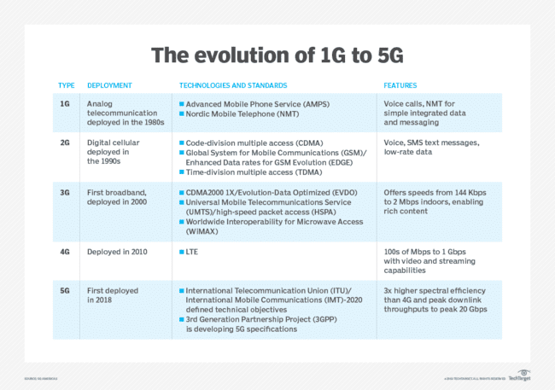

Figure 2: The Evolution 1G to 5G (Data Source: <https://www.techtarget.com/searchmobilecomputing/definition/GSM> )

The 5G network still enables communication between people, but also connects machines far more efficiently than the 4G network. It also creates better connections in the "Internet of Things" (IoT). The combination of IoT and 5G creates a revolutionary digital partnership that extends to various fields of application. In addition to smartphones and tablets, this also includes 360degree video content, virtual and augmented reality, smart homes and autonomous driving. (Schmitz 2018)

# Pricing Strategies

## Cost-Based

Cost-based pricing is a pricing strategy that takes the total cost of an item and adds a percentage of the cost as the desired income or profit. Mathematically, the selling price of a product is defined by p = C × (1 + m). Where C is the total cost, m is the markup, and the rate of return added to the total cost. The total cost of a product usually consists of fixed and variable costs.(Luong et al., N. C. 2022)

Companies using cost-based pricing use costs to find minimum rates and caps. Floors and ceilings are the lowest and highest prices, or price ranges, for a particular product or service. Ideally, the price should be set between the floor and the ceiling. Many companies that mass-produce products such as textiles, foods, and building materials use this pricing method.

*Pros:*

* Calculations to determine price are simple.
* During price setting unknowns are taken into account.
* Pricing ensures total profits for the business.

*Cons:*

* Ignores how customer demand affects price.
* It doesn’t take into account actions by competition.
* Price setting cannot be solely based on costs.

(Netrivals 2017)

## Value-Based

Pricing strategies that cover costs are easily copied by competitors. Therefore, in order to maximize long-term profits, sellers should price their goods or services in consideration of the perceived value of the buyer, rather than using traditional costs. The buyer's perceived value is the total utility derived from the price the buyer is willing to pay. To set prices based on perceived value, one must identify a set of value drivers that represent value perceptions for goods and sellers, create positive attitudes and emotions, provide a basis for differentiation, and provide reasons for purchasing needed goods. (Luong et al., N. C., 2022)

Companies that use value-based pricing consider product value and customer values ​​to be the key to pricing. They determine how much money and value a product will generate for its customers. This value leads to benefits such as increased efficiency, satisfaction and stability. By using this type of pricing technique, you can use pricing to support your product image, increase product sales, create product bundles to reduce inventory, and attract customers.

*Pros:*

* The price set supports product image.
* The value added helps increase product sales.
* Differentiation attracts new customers.

*Cons:*

* Calculations may ignore product costs.
* It might forget about existing competitors.
* It requires great selling techniques.

(Netrivals 2017)

## Arbitrary Pricing

This type of pricing occurs when a seller increases the prices of goods, services, or commodities to a level much higher than is considered reasonable or fair. If the pricing is described as arbitrary, it means it is not based on any principle, plan, or system.

# Roaming service and market structure

## Technology

For using international roaming there are few important components that are necessary, the Home Location Register (HLR), the Visiting Location Register (VLR), and the Mobile Switching Center (MSC). They are making the call-routing and roaming capabilities of the GSM network possible. Signaling System 7 (SG7), used also in PSTN and ISDN networks, is the system that makes the communication, between this intelligent network components mentioned above, possible. But of course, these are not the only components of the mobile network system. Thus, other components that are important to mentioned are Equipment Identity Register (EIR), the Authentication Center (AUC), and the Gateway Mobile Switching Center (GMSC).

Turning the mobile phone on or moving with it to a new location it records its location information to the VLR and the VLR forwards this location information to the HLR. With this procedure HLR aways possesses the updated location information of subscriber how is registered in the network. The SS7 address information of the new VLR is sent to the HLR, although it may be also a routing number. Usually, a limited number of routing numbers available in the new MSC/VLR are allocated on demand for incoming calls. If the subscriber is allowed to use a service, the HLR sends a subset of the subscriber information, needed for call control, to the new MSC/VLR, and sends a message to the previous MSC/VLR to purge the prior registration. Call routing is based on the dialed mobile number, which is a special number starting with country code. For a dialed local numbers, the connection is established locally, or else the call is passed on to the country of origin.

Depending on the situation, different routing models can be applicable for international roaming calls. (Preissl et al. 2009, p. 84)

We can differentiate at least 4 possible routing models:

Situation 1: Caller and a callee are in a visited country.

Situation 2: Caller is in a visited country and a callee in a home country.

Situation 3: Caller is in a visited country and a callee in a third country.

Situation 4: Callee in a visited country.

Obviously, three different countries may be involved in the handling of an international roaming call.

Home Country (e.g., Austria): Caller’s subscription country.

Visited Country (e.g., Italy): The country visited by the Caller/Callee.

Third Country (e.g., Spain): The country to which the call is directed, if is different from the home country and the visited country.

**Situation 1: Caller and a callee are in a visited country**

*1a) An* ***Austrian user*** *travelling in Italy calls an* ***Italian user*** *staying in Italy.*

In this case, the call is routed locally, in this example in Italy. The call set-up and switching are performed and maintained in Italy. However, even though the call is routed locally, there are signaling communications between Austria and Italy. Also, for this connection, one origination and one termination are set up.

*1b) An* ***Austrian user*** *travelling in Italy calls another* ***Austrian user*** *travelling in**Italy.*

Calls are routed to Austria and switching and call settings are also performed in Austria. Therefore, in addition to origination and termination, it includes two international transits between Italy and Austria to preserve the connection. Thromboning as referred to in a literature is a routing method that indicates that the call is sent to the home network and from home network back to visited network. This is a commonly used method, but there are technologies that can eliminate the thromboning part and just involve local termination in this scenario. This requires standardization and consensus between operators, and the incentives to reduce costs are not very high, so the use of these technologies is relatively limited.

*1c) An* ***Austrian user*** *travelling in Italy calls a* ***Spanish user*** *travelling in Italy.*

This case is the same as in 1b, but instead to Austria, here the call is sent to Spain. And the second difference would be a need for additional signaling.

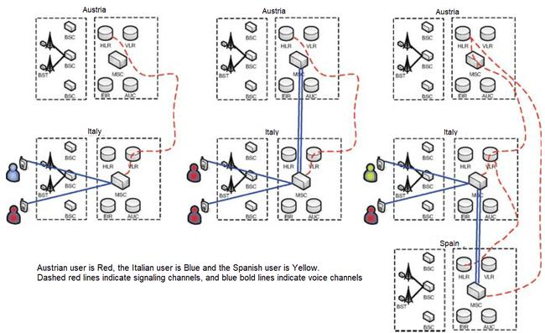

Figure 3. Situation 1: Caller and a callee are in a visited country

Source: (Preissl et al. 2009, p. 84)

**Situation 2: Caller is in a visited country and a callee in a home country**

*2a) An* ***Austrian user*** *travelling in Italy calls an* ***Austrian user*** *staying in Austria.*

In this case a call goes to Austria, and all necessary set up is taking place in Austria. For that is needed - one origination, one termination and one transit.

*2b) An Austrian user travelling in Italy calls and an Italian user travelling in Austria receives a call.*

Italy is country of origin where the call is established and maintained. An origination, termination and transit are performed. On top of that signaling between VLR in Austria and HLR in Italy is taking place.

*2c) An* ***Austrian user*** *travelling in Italy calls a* ***Spanish user*** *travelling in Austria.*

First, the call is transferred to Spain, then all necessary set up is taking place in Spain. One origination, one termination and a transit between Italy and Spain and between Spain and Austria are included. Also, a signaling between Austria and Spain is performed.

Variations of the Situation 2 are also represented in following illustration

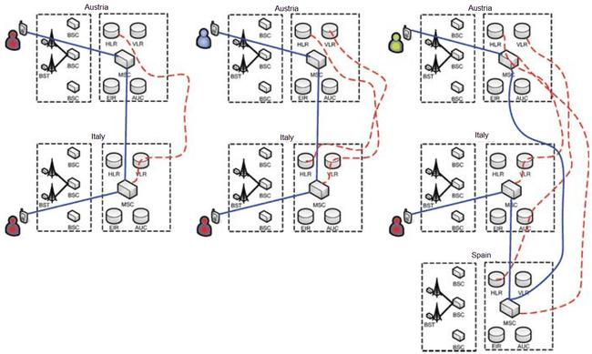

Figure 4. Situation 2: Caller is in a visited country and a callee in a home country

Source: (Preissl et al. 2009, p. 79)

**Situation 3: Caller is in a visited country and a callee in a third country**

*3a) An* ***Austrian user*** *travelling in Italy calls a* ***Spanish user*** *staying in Spain.*

In this case a call goes to Spain and all necessary set up for the call is in Spain. For that situation, one origination, one termination and one transit are required.

*3b) An* ***Austrian user*** *travelling in Italy calls an* ***Austrian user*** *travelling in Spain.*

First, the call is transferred to Austria and all necessary set up for the call is in Austria. There are two transits taking place, one transit between Italy and Spain and the other one between Austria and Spain. One origination and one termination are also happening.

*3c) An* ***Austrian user*** *travelling in Italy calls an* ***Italian user*** *travelling in Spain.*

Italy is country of origin where the call is established and maintained. Origination, termination and one transit between Italy and Spain are required.

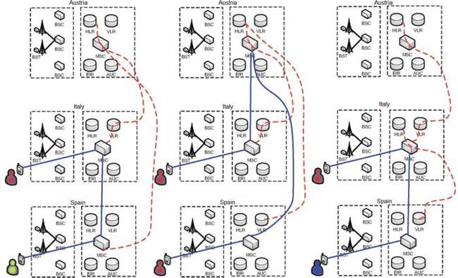

Figure 5. Situation 3: Caller is in a visited country and a callee in a third country

Source: (Preissl et al. 2009, p. 80)

**Situation 4: Callee in a visited country**

This applies to all of the above-cited situations, but with the distinction that here, the Austrian User traveling in Italy gets a call. This will, in all instances, contain one termination.

## Supply and demand conditions

### Retail Level - Demand conditions

International roaming is an important service used by large numbers of customers, but most subscribers use it only occasionally, and the level of roaming charges is relatively unimportant to the total cost paid by mobile subscribers.

As a result, few subscribers choose an operator based on the roaming charges offered. Another feature of the roaming service is the use of many different visiting networks. As a result, even high-traffic users have little benefit from reducing wholesale roaming charges by a particular operator.

Instead of international roaming, you can also buy a local SIM card to avoid paying roaming fees. This solution is especially attractive for local calls abroad and is used by many potential roaming "frequent caller" users.

Even if the roaming fee level is not used as a competitive parameter, it can still be a price-elastic service. According to a 2006 European field survey on roaming, excessive costs are the main reason for the decline in mobile phone use while traveling abroad, and if prices were more attractive, 6 out of 10 Europeans would use the service.

It also interesting to mention that almost all the subscribers using the roaming service are business customers, and they are likely to be less roaming price sensitive than private customers. Another factor, which may also cause low fee sensitivity is loss of transparency. If customers are not good informed about the roaming costs, their reduction, does not necessarily mean higher demand. Use of SMS informing strategy where roaming costs are communicated to subscriber arriving in foreign country makes the costs more transparent and might consequently boom price elasticity. (Falch and Tadayoni 2014, pp. 81–95)

### Retail Level - Supply Conditions

Retail market providers include all mobile network operators in the domestic market. Like most other telecommunications services, the retail market is more competitive than the wholesale market because it includes not only network operators, but also virtual operators and service providers. Even though we are taking about the same actors in both cases, the wholesale market seems less competitive. At the very least, the additional charges required by the operator are much higher than the additional charges for other mobile services. The reason for this is that international roaming is bundled with a domestic mobile service subscription (unless the customer purchases a new SIM card), and roaming charges are secondary to the customer compared to charges for other domestic services. (Falch and Tadayoni 2014, pp. 81–95)

### Wholesale Level - Supply Conditions

International mobile phones without roaming can be treated in the same way as international landline calls. Prior to liberalization, international landlines were billed according to international billing rates. First agreement of the system of international billing rates dates back to 1865. The billing rates determine the amount that an operator in one country must pay for termination of a call in another country. These fees are negotiated on a bilateral basis and are loosely related to the cost of maintaining end-to-end facilities between the two countries (ITU, 1996).

Payments for international roaming calls are organized like other international calls. Calls are processed by the operators that the call is coming from. If this call uses services from the other operator, its services are paid wholesale charges by the origin operator.

In international roaming, the call is created in the visited network, and the visited network operator (VMNO) bills the home network operator (HMNO) of respective subscriber in order to cover the cost for him. This payment is regulated by the transferred accounting procedure (TAP) using the implementing Inter Operator Tariffs.

The situation is slightly different when receiving an international roaming call. Here, the termination fee in the home network of the roaming subscriber is paid by the caller. Then the HMNO sends the call to the VMNO who will be charged a normal termination fee for the termination of the call. Additionally, the HMNO has to pay the international transit price for the call. Thus, the IOTs used for originating roaming calls are not used in this case.

Usually, in one country, the number of operators, offering roaming service, are the same as those offering the wholesale mobile service. In majority of EU countries there are at least 3 to 4 operators offering mobile services whereby one would expect that the competition level in roaming services is nearly similar to that for wholesale.

However, it is obvious that IOT did not follow the same pricing trends for wholesale prices such as other mobile services. Up to 1998 IOTs had been primarily based on local call price lists with a mark‐up at 15% (Salsas and Koboldt 2004). But since then, local tariffs, due the high competition, have declined drastically. This kind of competition did not have any influence on IOTs, and usually all service providers in one county use almost the same IOTs, and if you compare them with typical network tariffs you can see that they are the highest one.

There are some motives for this:

* Technical: Limitations withinside the desire of VMNO
* Tariffs are agreed on reciprocal basis
* Demand situations and shortage of transparency

As mentioned above, it is not always feasible for the HMNO to pick out the VMNO with lowest IOT. This means that providers of roaming cannot increase its market share just by decreasing their roaming fees. Market share of VMNOs is not connected with their fees, and consequently, there is no incentive to decrease fees because it simply will lower revenues.

In many ways, IOTs often reminds of international accounting fees. Usually, agreements are two-way street meaning that IOTs are not depending on call direction. In a marketplace where there is limited competition, both the HMNO and the VMNO have same goal to preserve IOT high pricing. The VMNO gets bigger revenue for offering the roaming, and the HMNO will just switch the roaming prices to its retail customers and consequently would not be afflicted by this. And the other way around when a roaming call is made in other direction it's the other operator who benefits. (Falch and Tadayoni 2014)

### Wholesale Level - Demand Conditions

International roaming services are in demand from all mobile network operators that provide international roaming to end customers. Few international operators can handle some of the roaming within their network, while others, including virtual network operators, are local mobile operators, and if they want to be a part of international roaming, they need to buy roaming service from national mobile operator. In addition to wholesale roaming costs, the operator charges end customers an additional fee that covers various retail costs such as billing and customer care. Incentives to lower wholesale costs depend on the degree of price-sensitive end customers. Moreover, there are also some technical reasons that does not make it always possible for home network operators (HMNOs) to choose the cheapest visiting network operator (VMNO). (Falch and Tadayoni 2014, pp. 81–95)

# Composition of Costs and Pricing

## Roaming Agreements

The concern about seemingly arbitrary and vary complex fees for international roaming has been an issue among the customers, ever since the late 90s. GSM operators do almost nothing to clarify to their clients the fees that may occur while they are abroad. On the other hand, checking the accuracy of invoices using public reviled charges range is almost impossible. The fees appear not to have any connection to the underlying costs, or to some other telecommunications fees. Coverage is likewise incomplete, with issues shifting from the GSM networks to others, especially withinside the USA, Japan, South Korea and regions of South America. (Sutherland, 2001, p. 6)

A Memorandum of Understanding (MoU) signed in 1987 enabled roaming functions. The European Union has endorsed the introduction of MoU to ensure a standardized system in all 15 member countries and to create incentives for the Trans-European Network. Previously fragmented requirements and markets made it difficult for European manufacturers to publish mobile communication standards in different countries. The success of Nokia, Ericsson and other manufacturers has been remarkable. The development and maintenance of GMS standards was initially monitored by the European Telecommunications Standards Institute but is now managed by 3GPP.

Many GSM operators have signed roaming contracts to be able to provide roaming services, which are commercially negotiated on a case-by-case basis by some of the operators involved. These contracts were negotiated by some agents on behalf of the operator.

The main agreement to promote international roaming for GSM operators is the International Roaming Standards (STIRA), which is now the Inter-Operator Fee (IOT). The use of IOT is facilitated by Transfer Accounting Protocol version 3 (TAP3).

The main goal of the GSM Association in creating these contracts is to simplify contracts between operators. This is understandable given that there are thousands of such agreements today. The major operators probably have up to 200 such contracts.

STIRA simplifies roaming contract negotiations by providing a framework and pricing principles. In this way, it offers financial and technical benefits. But on the other hand, there are also some undesired effects. Thanks to the Retailplus pricing model, customers can get very high prices. For roaming services, the operator charges a roaming fee. This is usually very expensive and adds a larger profit margin. Domestic operators will then add a 10-25% surcharge to this rate. Both operators are making big profits and neither has any incentives to lower commissions or rates of return. This can be very costly for the visitor as the roaming price is set by the roaming operator. Customers of TeleDanmark Mobile who are accustomed to billing on a one-by-one basis will be surprised that KPN Mobiel (Netherlands) will be billed on a minute-by-minute basis. This can make a significant difference to short calls. TeleNor customers who expect peak hours from 09:00 to 18:00 may be surprised to find that it's from 06:00 to 20:00, such as when roaming Vodafone in the UK. This seems to be lacking in the market if large operators are expected to negotiate price cuts.

The creation of the IOT allegedly provided for a bigger flexibility in the charges to each operator. However, this flexibility is not usually used in practice. To become usable, it will require operators to use TAP3. In some aspect, IOT/TAP3 is trying to improve information exchange between the operators, but it seems that it has a misguided approach. In this constellation it just increases complexity. The problem is that no mechanism has been introduced to help the subscriber to understand and discover the content and pricing of the roaming tariffs. It would be much easier if the handset could pick the cheapest option or if the tariff were set to a simple flat fee. There is no reason why a user could not just buy unit 100min of roaming for use across the European Union. Given that handsets select roaming operators in a relatively predictable way, it should be possible to achieve flat fees using a weighted average of operator tariffs in a foreign country.

One of the peculiarities of the GSM roaming market is that only license holders are allowed to enter into roaming agreements. Accordingly, there is an enhanced level of interest in GSM licenses in places such as Iceland and Lichtenstein. It does not seem to matter where you have a license or even if you operate a real network. There would appear to be no technical reason why other operators, given certain systems, could not engage in roaming. This form of discrimination severely limits competition in the market and may not comply with competition law. (Sutherland 2001, pp. 8–10)

## Europe Roaming Charges

In recent years, mobile phone penetration has skyrocketed in Europe, with an increasing proportion of the population using the benefits of roaming services wherever they are. The average penetration rate of mobile phones in the European Union exceeded 75% in 2002 and is expected to continue to increase. This growth was accompanied by a dramatic drop in prices for most wireless services. However, international roaming charges remain high, despite the overall decline in mobile phone charges and the increasing number of customers using mobile phones overseas. While it is widely believed that roaming capabilities available to GSM users play a key role in the growth of mobile communications, mobile customers and consumer organizations are clearly reluctant to reduce roaming fees. Regulators and competition authorities are concerned because the competition that is pushing down overall mobile prices has not affected roaming charges. (Salsas and Koboldt 2004, p. 498)

The Commission has received numerous complaints about persistently very high roaming fees, as well as complaints about roaming fee collusion. Willingness to deal with this issue notionally or internationally was not existent. November 1999, the International Telecommunications Users Association (INTUG) completed a study comparing roaming retail rates with non-roaming mobile retail rates. According to INTUG research, for mobile consumers, the price difference between roaming and non-roaming mobile calls to the same destination in the EU can be as much as 500% higher. There does not appear to be a compelling technical explanation for such differences at the retail level, suggesting that the underlying wholesale market is also uncompetitive. (Sutherland 2001, pp. 10–11)

Due to the apparent lack of competitive pressure on international mobile roaming charges, the European Commission launched a sector survey in July 1999. The preliminary results of this study can be summarized as follows:

• When assessing the competitive constraints of roaming charges, you need to consider at least two different related markets: the wholesale market (operators buy roaming services from each other) and retail market (retail roaming service is provided). Both markets are considered domestic.

• The Commission assessed that those two mobile operators charge about the same wholesale prices in many domestic markets, and some operators in these markets do the same in other. Accordingly, it can be concluded that that is most likely to be an evidence of coordinated pricing behavior or implicit conspiracy. Considered the fact that retail rates apply, this way of operating a business is, most likely, to be a source of excessive pricing in both markets.

• The Commission was concerned about the high barriers to entry (especially in the wholesale market) due to the limited number of licenses per country.

* The Commission also found that prices do not appear to be cost-oriented because: Regardless of the differences in wholesale prices between member countries from 1997 to 2000, they diminished over time and were too large to justify due to cost differences.
* On average, wholesale price, and therefore retail price (usually calculated by applying an additional charge to the wholesale price) increased. This was in stark contrast to the general decline in domestic retail prices. (Salsas and Koboldt 2004, p. 2)

Even though that first roaming agreement was signed between Vodafon UK and Telecom Finland back in 1992, the market for roaming services actually began in 1998 when mobile network operators (MNOs) began charging extra for international voice calls.

The GSMA, an industry group that represents the interests of mobile network operators, has proposed a framework of standard conditions for International roaming contracts (STIRA) to simplify MNO roaming contracts negotiations, which among other things treats all MNOs and their pricing terms equally according to a non-discriminatory policy. This had an unexpected anti-competitive outcome, effectively extinguishing competition and discounts. In addition, it has restricted international roaming contracts to operators with spectrum licenses. This does not apply to mobile virtual network operators (MVNOs) and network service providers that provide fixed-line services. The agreed price was called the regular network tariff (NNT). For its pricing, the visited MNO calculates the so-called normal retail price as a wholesale price. The home MNOs then puts an additional 15% on top as its retail margin. Retail and wholesale prices are interrelated.

However, the DG Competition did not consider wholesale or retail prices to be cost-based, as it is based on the domestic retail prices of the countries visited plus arbitrary margins. Therefore, the European Commission has called for amended regulations. As a result, the framework was revised by the GSMA and named the InterOperator Tariff (IOT) scheme. The IOT had no assumptions about wholesale levels or margins, which could theoretically cause competition.

This was done by the MNO between May 1998 and April 1999. Under these negotiating terms, the IOT did not have to reflect the actual wholesale costs, as it only set an agreement on the charges between the two MNOs, regardless of cost. Therefore, each contract can be unique. In addition, participants were charged for the first time for calls routed from their home MNO.

However, there were unintended consequences. Since wholesale market prices are virtually free to fluctuate, naturally they went up, thus increasing the retail prices as well. Therefore, in the early 2000s, the wholesale quantity processed by the visited network was determined not by the wholesale price offered, but by its market share and coverage. There was virtually no link between the wholesale price and the amount of wholesale minutes processed. As a result, commercial logic has tended to charge MNOs high for wholesale services. This revenue can be used to reduce retail prices for domestic services through cross subsidization whenever the MNO faces fierce competition for market share. (Simon Forge, p. 8)

Like Figure 6 form 1999 shows, roaming charges were, without any reasonable explanation, very high and random.

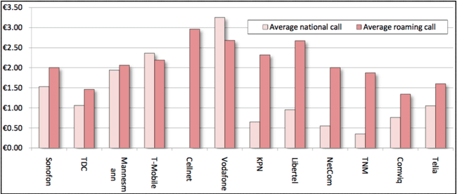

Figure 6. Comparison of Local and Roaming Voice Call Rates in 1999 (€)

Source: Fischer-Madsen, 1999 (cited in Sutherland, 2010).

## Cost factors for roaming charges

There are four different cost drivers determinating a costs structure of international roaming:

* Mobile origination (MO)
* Mobile/Fixed termination (MT/FT)
* International Transit (IT)
* Roaming specific costs (RSC)

Mobile origination includes the cost of initiating a call and connecting the caller's mobile device to the core network.

Mobile termination includes calls related to transferring calls from the recipient's core network to the mobile device.

International transit costs include the cost of connecting the sender and receiver's core network.

Roaming-specific costs include costs directly related to roaming transactions. These are costs that are not included in regular international calls

The cost of mobile origination is comparable to the cost of mobile termination. For data services, it can even be difficult to distinguish between these two. For voice services, mobile termination rates are subject to EU regulations and are usually cost-based. Before the regulation was introduced, the mobile termination rate per minute in October 2007 fluctuated between € 0.0206 in Cyprus and € 0.1882 in Bulgaria. However, in most countries, prices were close to the EU average of 0.0967 euros. The European average for local landline terminations is € 0.0083. In 2011, the average European MTR was reduced to € 0.044. International transit costs depend on the rates agreed between the operators. These charges are confidential, but the costs are well below the MO and MRT costs. Various EU impact assessment reports estimate international shipping costs and specific roaming costs to be around € 0.02 each. (Falch and Tadayoni 2014, pp. 88–89)

International transit expenses rely upon the inter-operator Tariffs agreed among operators. These agreements are confidential, however a few facts have been supplied to the Commission. According to Copenhagen Economics, global transit costs range are somewhere between 0.01 and 0.025 €/min (Jervelund et al. 2007). International Telecommunications Users Group (INTUG), for instance, estimates that the wholesale price for international calls among EU states is 0.01/min (INTUG 2006). In the document of Copenhagen Economics, roaming particular costs are predicted to account for 0.01–0.02/min. In the next table are costs summarized that are used in the calculation.

Using the price estimates from the Table, roaming costs for every situation, stated above, may be calculated, as presented in Table 2. Gained results match the wholesale costs estimated in the EU Commission impact report. In spite of this, retail prices for roaming call are nearly 4 times higher than national wide mobile calls (Fig. 7). This shows that the fees presently paid for international roaming by mobile subscribers are way over the underlying costs what made EU regulatory intervention plausible. (Preissl et al. 2009, p. 81)

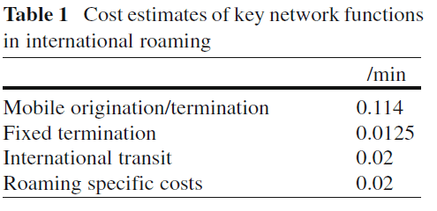

Table 1

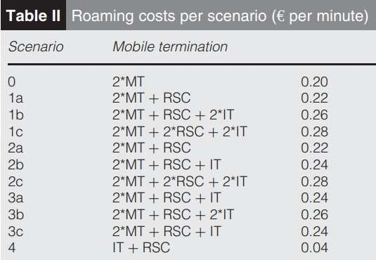 Table 2

Note: Scenario 0 includes the costs for a national call without roaming.

RSC are included for 2c as this type of call involves more complicated call handling than the other scenarios.

Scenario 4 includes costs incurred in addition to those paid by the calling party only.

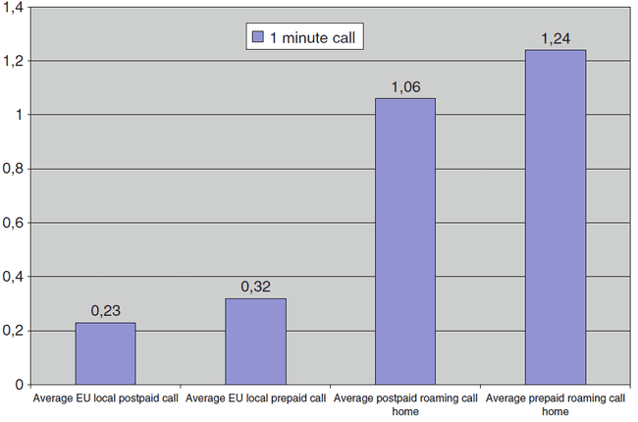

Figure 7. Prices of local and roaming calls

Source: CEC 2006a

## EU Roaming Regulations 2007-2017

**The first - 2007 Regulation:** After a nearly unanimous parliamentary vote in the spring of 2007, the first rule on international roaming services within the EU was published on June 29, 2007. Eurotariff caps for wholesale and retail voice calls were the main mechanism. The cap applies to roaming retail charges for active (outgoing) and passive (incoming) calls, and wholesale charges charged by the visited network operator, carrying roaming calls to the roaming customer's home operator. Roaming outside the EU is not regulated. Significantly reduced prices quickly highlighted the success of this roaming regulation, and retail prices have remained below the cap since then. (Simon Forge, p. 9)

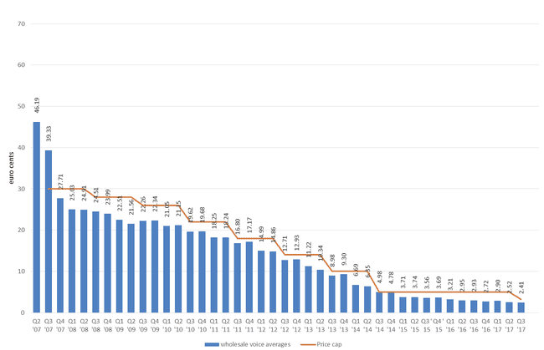

Figure 8. EEA Average wholesale price per minute for wholesale voice calls

Source: (BEREC, 2018)

***The Second step - the 2009 amended Regulation:*** The regulations amended in 2009 introduced the concept of glide route reduction with price regulation for wholesale data roaming services when the European Parliament adopted Regulation (EC) No 544/2009. Revised Regulation (EC) No 717/2007 to introduce early rate reductions for voice services with retail and wholesale caps in the gradual reduction glide path for cost-based pricing. SMS roaming services are also subject to wholesale and retail price restrictions. This regulation was scheduled to expire in 2012 (BEREC, 2018). (Simon Forge, p. 9)

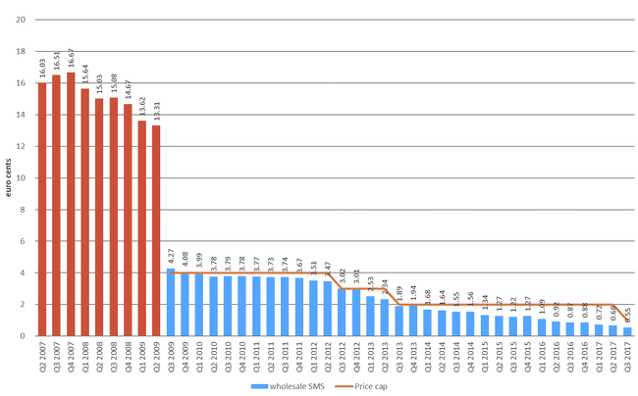

Figure 9. EEA Average wholesale price per SMS

Source: (BEREC, 2018)

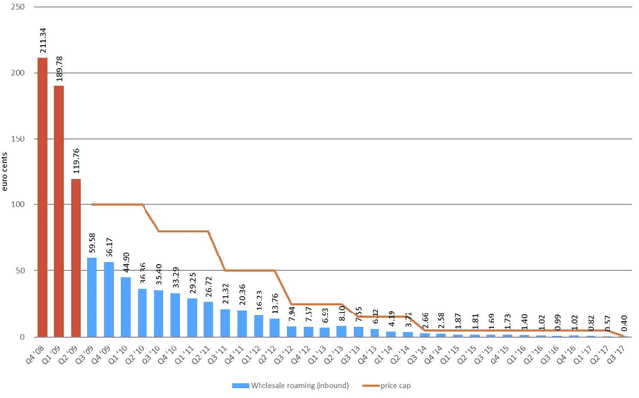

Figure 10. EEA Average wholesale data price per MB

Source: (BEREC, 2018)

***The Third Step - (the 2012 Regulation):*** After a public consultation in December 2010, the Commission took a 10-year outlook and developed roaming regulations that would apply from July 2012 to June 2022. Revised in 2016, it added a new step-by-step procedure and schedule for the Roam Like at Home (RLAH), meaning to have domestic fees applied also abroad, starting on June 15, 2017. First step was an expansion of the data wholesale price regulation decreasing the level of the caps annually until 30 June 2014.

The logic behind this decision was in fact that the data services have become the key indicator in roaming charges for an end-costumer rather than voice prices. Focusing on wholesale data pricing was considered important for the successful deployment of International Mobile Roaming services across the EU. These caps were to stay in effect until June 30, 2022, but would be further revised by June 30, 2016, when the retail price regulations for data roaming services was revised and decided that the caps would be valid up to June 30, 2017. For voice and SMS, an extension of wholesale and retail price restrictions has been enacted and the annual limit has been lowered until June 30, 2014. These limits remain until June 30, 2022 for wholesale services and June 30, 2017 for Eurotariffs also with a review by June 30, 2016. Beginning with July 1, 2014, the MNO has also been obliged to meet all reasonable requirements for wholesale roaming access, whether directly or for resale. Consumer protection regulations required service providers to provide a monetary or volume-capped "cut-off mechanism" for data roaming during this period. (Simon Forge, pp. 9–10)

***Step four (the 2012 amended Regulation):*** Under Regulation for a European Single Market for Electronic Communications the European Parliament on April 3, 2014 resolved to remove retail roaming surcharges with new Regulation in order that subscribers would “Roam Like at Home” however with a fair use policy. There are some exceptions regarding surcharges within the policy, like in a case for breaching a four-month EU roaming limit, or a data volume cap. These exceptions are permitted only if roaming services are provided under cost. (Simon Forge, p. 10)

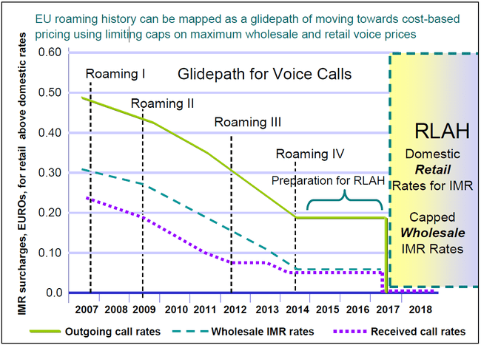This four steps path form arbitrary pricing to cost-based pricing is represented in the Figure 11 graph.

Figure 11. Glide Path of EU Tariff Caps for Voice Roaming, 2007-2017

Source: (BEREC, 2018)

Originally, the abolition of roaming fees applied until June 2022 but on April 4, 2022, EU member states decided to suspend additional costs for telephone and internet use in the EU countries for a additional ten years, until 2032.

# Conclusion

Roaming is a service that enables the use of a mobile phone outside of a subscriber’s home network. Offering this service causes costs and of course have its price.

The goal of this work was to investigate and determine, from one hand witch costs are part of the roaming service, and to another, witch pricing strategy is pursued in forming a retail price.

At early stages till late 90s, mobile operators claimed that international mobile roaming was a premium service, justifying high prices, comparable to a bottle of fine wine in a restaurant.

Nevertheless, this justification did not find acceptance, and not just in the EU but also in other world regions.

As a result, it led to introduction of different regulations imposing a price cap in wholesale segment (inter operator tariffs) and also in retail pricing, practically forcing the mobile operators in cost-based price strategy. This regulation in the EU is known as “roam like at home” regulation.

But the roaming pricing “problem” is still not solved because these regional regulations, like the EU regulation, do not treat the roaming prices between, for example EU and Turkey, like in this example from my introduction, where we still have excessively high pricing for roaming services, that are arbitrary formed.

Thus, to regulate this issue is very complicated task, in particular because the regulation authority of a one country or a region, like EU, has no authority over mobile operators outside this country or a region.

Finally in order to have something like Rome Like at Home and cost-based pricing applicable worldwide it has to be archived eider with some new worldwide mobile regulation authority, maybe within the WTO, or to impose some initiatives for mobile operators to do it themselves, either way it has to be coordinated international project.

# Publication bibliography

Falch, Morten; Tadayoni, Reza (2014): Regulation of international roaming data services within the EU. In *Int Econ Econ Policy* 11 (1-2), pp. 81–95. DOI: 10.1007/s10368-013-0246-7.

Hild, Stefan G. (1995): A brief history of mobile telephony. Available online at https://www.cl.cam.ac.uk/techreports/UCAM-CL-TR-372.pdf, checked on 3/12/2022.

Dunnewijk, Theo; Hultén, Staffan (2007): A brief history of mobile communication in Europe (24). Available online at https://reader.elsevier.com/reader/sd/pii/S0736585307000226?token=6F96840E910F32998C22D6D042CA441CF936F15BA710E9EB7F3DA4B11A04123CCEC978EA39F59C4593A9B0376A798A01&originRegion=eu-west-1&originCreation=20220312215916.

Luong et al., N. C. (2022): Data Collection and Wireless Communication in Internet of Things (IoT) Using Economic Analysis and Pricing Models: A Survey | EndNote Click. Available online at https://click.endnote.com/viewer?doi=10.1109%2Fcomst.2016.2582841&token=WzM1MjE2NzgsIjEwLjExMDkvY29tc3QuMjAxNi4yNTgyODQxIl0.daF0axP6V3SrUcKdyETfeYlBGbo, updated on 4/2/2022, checked on 4/2/2022.

Netrivals (2017): 3 Major Pricing Strategies: A Short Guide | netRivals. Available online at https://www.netrivals.com/resources/guides/3-major-pricing-strategies-a-short-guide/, updated on 10/26/2021, checked on 4/2/2022.

Preissl, Brigitte; Haucap, Justus; Curwen, Peter J. (2009): Telecommunication markets. Drivers and impediments. Heidelberg: Physica-Verlag (Contributions to economics). Available online at https://link.springer.com/content/pdf/10.1007%2F978-3-7908-2082-9.pdf, checked on 3/12/2022.

R.N.A. Bekkers; J.M. Smits (1999): Mobile telecommunications : standards, regulation, and applications. Available online at https://www.researchgate.net/profile/j-smits/publication/323187013_mobile_telecommunications_standards_regulation_and_applications.

Salsas, Roger; Koboldt, Christian (2004): Roaming network selection and inter-operator tariffs. Roaming free? (16). Available online at https://reader.elsevier.com/reader/sd/pii/S0167624503000738?token=B661833DEF356B8E822F03F290AAD65851AD4C2D925DD37407331236A16C165F49268C9E5CF2A0CA2DDC64AB8EECB7B3&originRegion=eu-west-1&originCreation=20220312205131.

Schmitz, Tobias (2018): Mobilfunkstandards 2G, 3G, 4G und 5G – alle Infos zu den Generationen, 1/25/2018. Available online at https://www.sparhandy.de/mobiles-internet/info/mobilfunkstandards/#4g, checked on 3/28/2022.

Schnabel, Patrick (2012): Elektronik-Fibel: Elektronik einfach und leicht verständlich. Available online at https://www.elektronik-kompendium.de/sites/kom/0406221.htm, checked on 3/22/2022.

Simon Forge, Colin Blackman: Roaming: One Year After Implementation. Available online at https://www.europarl.europa.eu/RegData/etudes/IDAN/2018/626090/IPOL_IDA(2018)626090_EN.pdf, checked on 5/8/2022.

Sutherland, Ewan (2001): International roaming charges: over-charging and competition law (25). Available online at https://reader.elsevier.com/reader/sd/pii/S0308596100000847?token=B488DF1DCBC8057057DFD8A31F6584DE0132B367DBB43C247064B13077AF88088C6A2BF2004D2D455C21CDDB4E29EACF&originRegion=eu-west-1&originCreation=20220312203738.

Tnuda (2016): Cellular Communication Network Technologies. Available online at https://www.tnuda.org.il/en/physics-radiation/radio-frequency-rf-radiation/cellular-communication-network-technologies#Code%20Division%20Multiple%20Access%20(CDMA)%20technology, updated on 5/10/2017, checked on 3/17/2022.

Wikipedia (Ed.) (2022): Roaming. Available online at https://en.wikipedia.org/w/index.php?title=Roaming&oldid=1073058371, updated on 2/20/2022, checked on 3/11/2022.