

**Seminar Paper**

Theme:

*“Comparison and Critical Comparison of Charges for NFC Payments Accounted for by Credit Cards and Debit Cards Instead of Paying with Cash. (Vergleich und kritische Evaluierung der verrechneten Kosten beim Bezahlen über NFC mit Kreditkarten und Bankomatkarten (Debit-Cards) anstatt mit Bargeld)“*

Yasir Durmaz

Matrkl. Nr.: h01429347

Sprache: Englisch

SBWL – BIS Kurs 5 / 4167

Univ. Prof. Dr. Rony G. Flatscher

Declaration of Authorship

I assure:

to have individually written, to not have used any other sources or tools than referenced and to not have used any other unauthorized tools for the writing of this report.

to never have submitted this report topic to an advisor neither in this, nor in any foreign country.

that this report matches the report reviewed by the advisor.

Date: 03.06.2020 Signature: Ein Bild, das Objekt, Spiel enthält.

Table of Contents

1 Introduction 4

2 NFC Introduction 6

2.1 History 7

2.2 Overview 7

2.3 NFC Functioning 8

2.4 NFC Mobile Architecture 9

2.5 Operation Modes 11

2.5.1 Reader NFC Communication 12

2.5.2 Peer-to-Peer NFC Communication 12

2.5.3 Card Emulation Mode 13

2.6 Functioning of Contactless Payment 13

2.6.1 With Smart Cards 14

2.6.2 With Smart Devices 14

3 Concerns 15

4 Usage Areas of NFC 17

4.1 Smart Card Technology 18

4.2 Earlier Form: Magnetic Stripe Cards 19

4.2.1 Types of Smart Cards: Based on Capabilities 20

4.2.2 Smart Card Operating Systems 21

4.2.3 Types of Smart Cards: Based on Mechanism 23

4.2.4 Smart Card Applications 24

4.3 Other Usage Areas for NFC 25

5 Actual Charges for Usage 26

6 Comparison of Different Providers 27

6.1 EU Countries and England 27

6.2 USA and Switzerland 31

7 Critical Evaluation 34

Bibliography 36

Table of Figures 37

# Introduction

Nowadays the amount of cashless payments is increasing, according to several statistics like one in Austria, Statista. This trend mostly started with the younger generation and has already arrived at the older one too. The popularity of cashless (card) payments is increasing from day to day and could be led back to huge developments in information technology and to the progress in technologies general.

According to statistical data from Statista (German Statistics Institute), the amount of payments with credit and debit cards are increasing not only in Austria but also in Europe and worldwide. This trend gives huge opportunities for financial institutes to widen their activities in the financial sector and also open up new chances to engage in new financial sectors.

At first glance it seems that these developments contain only advantages for consumers and also businesses. But on the other side the grey areas are increasing where these bank institutions charge for the new emerging technology in payments with NFC and credit/debit cards.

In following chapters, the history of the NFC technology used in these so-called smart cards will be further explained and their use cases will be introduced. Additionally, the history of smart cards, their development, their usage areas nowadays will be discussed in detail.

NFC Payments in Austria

According to extensive surveys from a German statistics institute Statista, NFC payments in Austria becoming more and more popular, also mentioned above in the Introduction. Down below a figure from Statista shows the amount of NFC transactions between the years 2016 to 2019, in terms of Million €. (Department, 2020)

The source for these statistics is also from the institution Payment Services Austria, which is also written on the figure.

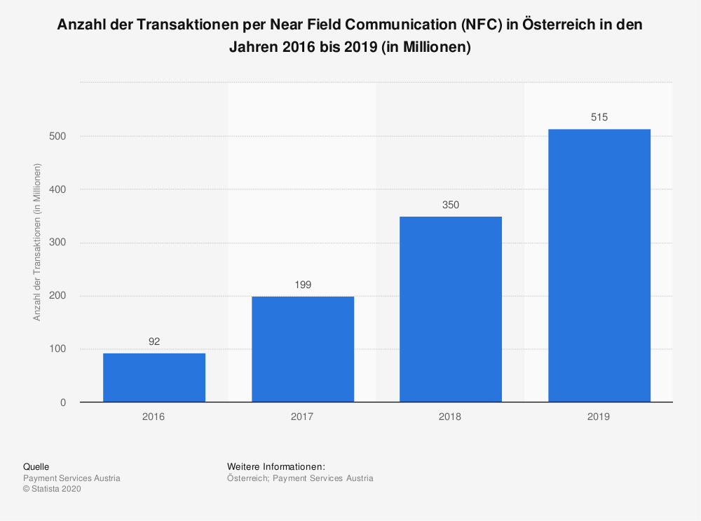

Figure 1; Amount of Transactions; Source: (Department, 2020)

This statistic above shows the amount of transactions with NFC (Near Field Communication) in Austria between the years 2016 to 2019. Around 515 Million transactions were made in the year 2019 with contactless payments technologies. This equates an increase of 47 percent compared to the previous year. In conclusion 68 percent of transactions made with debit cards were made contactless. (Department, 2020)

Another statistic also collected from Statista and Payment Services Austria shows the transaction volume for NFC payments between the years 2016 and 2019. These statistics are only about the situation in Austria but the figures in this section are not much different from those here.

Ein Bild, das Screenshot enthält.

Figure 2; Amount of Transaction Volume; Source: (Department, 2020)

In Austria from the transactions made total of 715 Million € in the year 2019, around 515 Million of these were made through NFC payments. This means, 68 percent of the payments were made contactless. The volume for these transactions were at 15 Billion Euros, which shows an increase of 48 percent compared to the previous year. (Department, 2020)

# NFC Introduction

Near Field communication is a set of communication protocols between two electronic devices that require a distance of 4 cm or even less. NFC devices can be used or act for example as electronic documents for identity and also as keycards. One the most popular areas where it is mostly used is in contactless payment systems, allowing our mobile phone to act as a credit/debit card and therefore replace our plastic cards or it also can be used as an substitute for it, if we forget to pick up our money bag. Other areas like sharing small files like contacts on a phone or photos, videos and many other small files, are also common use cases. (Wikipedia, 2020)

## History

NFC also Near field communication technology truly started with its form as RFID – radio frequency identification in early 1980s. RFID makes use of sending radio information to a so-called receiver. This technology is perfect use for tracking purposes and also for the purpose of using it as security tags. (Ed, 2020)

Down below a figure gives a detail about the invention of the NFC technology.

Ein Bild, das Screenshot enthält.

Figure 3; History of NFC; Source: (Coskun, Ok, & Ozdenizci, Near Field Communication - From Theory to Practice, 2012)

## Overview

NFC is a set of wireless technologies that typically works on maximum range of 10cm or even less. It operates at specific frequencies at 13.56 MHz and at rates ranging from 106 Kbit/s to 424 Kbits/s. NFC always needs/involves a so called initiator and also a target. The power supply mostly initiated actively by the initiator that generates an RF (Radio Frequency) field that powers a passive target. This is also the reason for, that the NFC targets can be built very simple and in an smaller form factor such us tags, stickers, or even cards. (Wikipedia, 2020)

The contained data in the NFC tags are mostly read-only, but sometimes in rare cases also writeable. They can also be custom coded by their manufacturers or use NFC Forum specifications. In these tags personal data such as credit or debit card information, PINs and also data like networking contacts, among other information can be securely stored. The so-called NFC Forum defines different types of tags that each provide different specs that can be customized for specific needs, like configurability, memory, security, data retention, and also write speed. These tags currently offer a usable memory between 96 up to 4.096 bytes. (Wikipedia, 2020)

In the case of proximity card technology, NFC makes use of the so-called inductive coupling where two antennas form effectively an air-core transformer. Thus the distance between them is so little compared to the wavelength of an electromagnetic radio waves of that same frequency, therefore the interaction is called as near field. The reason why interference is prevented between such devices and the radio communication at same frequencies is that there is almost no power radiated in form of radio waves during this process. The operation radio frequency is globally set to ISM band of 13.56 Mhz. (Wikipedia, 2020)

Ein Bild, das Zeichnung, Schild enthält.

Figure 4; Global NFC Logo; Source: (Coskun, Ok, & Ozdenizci, Near Field Communication - From Theory to Practice, 2012)

The working distance with compact antennas and realistic power levels could be extended up to 20 cm, but practically said the distance never exceeds 10 cm. (Wikipedia, 2020)

## NFC Functioning

We know now what NFC exactly is, let’s take a deeper look how it works basically. The working mechanism is similar to Bluetooth which is also a wireless connection technology. They all work through wireless signals, but NFC works on the principle of sending information over radio waves. Near Field Communication is also another standard for wireless data transition, which means that both devices reader and receiver must adhere to certain specs for the communication to work the right way. (Triggs, 2019)

NFC has several similarities to other wireless technologies like Bluetooth, RFID, Infrared. In the table down below some basic characteristics of these technologies are shown, like capabilities, setup time etc. and are compared to each other.

|  |  |  |  |  |
| --- | --- | --- | --- | --- |
|  | NFC | Bluetooth | RFID | Infrared |
| Set-up Time | < 0.1 msec. | ~ 6 sec | < 0.1 msec. | ~ 0.5 sec |
| Range | Up to 10 cm | Up to 30m | Up to 3m | Up to 5m |
| Speed | 424 kbps | 721 kbps | 424 kbps | 115 kbps |
| Usability | Human-Centric, Easy | Data Centric, Medium | Item Centric Easy | Data Centric Easy |
| Cost | Low | Medium | Affordable | Low |

Table 1; Comparison of Wireless Technologies; Source: (Garima Jain, 2015)

## NFC Mobile Architecture

In this chapter the architecture of an NFC enabled mobile devices will be further explained in detail.

NFC technology integrated also NFC-enabled mobile devices consist of various types of parts. The components built in their architecture are: different types of integrated circuits, like a secure element (SE) and an NFC communication interface as visible on the figure on the bottom of the page. This interface is composed of a contactless, analogue /digital front-end called as NFC Contactless Front-End (NFC CLF), an integrated circuit called NFC controller to enable NFC transactions and an NFC antenna. (Coskun, Ozdenizci, & Ok, A Survey on Near Field Communication (NFC) Technology, 2012)

Also, a study from two scientists called Gerhart and Szoncso describes various design types for antennas in combination with transponder system properties of how to efficiently combine established chip platforms with smaller antenna form factors. There are also similar methods in literature and other experimental approaches can be found in optimizing the design of the NFC antennas for readers and also transponders, and also the design of the NFC transceiver chipset to improve the communication quality and Radio Frequency interface and also security. (Coskun, Ozdenizci, & Ok, A Survey on Near Field Communication (NFC) Technology, 2012)

For instance, an NFC enabled mobile phone consists of secure elements for performing secure transactions using an NFC devices as well as storing sensitive data in a secure environment. These secure elements provide a dynamic and secure environment for both programs and data. They also enable storage of valuable, sensitive and private data like credit card information of the user and also secures storage and execution of NFC enabled services like contactless payments, which is valid in card emulation operating mode as described in further in the text in chapter for operating modes of NFC. (Coskun, Ok, & Ozdenizci, Near Field Communication - From Theory to Practice, 2012)

Some of the mobile devices may contain a second SEs based on its requirements. The build in NFC Controller is connected to the Secure Element either through Single Wire Protocol (SWP) or NFC Wired Interface (NFC-WI). (Coskun, Ok, & Ozdenizci, Near Field Communication - From Theory to Practice, 2012)

The Secure Element can be accessed either from host controller (HC) internally as well as from RF field externally. Another name for the host controller is also baseband controller, it is heart of the NFC Mobile. Host Controller Interface (HCI) than creates a bridge between the NFC controller and hos controller. The host controller than sets the operating modes of the NFC controller through HCI, processes than data that is sent and received and establishes the connection between the NFC controller and the secure element. (Coskun, Ozdenizci, & Ok, A Survey on Near Field Communication (NFC) Technology, 2012)

Down below the architecture is shown and the mentioned different operation modes of NFC will be further explained in the following chapter in detail.

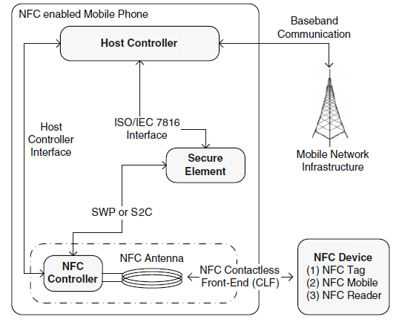

Figure 5; NFC Mobile Architecture; Source: (Coskun, Ozdenizci, & Ok, A Survey on Near Field Communication (NFC) Technology, 2012)

## Operation Modes

NFC technology as mentioned above has three main operation modes, which are a little bit different compared to each other. These 3 types will be described further in detail below. These modes are: Reader NFC Communication, Peer-to-Peer NFC communication and Card Emulation which is also common in contactless payment systems. A figure below shows them briefly.

Ein Bild, das Screenshot enthält.

Figure 6: Operation Modes (Source NFC Forum)

### Reader NFC Communication

This operation mode is a passive communication, in which information can be transmitted without the need of a power source. Only the reader device uses a power supply, so as will be mentioned further above a tag can be a sticker placed on a poster or other various objects. The simple way to make use of NFC services is through peaking up your mobile NFC enabled device like in the most cases smartphones over a sticker or tag and a big amount of information will pop up on the display. This type of operation mode is widely used in public services like on menu cards of restaurants. This type is also often compared to QR-Codes but this comparison is not quite right, because QR-Codes often need specific applications whereas NFC operates without such an app. Common things like key cards or even microchips for your pet operates on that mode and also public transport cards. The NFC payment on that mode works also via reader as well as through tap and go payment cards/systems. (Allison, 2017)

### Peer-to-Peer NFC Communication

Peer to peer communication means that we need both sides of the interaction which means the reader as well as the writer, as an example two NFC enabled smartphones. In this type of operation mode, different types of information like photos, videos or contacts can be transferred to the other device just by simply tapping both devices one another without the need to open a specific app or even without selecting any “send to” option. At the end, there is huge potential for NFC payments to work by sending money just to the other user by holding the devices together, something which Samsung is currently working on to develop. (Allison, 2017)

While this operation type has huge potentials, it has not quite caught on yet, just because not all smartphones are equipped with NFC technology. But phone manufacturing companies are working on it, though in year 2013 NFC enabled smartphones grew 128 percent over the previous year, and in the year after is expected to have grown another 325 percent, with 75 percent of all smartphones being equipped with this technology now. Still, having NFC on a smartphone is a one thing, and to really make use of it is another. In the year 2015, only 5 percent of users who had NFC enabled smartphones used it at least once a month. (Allison, 2017)

### Card Emulation Mode

Card emulation method is perhaps the best-known operating method for the payments landscape as this technology which is empowered by Apple Pay and Android Pay, among users. NFC payments work in so called digital wallets through NFC enabled mobile devices that contain credit and debit card accounts, loyalty cards and many other financial details into information transmitted by the phones NFC tag. NFC payment works when users want to pay with their smartphones instead with their credit cards by simply waving the device over the payment terminal. It does also do not require opening up an app, entering a PIN, providing a signature or even entering any additional information; it´s therefore a very convenient way to pay. Although it hasn´t been widely adopted with only 3.5 percent of applicable transactions made via Apple Pay as March of 2016. (Allison, 2017)

## Functioning of Contactless Payment

On the one hand there is the method which is the most popular one among customers, contactless payment with smart cards like debit/credit cards and on the other hand which became more and more popular among the young age which already growing up in the digital era of living. Further below these two most known methods will be explained or will be given a quick overview of how these function.

### With Smart Cards

Both smart card and also the reader has an electromagnetic field. Once the card is brought into the field of the reader, the energy transfer starts from the reader into the microchip of the smart card. In this whole process, the chip inside the card is supplied with the signal from the reader. Once the microchip is powered, the wireless communication is set between the card and the card reader and data transfer starts. (Coskun, Ok, & Ozdenizci, Near Field Communication - From Theory to Practice, 2012)

On the other hand, payments with smart cards which are made by plugging in the card into the reader are meant as cashless payment, but are also partly contactless. Because most card providers have limitations on amount of cashless or contactless payments. Therefore, the paying process only continues after tipping the PIN code on the payment terminal. As already said, the process only starts when the credit or debit card is plugged into the terminal.

### With Smart Devices

This process is a little bit time consuming compared to the previous function method. First of all, to be able to undertake a contactless payment with a smart device, in most cases a smartphone, you should get an NFC enabled phone. Then in most cases it is necessary to install the application of your own bank provider in order to be able to add your debit/credit to your smartphone. Once this whole process is done the next step is similar to the first one.

To make a contactless payment just start your smart card application on your device and bring it into the near of a reader. The data transfer functions similar like with smart cards. One major difference is that the transaction is validated through a separate chip within the smart device, the secure element (SE), which relies on an authorization back to the NFC modem. In some cases, it could be necessary to tap your PIN code or password if the payment exceeds the specific contactless payment limit of your bank provider. After that process the payment finishes processing in the same way like with traditional credit card swipe. (Profis, 2014)

# Concerns

In this chapter general concerns about the usage of NFC technology and specific concerns about using this technology in mobile payment systems will be further explained. The major concerns are about the security and further other possible dangerous sides about the implementation of NFC, like breaching the privacy of users. Furthermore, specific concerns in one of the three different operation modes will be explained more in detail.

To begin, one of the major concerns about the NFC operation mode card emulation is security. In mobile payment systems, highly sensitive data is transmitted through the transaction process. This type of data is mostly secured in two possible ways. First the so called Host Card Emulation (HCE) is a cloud-based way to secure data and Secure Element (SE), which also described above is contained in the architecture of any NFC enabled smartphone and is device based. Major firms like Android and Google use HCE, further in detail – the device uses a virtual credit card number, which is then verified by the mobile payment providers server, which then sends the users real credit card number to the merchant to complete the transaction process. Second the SE, operates a bit different compared to HCE. The SE operates like an EMV chip card, which uses tokenization embedded in the device itself. In detail, this means that the users credit information like credit number is never stored in the device itself. But despite various security measures, emulation still seem dangerous to users and make them a bit nervous. On the one hand there is a huge potential risk in HCE. If the cloud gets hacked, the possibility that credit card information is being stolen is pretty high. On the other hand, if the security is stored in device itself, losing that device is linked with many dangers than ever before. The major reasons why many people are scared using digital wallets are these two described above. (Allison, 2017)

Like any other new emerging technology, NFC has also it´s disadvantages which are called in this perspective as concerns. To begin with there is still a bit of confusion in the marketplace about using this technology. Some of smartphones support NFC technology and some still do not have it. Some manufacturers also try to create their own NFC system which makes their devices incompatible with others. Also, will be further explained below, tag producers are still unable to reach globally interoperable standards. As more and more devices and tags will reach mass markets this compatibility concern will sure frustrate consumers. (Hoy, 2013)

Another big concern area is surely about security and privacy. Some uses of NFC are not that sensitive like others, like sharing URLs, giving commands to a smartphone or saving text. In case of financial and access control applications, security and privacy plays a huge role. These two major concern areas held back many retailers and manufacturers to widely implement RFID due to privacy concerns lifted up by the public authorities. Near Field Communication systems avoid many of these privacy concerns of RFID because of the close range needed to for example read tags or connect to another NFC enabled device. But however as already explained above, losing such devices is a huge potential risk for the owner who eventually saved their sensitive information on that smartphone. (Hoy, 2013)

Security is not only a huge concern from the user´s perspective but also from the other side whose information passed over in wrong hands. Therefore, if an organization or firm takes payments or grants access to such information, it should ensure their system’s correctness and their susceptibility to any attacks or misusage. Two researchers also found a way to obtain free rides just by connecting their smartphones to NFC-enabled transit card and on that way editing the contents of that chip. (Hoy, 2013)

Another big concern area is surely also about costs in implementing such NFC chips inside of smartphones or other devices useful devices. Like purchasing tags, encoding them, attaching them into items/devices, and finally educating staff and clients, all means money and time, which is nowadays very costly, and the technology is still not fully proven. (Hoy, 2013)

These are mainly concerns about if the credit or debit cards were used on NFC enabled smart devices like smartphones or custom NFC tags. But surely the main problem about using your smart card (will be further explained in chapter 3) instead of cash money.

Maybe one big advantage and why people prefer using cash money instead of a smart card is the fact that people know that if they use cash major firms or even the own bank is not able to trace back where the money was spend for what is was spend. This is a huge thing in our digital era where data means money. To further explain this, if people use their smart card instead of cash money all the digital data about the spending habits of a person could be saved and used eventually and can be used for marketing purposes like targeted marketing. This means that this data could be sold to third firms for marketing reasons where other big companies could make use out of this user information.

Another thing that can be seen as an advantage is the spending amount. If you handle your businesses with cash, like shopping, paying bills, going to cinema etc. you do not know how much you spent your money on these things. On the other hand, it is quite easy to know about that if you only use your smart card for payment purposes. You know exactly how much and for what you spent your money on, which gives you a detailed overview about your spending.

On the other hand, it is also scientifically proven that there is a huge difference between a person who settles his payments with cash and to whom that does it cashless e.g. with a smart card. Because of the absence of feeling something in our hands, the concern about if we spend too much or not is missing. Therefore, the feelings are quite different if paying with cash is better or the cashless payment.

Surely the new age whom already growing up in this digital era would prefer the much easier and uncomplex way of settling payments cashless rather than with cash. Because they are already using it daily in their lives. On the hand the older generation who are not always used to live in this era would not think the same way as the younger generation.

# Usage Areas of NFC

This new technology opens up huge opportunities for usage in several different areas. From usage in payment systems like smart cards till to access control applications, this technology opens new doors for pretty much all areas of our lives.

In today´s situation where safety and health is very important which leads to the fact that money is one of the most dirtiest things in the world, in a broad sense, because a 10 € cash money for example touched by thousands of hands per day which could also spread a virus like the corona virus. This situation could lead to the abundance of cash money and which is also encouraged by local authorities to use smart cards and contactless payment systems to prevent such a risk. Therefore, the importance of contactless operations has become more and more popular during these times which will surely lead that to rise of the popularity of NFC again.

Further below, the main or better said the most known and popular area, the payment services and also several other usage areas will be further explained. In detail the invention of smart cards, their usage areas and also different types of them will be discussed in detail. As well as other usage areas of NFC technology will be shown.

## Smart Card Technology

A smart card is the general term for today’s classic credit/debit cards. Further below their general structure will be explained in detail and a quick overview of their invention will be given.

They were invented in the early 1970s. They were first used in public for telephone payments in 1980s. In the meantime, the microprocessor smart cars were introduced. Their first integration into today’s debit cards was in the 1990s. Smart card based electronic wallet systems which store data on the card and did not need a network connectivity, were first used from mid 1990s in Europe. Then a major improvement in smart card technology was introduced in the 1990s, which were smart card based SIMs and were started to be used by GSM based mobile phones in Europe. (Coskun, Ok, & Ozdenizci, Near Field Communication - From Theory to Practice, 2012)

Surely the usage of smart cards set a huge step towards ubiquity of Mobile Phones. In 1993, the major international payment brands, EuroPay, VISA, and Mastercard (EMV) made a collaboration to develop new specs for smart cards in order to make it possible to use them both as credit and debit cards. This collaboration was also a huge step to develop EMV compliant Point of Sale (POS) equipment. Furthermore, the cooperation between Visa and MasterCard in 2004-2006 implemented a contactless payment and ticketing applications such as transit and highway tolls in USA. When Philipps introduced their contactless smart card MIFARE proximity smart card, contactless smart card applications started to have considerable market share in Europe and also in the US. (Coskun, Ok, & Ozdenizci, Near Field Communication - From Theory to Practice, 2012)

## Earlier Form: Magnetic Stripe Cards

This type of technology for putting a magnetic stripe on a card was invented first by IBM in the 1960s. Such a magnetic stripe was usually picked in form of black or brown stripes typically on credit cards, or also on airline tickets as well as on transit cards. The stripe is composed of very tiny magnetic particles in a resin. The particles can be applied directly to the card or it is also possible to include it into a stripe on plastic backing which is than applied to the card. These types of cards are able to store data. The reading process is done by physical contact, like just swiping the card through the external device like a reader which has a magnetic reading head shown in the figure down below. Their usage range nowadays mostly in the financial debit or credit smart cards, airline tickets and also for boarding passes. (Coskun, Ok, & Ozdenizci, Near Field Communication - From Theory to Practice, 2012)

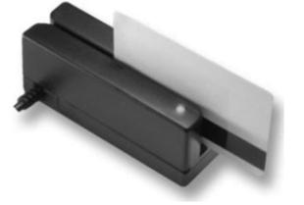

Figure 7; Magnetic Stripe Card; Source: (Coskun, Ok, & Ozdenizci, Near Field Communication - From Theory to Practice, 2012)

The so called coercivity of the stripe is defined by the material used. Coercivity is the measure of difficulty to encode information on the magnetic stripe. It is possible to adjust the measure of the coercivity by the material used to make the particles. For example, low coercivity stripes use iron oxide and high coercivity stripes use barium ferrite. High coercivity has an advantage, these are harder to encode information from the stripe. Therefore, it is more difficult to erase information on the card, so accidental erasures are eliminated. (Coskun, Ok, & Ozdenizci, Near Field Communication - From Theory to Practice, 2012)

### Types of Smart Cards: Based on Capabilities

As many already know smart cards are simple plastic cards with an extra build in microprocessor and memory as their name already tells us. But there are nonetheless different types of them. Some of them are programmable and some not, but they have also limited capabilities. Smart cards which have a microprocessor are able to fulfill different tasks and have various functionalities. Based on capabilities, these cards can be divided into two major categories: memory based and microprocessor based one´s. (Coskun, Ok, & Ozdenizci, Near Field Communication - From Theory to Practice, 2012)

#### Memory Based Smart Cards

We can already identify what kind of a smart card it is, namely they have a memory built into the card which makes the smart card able to store data like financial, personal and other types of information. Nevertheless, they do not have a processing ability. Therefore, they need an external device which brings up this missing part to interchange the stored information into the card. This type of cards are mostly used as prepaid telephone cards simply SIM cards. (Coskun, Ok, & Ozdenizci, Near Field Communication - From Theory to Practice, 2012)

#### Microprocessor Based Smart Cards

Microprocessor based smart cards have a build in microprocessor which is able to operate not specifically dependent to an external device like memory based one´s. These cards have a microprocessor and a memory where information can be stored, as shown in the figure below. The purpose of this microprocessor is to manage the memory allocation and management. These cards are compatible with minicomputers without internal power source. Like every computer whatever it is small or big, they also have an own Operating System (OS), simply said Smart Card Operating System (SCOS) which enables the stored data in the card to be managed and gives these cards multiple other functionalities. On the one hand they can handle data, on the other hand are also able to solve complex calculations on the stored data. Also, unlike simple memory based smart cards they are able to record modify and process. Their memory storage capacity is also considerable higher than those of memory based smart cards. (Coskun, Ok, & Ozdenizci, Near Field Communication - From Theory to Practice, 2012)

Ein Bild, das Elektronik, Foto, sitzend, weiß enthält.

Figure 8: Smart Card; Source: (Coskun, Ok, & Ozdenizci, Near Field Communication - From Theory to Practice, 2012)

### Smart Card Operating Systems

As already talked about specific operating system of smart cards, there are also two popular one´s which are nowadays used mostly. Nevertheless, it was not possible until the end of the 1990s to run more than one application on them because of memory restrictions on their chips. But, with the development of SCOS systems, it is now possible to run various applications at the same time and also loading new ones. This specifically designed operating systems for smart cards it was now possible to make the most use out of the embedded microprocessors in them. (Coskun, Ok, & Ozdenizci, Near Field Communication - From Theory to Practice, 2012)

Nowadays each smart card has its own operating system, which can be used for specific needs. As already mentioned above, there are two main categories of SCOS. One of them has a general purpose for generic commands and covers up nearly most of the knowing applications and the other one is designed for specific applications which contain only related apps like payment smart cards which is designed only for payment purposes. (Coskun, Ok, & Ozdenizci, Near Field Communication - From Theory to Practice, 2012)

The basic functions of a smart card are listed below:

* Managing interchange between smart card and external device like POS terminal
* Managing the stored data in the card
* Controlling the access to the stored information and also functions
* Managing the security of the card especially in terms of data integrity
* Managing the card’s lifecycle

The current most known and biggest OSs t also having the biggest market share are MULTOS and Java Card OS.

Ein Bild, das Screenshot enthält.

Figure 9; Smart Card Mobile Architecture; Source: (Coskun, Ok, & Ozdenizci, Near Field Communication - From Theory to Practice, 2012)

MULTOS means Multi-application Operating System and is one of the ideal OS solutions with enhanced security features. This operating system is controlled by an industrial MULTOS consortium which involves several big firms of smart card manufacturers. (Coskun, Ok, & Ozdenizci, Near Field Communication - From Theory to Practice, 2012)

This OS aims to provide a secure standard SCOS (Smart Card Operating System) which could be implemented in almost any silicon chips and run smart card applications like payment, identity and ticketing. This allows to run multiple applications at the same time both independently and securely. This also provides a combination of various apps from different vendors and all of them can exist independently from each other. It has one major difference compared to other SCOSs, which is that it is designed specifically to secure applications. (Coskun, Ok, & Ozdenizci, Near Field Communication - From Theory to Practice, 2012)

The other major OS system is the Java Card OS. This OS enables applications written specifically in Java Card Language which also run on smart cards. Java Card provides secure, interoperable and multi-application platform through the use of the Java Language, which basically stands for object-oriented programming and makes also use of already existing development environments. One major advantage of it is that it gives its programmers a sort of independence over the architecture. Another major advantage is that it allows post-issuance of applications, which basically means allowing upgrading and updating applications on smart cards which are already in the hand of end consumers when necessary. (Coskun, Ok, & Ozdenizci, Near Field Communication - From Theory to Practice, 2012)

### Types of Smart Cards: Based on Mechanism

This type of smart cards is divided into three main categories based in terms of the mechanism with external devices; contact smart cards, contactless smart cards and hybrid ones according to Coskun, Ozdenizci & Ok.

The contact smart cards are basically todays SIM cards and therefore not quite important for our case. They also have no power supply therefore needs a power source from external devices like mobile phones. For this reason, the contactless smart cards and hybrid ones are the important ones in type of NFC.

#### Contactless Smart Cards

This type of smart cards are those ones that do not need an external power supply. It contains a microchip embedded within the card and an antenna which allows to track the card (see Figure 4).

Ein Bild, das Screenshot enthält.

Figure 10; Contactless Smart Card; Source: (Coskun, Ok, & Ozdenizci, Near Field Communication - From Theory to Practice, 2012)

On these contactless smart cards the information is stored in the microchip itself which also build up from a secure microcontroller and also internal memory. Compared to the contact smart card the power supply is secured through the build in antenna on the chip. Data exchange between the smart card and an external device like a card reader is also provided through this antenna. (Coskun, Ok, & Ozdenizci, Near Field Communication - From Theory to Practice, 2012)

These cards are also able like other types of smart cards securely store and manage data. They also provide access to the stored data. Another ability they can perform is securely interaction with an external device.

Ein Bild, das Zeichnung enthält.

Figure 11; Universal Symbol of Smart Card Reader; Source: (Coskun, Ok, & Ozdenizci, Near Field Communication - From Theory to Practice, 2012)

#### Hybrid Models

Seeing both models like mentioned above is also possible in form of dual interface and hybrid cards: (Coskun, Ok, & Ozdenizci, Near Field Communication - From Theory to Practice, 2012)

* Dual interface means that a smart card has contact as well as a contactless interface but has however only one chip. This chip provides for both interaction methods a high level of security.
* A second form of a hybrid card includes two separate chips on a card. One chip used for contact interface and the other one used for contactless interface and these chips are also not connected to each other

### Smart Card Applications

As already briefly named above the very first usage area for smart cards were prepaid telephone cards in Europe in the mid 1980´s, which were just simple memory smart cards. But in today’s era their usage range is much wider than just for telephone cards. They are used in major areas of life from finance, communication, identification to physical access control in buildings like hotel rooms, transportation and also health care like our E-cards we use today for several health care services. As already mentioned, the functionality of smart cards, which are able to run more one application at the same time simultaneously, can combine physical security access, financial and loyalty applications on the same card. Further below some major smart card application in different areas are shown in a table. (Coskun, Ok, & Ozdenizci, Near Field Communication - From Theory to Practice, 2012)

|  |  |
| --- | --- |
| Application Areas | Examples |
| Finance | Electronic purse cards for replace coins for small purchases |
| Communication | GSM based SIM cards popular for secure communication |
| Identification | Access cards for employees with ID and password |
| Physical Access Control | Student IDs cards like on the WU for access project rooms, library and also meal card |
| Transportation | Driver license, public transport |
| Loyalty | Membership cards for different shops like Billa/Penny |
| Health | Storage of health information and medical data |

Table 2; Application Areas of Smart Cards; Source: (Coskun, Ok, & Ozdenizci, Near Field Communication - From Theory to Practice, 2012)

## Other Usage Areas for NFC

NFC can perform similar tasks and object hyperlinking application as barcodes, QR-Codes (Quick Performance) and RFID. They could be used in like embedding information in posters, stickers and other physical object like product packages. This operations can also be done by using QR-Codes, but NFC has the ability to provide much more data and as mentioned above perform specific tasks if needed. (Schnell, 2013)

Putting a QR-Codes on conference or advertising posters has become common but a product that uses NFC can come in many other forms like posters, billboards or even on a magazine pages. Using NFC tags on such given examples can provide media downloads like a movie trailer, E-books or any other possible digital data. For instance, an NFC tag placed on movie poster can show nearby movie theaters to watch the specific movie and can also provide show times for this movie and even more allow consumers to buy a ticket for the show. On an poster it can contain information about the event shown on the poster like starting time and the information about where this event will take place. (Schnell, 2013)

As mentioned above NFC can be programmed to do specific tasks. As an example for that Samsung Tec Tile is an application that can be used for reading and writing customized NFC tags where users can save different settings for a phone, launch apps or make phone calls and even send text messages. To read such a tag it is enough to place it on an even surface and just open that Tec Tile and place the phone over it. These tags can be used for different needs like in the bedroom where the phone goes automatically to silent mode and activates an alarm for tomorrow. (Schnell, 2013)

The opportunities where these tags can be used are almost endless. For instance, placing one in 3 dimensional objects like product packages where information about the product can be saved or manuals for a repairment can be opened. There are many other areas and examples where NFC can be used. (Schnell, 2013)

The most common and popular way to use NFC technology is for sure one that everybody daily uses – contactless payments with our Phone or even with the debit/credit card itself as already described above in detail. (Schnell, 2013)

# Actual Charges for Usage

Nowadays, most Banks which provide banking services for private or business customers charge for their services. Therefore, charges for payments without cash, with credit or debit cards are included within the charges for the banking products. So at least in Austria there are no extra charges besides those for the banking services. Most of the banks and also virtual banks offer many different bank products and bank accounts for different needs.

In the following chapters, I will introduce different bank accounts from those banks which are based in Austria and which are called as the main 3 banks in Austria and also some virtual banks which offer banking services here. Those main banks are Raiffeisen, Erste Bank (Sparkasse) and Bank Austria (Uni Credit). Different bank accounts from these 3 banks will be compared in the chapters below and examples from the virtual banks will be shown. Besides those in Austria, examples from Germany will also be shown.

Nowadays there are special bank accounts for students or youths which are free of charges, meaning all banking services are for free. Those bank accounts include payments with cash, which is free of charge anyways, cashless payments with credit/debit card and many more. In almost all cases those chargeless services are only available within the currency area like the Eurozone or the EU. All services beyond those regions or zones are with charge and is these are mostly dependent on the currency course of the country where these services are used, like cashless payments or money withdraws on cashpoints also called ATMs.

For wider comparability reasons, examples from overseas will be shown. Then such charges for cashless payments differ from country to country and also from region to region.

# Comparison of Different Providers

In this chapter different banks from different regions and countries around the world will be compared to spot the differences of each country presented. Mostly every bank around the world, it could be one of the biggest banks in England the Barclays, or one from the US, and also from Switzerland which is in geographical region of Europe but not in the currency union nor in the EU.

For clarity reasons, only 1 or 2 biggest banks from each country and region will be shown and also the biggest 3 banks from Austria. Since most of the Countries in the European Union are also a part of the Euro Currency Union, the examples from Austria and Germany will therefore be enough for brief overview.

## EU Countries and England

Since half of the countries in European Union are also using the same currency Euro, examples from Germany and Austria about the charges for cashless payments will be enough to evaluate the real costs of transactions with credit/debit cards.

Austria

We will begin with Austria, who has 3 famous banks operating in the country. These are: Raiffeisen, Erste Bank and Bank Austria Uni Credit. Besides physical banks there are also virtual banks who began slowly gaining on popularity. In this case, a virtual bank named Hello Bank will be shown as an example to that.

For clarity reasons, only Raiffeisen will be shown in the comparison and detailed clear information about charges and fees on transactions inside the country and the so called SEPA (Single Euro Payment Area) area, where mostly countries in the EU belong to and also charges for payments with credit/debit card abroad, they will be the only bank shown in the comparison.

Down below an extract from the information sheet about the costs for opening a bank account, shows all the fees and charges for payments in Austria itself and SEPA area and for transactions outside the SEPA area.

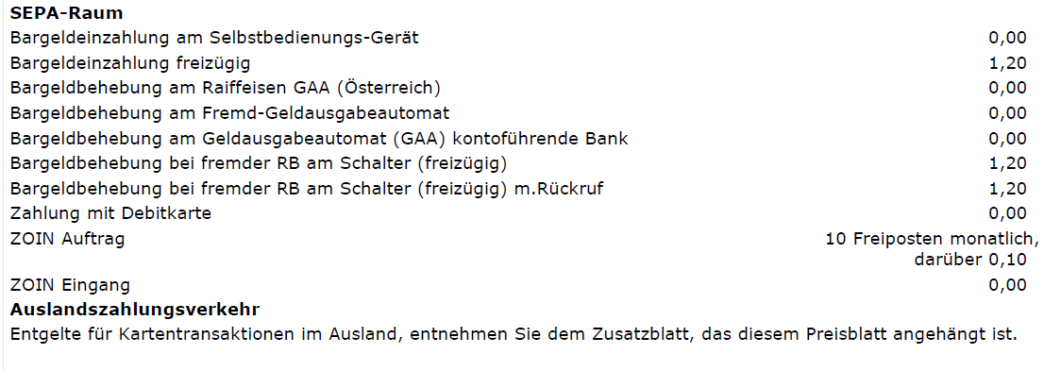

Figure 12: Raiffeisen Information Sheet; Source: Raiffeisen Bank

As we can figure out of the information sheet above, cashless transactions inside the SEPA area and in Austria itself are free of charge. Whereas payments with credit/debit card outside the area are with charges.

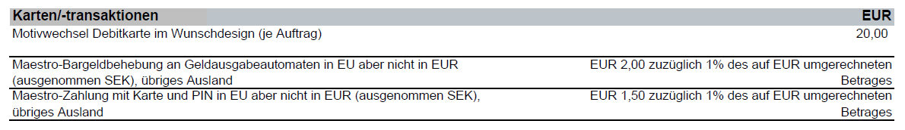

Figure 13; Raiffeisen Information Sheet; Source: Raiffeisen Bank

As an example, if a customer makes a cashless transaction about 100 €, it will cost him 1,5 € and also additionally 1% on the currency exchange rate to Euros. Basically, said there will be an additional charge of 1,50 € and the transaction will cost 101,5 € without the current exchange rate.

A figure down below shows all providers/banks in Austria and their charges and fees for cashless transactions outside the SEPA-area. The bank Raiffeisen is named with RLB NÖ Wien.

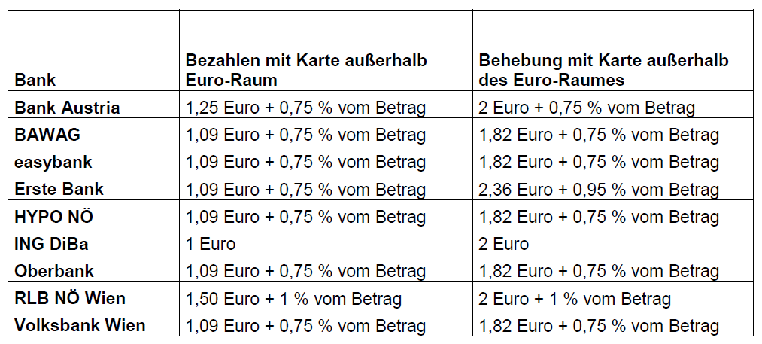

Figure 14; Comparison of Banks from Austria; Source: Arbeiterkammer

Germany

According to a new survey of the German finance portal Biallo, every second bank in Germany charge for cashless payments inside the country, besides the actual charges for banking services. These charges could according to them, go up to a maximum of 0,70 € for each cashless payment. They also listed top 10 banks for each province with the highest charges. They also mentioned that these charges are mostly in banking accounts which called “Klassik”. (Biallo, 2020)

This basically means that if the transaction amount is about 100€, it will cost the customer actually 100,70€. Down below are the results of the survey from finance portal Biallo, where average, maximum and minimum charges for cashless transactions are shown.

Ein Bild, das Screenshot enthält.

Figure 15; Results of the Survey; Source: (Biallo, 2020)

Due to clarity reason only an average view of the German Banks was mentioned, where only charges inside of Germany are shown. It is therefore highly probable that these banks also charge fees for card payments outside the country since there are fees inside the borders too.

England

Since England is still a part of the European Union but uses another currency than the Euro, it is an exciting example to see what charges they have on transaction without cash. To not blow with too much examples only one of the biggest banks in England, Barclays will be shown in the comparison.

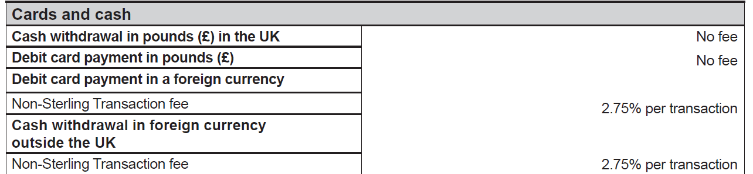

Figure 16; Barclays Information Sheet; Source: Barclays Bank

The figure above shows that Barclays charge their customers for each transaction with a debit/credit card 2,75 percent fees. It basically means that if the transaction amount is about 100 pounds, it will cost actually 102,75 pounds without the exchange rate corrections.

## USA and Switzerland

USA – United States of America

The most popular and also according to their profits one of the biggest banks in the US is Wells Fargo, where private customers but also business customers can use their offered financial services. From simple checking accounts to student accounts, it offers various banking products for different needs.

Like mostly in other countries too, using the credit/debit card inside the US is mostly free of charge. Down below a figure from the website of Wells Fargo gives detailed information about the fees for actual usage of a classic checking account and also the charges for cashless payments. All data about the fees are directly from Wells Fargo itself.

Ein Bild, das Screenshot enthält.

Figure 17; Wells Fargo Charges; Source: Wells Fargo

According to the sheet above international usage of debit cards for purchases outside the US, there is a charge of 3 percent of the transaction amount. In conclusion it means that if somebody concludes a transaction of about 100 US Dollars, the actual costs for the customer will not be 100 Dollars, but 103 Dollars which equals the 3 percent of the transaction amount.

Of course, the actual costs will differ if the transactions are not made in Dollar. In such a case, the exchange rates for different currencies play a huge role to calculate the real cost of the transaction.

Switzerland

Like England, Switzerland is also an exciting example to evaluate since they are geographically in Europe, but not part of the EU, nor using the Euro as their currency. They use the Swiss Franc as their currency, and it is also one of the strongest currencies compared to other ones.

For clarity reason, there will be only one bank in the comparison which also the biggest and strongest bank in Switzerland, the United Bank of Switzerland. Down below a paragraph from the information sheet of United Bank Switzerland (UBS), shows the actual costs of card payments inside the country and abroad.

Ein Bild, das Screenshot enthält.

Figure 18; UBS Card Fees; Source: United Bank Switzerland

Card usage within the borders of Switzerland are without charge, as expected. On the other hand, fees for cashless payments outside the country amounted to 1 percent of the transaction value, at a minimum of 1,50 CHF (Swiss Franc), additionally exchange rate courses for the currency of the country where the payment was made.

It means that if the transaction cost is about 100 CHF, it will not cost 101 CHF as expected but 101,5 CHF. The reason is that the fee amounts to a minimum of 1,5 CHF as already mentioned above and is visible on the information sheet above.

This calculation is very simple and brief and might therefore not correct. One reason is the difference of the currency CHF on the one hand, and on the other hand the confusing information on the sheet about the fee for cashless payment outside the country.

# Critical Evaluation

Since every bank in several different countries charge fees in different amounts, it is hard to find related critics for the fees charged in cashless transactions like paying with credit/debit card.

Most of the compared examples from different countries mostly charge for payments outside the country, whereas transactions inside its borders or in the same currency remain without charges. Of course, every bank shown in the comparisons have general charges for opening and using the related bank services like transaction or account fees and card fees. But other than that, mostly there are no charges especially for paying with card inside the country.

Only in Germany, an independent survey of a finance portal named Biallo revealed that 50% of the banks reviewed in the survey charge for card payments also inside the country. Every other bank as observed only charges for card payments in other countries and currencies.

These charges differ from country to country, but in general it could be said that average fee for card payments vary between 1,5 to 3 %. This percentage is relating to the transaction amount of the payment made. Additionally, most of the banks charge also an additional fee in their own currency like additional 1,5€ or 2 CHF, besides the percentage charges relating to the transaction amount.

I think this amount of charges are justified since every bank wants that their customers make payments inside the country or inside a defined currency area. Thus, this could also be the reason why sometimes fees are higher than usual.

Another reason for this high charges could also be the volatility in exchange rate between different currencies around the world. Therefore, every bank in the comparison charges a fixed percentage rate in relation to the transaction amount.

At first glance, it was not expected that the charges for payments in such different countries could be similar to one on other. But my research revealed that it is the case that their charges are similar.

Maybe the future will bring us a world where card payments around the world no matter in which country we pay or in which currency we make our transactions, will be without any additional charges besides the ones for the banking services. Because card payments become more and more convenient than cash payments and since the technology evolves from day to day, card payments could replace cash completely. Until that date, cash payments are still playing an essential role in our lives.

# Bibliography

Allison, C. (2017, 2 20). *Fin .* Retrieved from https://fin.plaid.com/articles/how-does-nfc-payment-work/

Biallo, H. (2020, 5 08). *Biallo*. Retrieved from https://www.biallo.de/girokonto/news/jede-zweite-bank-kassiert-beim-bargeldlosen-zahlen/

Coskun, V., Ok, K., & Ozdenizci, B. (2012). *Near Field Communication - From Theory to Practice.* John Wiley & Sons Ltd.

Coskun, V., Ozdenizci, B., & Ok, K. (2012, 12 1). A Survey on Near Field Communication (NFC) Technology. (Springer, Ed.) *Springer Science+Business Media New York*, pp. 2259-2294. doi:10.1007/s11277-012-0935-5

Department, S. R. (2020, 1 28). *Dossier-Bargeldsloser Zahlungsverkehr in Österreich.*

Ed. (2020, Mai 12). *NFCNearFieldCommunication.org*. Retrieved from http://www.nfcnearfieldcommunication.org/history.html

Garima Jain, S. D. (2015, 8 4). NFC: Advantages, Limits and Future Scope. *International Journal on Cybernetics & Informatics*.

Hoy, M. B. (2013, Juli 22). Near Field Communication: Getting in Touch with Mobile Users. *Medical Reference Services Quarterly*, pp. 351-357. doi:https://doi.org/10.1080/02763869.2013.807083

Profis, S. (2014, 9 9). *CNet*. Retrieved from Zugriff: 16.05.2020: https://www.cnet.com/how-to/how-nfc-works-and-mobile-payments/

Schnell, E. (2013, 6 10). Near Field Communications: Features and Considerations. *Journal of Electronic Resources in Medical Libraries*, pp. 98-107. doi:10.1080/15424065.2013.792605

Triggs, R. (2019, 6 30). *Android Authority*. Retrieved from https://www.androidauthority.com/what-is-nfc-270730/

*Wikipedia*. (2020, 5 7). Retrieved from aufgerufen 16:30: https://en.wikipedia.org/wiki/Near-field_communication

# Table of Figures

Figure 1; Amount of Transactions; Source: (Department, 2020) 5

Figure 2; Amount of Transaction Volume; Source: (Department, 2020) 6

Figure 3; History of NFC; Source: (Coskun, Ok, & Ozdenizci, Near Field Communication - From Theory to Practice, 2012) 7

Figure 4; Global NFC Logo; Source: (Coskun, Ok, & Ozdenizci, Near Field Communication - From Theory to Practice, 2012) 8

Figure 5; NFC Mobile Architecture; Source: (Coskun, Ozdenizci, & Ok, A Survey on Near Field Communication (NFC) Technology, 2012) 11

Figure 6: Operation Modes (Source NFC Forum) 12

Figure 7; Magnetic Stripe Card; Source: (Coskun, Ok, & Ozdenizci, Near Field Communication - From Theory to Practice, 2012) 19

Figure 8: Smart Card; Source: (Coskun, Ok, & Ozdenizci, Near Field Communication - From Theory to Practice, 2012) 21

Figure 9; Smart Card Mobile Architecture; Source: (Coskun, Ok, & Ozdenizci, Near Field Communication - From Theory to Practice, 2012) 22

Figure 10; Contactless Smart Card; Source: (Coskun, Ok, & Ozdenizci, Near Field Communication - From Theory to Practice, 2012) 23

Figure 11; Universal Symbol of Smart Card Reader; Source: (Coskun, Ok, & Ozdenizci, Near Field Communication - From Theory to Practice, 2012) 24

Figure 12: Raiffeisen Information Sheet; Source: Raiffeisen Bank 28

Figure 13; Raiffeisen Information Sheet; Source: Raiffeisen Bank 28

Figure 14; Comparison of Banks from Austria; Source: Arbeiterkammer 29

Figure 15; Results of the Survey; Source: (Biallo, 2020) 30

Figure 16; Barclays Information Sheet; Source: Barclays Bank 31

Figure 17; Wells Fargo Charges; Source: Wells Fargo 32

Figure 18; UBS Card Fees; Source: United Bank Switzerland 33