

**Vienna University of Economics and Business Business Information Systems: 4201 Seminar aus BIS**

**Seminar Thesis:**

LineageOS

**Written by:**

Richard Lichtenberg h1551354

Supervisor: ao.Univ.Prof. Dr. Rony G. Flatscher

Submission date: Wien, der 19.06.2019



Welthandelsplatz 1, A-1020, Wien

Telefon: +43/1/313 36/4622 ● Telefax: +43/1/313 36/717

Web: www.wu.ac.at/

Inhaltsverzeichnis

Introduction: 3

1.History of the operating system 4

**1.1 The creation of LineageOS**: 4

**1.2 The Motivation behind the Development** 5

2. Differences between LineageOS and Android 7

**2.1 Additional Functions of LineageOS** 7

**2.2 comparison of the security of Lineage OS and Android:** 10

2.3 LineageOS 16: The latest version of the operating system 12

2.4 Which smartphones work with Lineage OS 14

3. Installation and Practice: 15

3.1 How to enable ROOT for LineageOS 15.1 15

3.2 Flash LineageOS to my Smartphone 19

3.2.1 Step One: Get Downloads together and enable Developer Mode: 20

3.2.2Step Two: Unlock the Bootloader 22

3.2.3 Step three: Flash TWRP 23

3.2.4 Step Four: Reset/Wipe partitions: 24

3.2.5 Step Five: Flash Lineage, GApps, and SU 25

3.2.6 Step 6: Boot and Set Up: 27

4. Market Situation of LineageOS and Outlook for the Future: 28

4.1 Market Situation of LineageOS: 28

4.2 Outlook into the Future of Custom ROMs: 32

Conclusion: 33

Table of Resources: 35

# Introduction:

With around 1.8 million installations, LineageOS is the most widely used Custom ROM in the world. It is a modification of the Android operating system which was developed by Google. In the context of my seminar work I dealt extensively with the operating system in a theoretical and in a practical way.

In my seminar paper I first write about the history of the operating system and describe how the project came about and what motivated the developers to create it.

Furthermore, I will discuss the differences between LineageOS and Android and focus on the security for their users and the adaptability of the two operating systems for their users. In addition, additional functions will be presented that come along with the installation of the Custom ROM. Also in this part of my thesis, I will discuss LineageOS 16.0, the latest version of the operating system and explain which updates this version brings with it and which devices are supported by it. In the following part my practical experiences with the operating system will be presented. I will first describe which devices are supported by the provider. In the following, the installation of the operating system on a smartphone and the activation of a root access on the smartphone are described in more detail. Moreover, the market situation of the operating system is described. Other custom ROMs will be discussed in more detail and a comparison with LineageOS will be drawn. Last but not least, an outlook into the future is given, which is accompanied by a conclusion.

The aim of my work is to uncover the advantages and disadvantages of the Custom ROM and for whom the installation of it is worthwhile. Furthermore, the work should enable the reader to understand what has to be considered during the installation of the operating system and which steps have to be followed. Last but not least, I analyze the market situation of the operating system in order to conclude whether LineageOS has an advantage over the other market participants. In order to answer these questions, I based my work on literature sources from the Internet and made my own experiences with the installation of the operating system.

# 1.History of the operating system

## 1.1TheFoundationofLineageOS:

In order to understand the history of the operating system LineageOS better, we need to take a look back on the year 2009. In May of this year the Android modification CyanogenMod was published in the forum of the XDA-Developers community by Steve Kondik. The XDA-Developers community is a developer community with more than 6.8 million developers. The main contributions are about the mobile operating system Android. The username Cyanogen comes from the fact that it was the username of Steve Kondik in the Developer Forum. He developed the operating system and named it after his username. The project was very well liked by the community and was further developed as a community project. Even outside the forum, the operating system became very popular the number of its users grew rapidly. In 2015, it already counted over 50 million users, making it the most used Android derivative in the world at the time.

The venture capital funds Benchmark Capital and Redpoint Ventures provided Steve Kondik and CyanogenMod with a total of 7 million US dollars in 2013. The goal was to commercialize and monetize the operating system. They wanted to achieve the commercialization and monetarization of the operating system by installing the hardware of it ex works for corresponding smartphones. As a result, the start-up company Cyanogen Inc. was founded. At the same time, Kirt McMaster, the co-founder of the company, was assigned the role of the CEO. However, the attempt to commercialize the operating system failed for various reasons. Although the company succeeded in concluding contracts with some hardware manufacturers, there were internal disagreements within the company that are said to have contributed to the failure of the commercialization. Investors of the start-up decided to subject Cyanogen Inc. to a fundamental restructuring in July 2016. This led to the degradation of the founder Steve Kondik and the dismissal of the company’s CEO McMaster. In addition, all employees in the operating system development department were made redundant. Kondik also left the company shortly after in November 2016. Instead of McMaster, Liar Tol took the place of the CEO.

Cyanogen Inc. then announced on the 23rd December of 2016 the termination of its services by the 31st December of the same year. However, they also announced that the source code would continue to be provided.

A few regular developers of the operating system told the public a day later that they would continue to develop CyanogenMod in the form of a new project by forking the previous source code. As with CyanogenMod, this was supposed to be free software. Only one day later the copy of the previous source code was uploaded to GitHub and LineageOS was created. GitHub is an online platform providing software development projects on its servers.

The name change from CyanogenMod to LineageOS can be explained by the fact that the name rights to CyanogenMod were held by Cyanogen Inc. The name LineageOS was chosen deliberately because lineage means ancestry.[1]

## 1.2 The Motivation behind the Development

Basically, The Android operating system is a free open source operating system that the respective user can freely design according to his desires. If you take a closer look, you will see that this is not entirely true. Thus, the company Google, which is the most important and at the same time the biggest Android developer, is the one who determines what the operating system can do and what it cannot do. The operating system is given its own interfaces by the smartphone manufacturers, which often hinder and limit the system's functions. This slows down the operating system and prevents it from unfolding its true potential.

Steve Kondik and an independent group of developers developed and released the extended open source operating system CyanogenMod based on the Android operating system. The system is constantly being further developed by the developer community. The goal of them was to free the operating system from the ballast, which is present in the Google version Android. They wanted to get rid of all the programs they found annoying in the Android Version from Google. Thus, CyanogenMod was freed from Bloatware, i.e. pre-installed advertising apps of different online shops, delivery services, taxis and hotels. Furthermore, it has been freed from spyware, which protects the user of the operating system from being spied on by Google. Moreover, the user is offered additional advanced settings that are not available on most Android versions. These aspects were designed to increase reliability and improve the overall speed of the operating system. CyanogenMod runs better on weaker and older models due to the elimination of unnecessary background services and can therefore achieve a performance improvement that cannot be reached with the classic Android version. Furthermore, hardware manufacturers often do not deliver current Android versions or only deliver them with considerable delays. In most cases, it is not technical but product policy aspects that are to blame for this late, or even non-delivery. This was a thorn in the side of Steve Kondik and the developers of CyanogenMod and motivated them to develop a modification that would provide also smartphones with current Android versions. Furthermore, additional program functions are offered with the modification, about which I will write later. Another big aspect for the motivation of the developers was the reason that they wanted to design an operating system that gives the user the feeling to have the entire control over his smartphone. This is possible in the case of LineageOS, because the operating system can also be used without Google services.[2]

# 2. Differences between LineageOS and Android

In the following section I describe the most important additional functions of LineageOS, which are not available in the Android version developed by Google and which can offer the user additional added value. However, it should be mentioned that the different additional functions are not available on every version or every device of the operating system LineageOS. This depends on the installed version. Thus, the different versions differ a little regarding the features. On the whole, however, the versions are very similar. At the end I will discuss LineageOS 16.0, the newest operating system of the Custom ROM. Also I will discuss which devices are supported by it.

## 2.1 Additional Functions of LineageOS

In the following part I want to talk about the additional functions of the user interface and about the differences between the pre-installed apps of the two operating systems. Finally, I will write about some more exclusive features that come along with LineageOS.

**The User Interface:**

Like Google Android, LineageOS relies on a less decorated user interface and keeps it minimalistic. The Pixel Launcher, which is the start screen for the smartphones Pixel and Pixel XL from Google, is not integrated into the custom ROM of LineageOS.[3] Nevertheless, by flashing Google Apps on the smartphone, it can be installed afterwards on the operating system. Furthermore, the Google Assistant by Android and the Trebuchet Launcher by LineageOS can be compared for the user interface of both operating systems. It is an intelligent personal assistant of the smartphone, which can receive both, spoken language and also answer questions about the screen content.[4]

The Google Assistant is not included in the custom ROM in its raw form, which is why LineageOS uses the Trebuchet Launcher. Compared to the Google Launcher a better personalization is possible with it. LineageOS offers more possibilities than Android to customize the appearance of the system, whereas the Google version only allows the setup of a different background image on the home screen or the placement of widgets. For example, users can hide icon labels if they do not like the Google search bar. You can also enable or disable scrolling of the background image, which is not possible with the Android version. Another feature of LineageOS is that the size of the icon grid can be changed. Moreover, the user can choose in the App-Drawer if he wants to scroll horizontally or vertically and if he wants the background to appear dark or light.

Further differences can be seen in the notification bar. With the LineageOS version, you can set the notification bar to expand further to the right or further to the left with a single movement when wiping down. That makes the use very pleasant for the user. Android requires two fingers for that action. A further aspect is that the screen brightness of LineageOS can be adjusted at the top of the screen by wiping the status bar. The screen can even be completely switched off by double tapping on the status bar. Further small features are, for example, that the clock can be displayed centered, right or left and that the battery status display can also be displayed as a circle.

Another positive feature of LineageOS is for its left-handed users and people whose smartphones have a large screen. They can swap the on-screen keys in the navigation bar at the bottom of the screen. This can be done by holding down the home button or tapping it twice in a row. The lock screen can also be personalized. There you can exchange the apps for the three quick start buttons at the bottom of the screen and design them according to your personal preferences.[5]

**The pre-installed apps:**

If you buy a smartphone that runs the Android operating system, the mobile phone is equipped with an extensive app package by Google. This app package includes for example applications for music, news, photos and maps. In addition, there are the standard apps for SMS and e-mail writing, telephoning and photography. These apps cannot be deleted individually or collectively from a smartphone with Android installed as an operating system on it. If you have a smartphone with the LineageOS operating system, the smartphone comes without the Google Apps. These apps have to be flashed if the user wants them on his smartphone. But if you do not want them, because some of the many apps seem to be unnecessary or annoying for you, LineageOS comes still equipped with enough apps even without GApps. So that it can still be used as a normal smartphone. Many of the apps that are pre-installed on the operating system are based on the source code of Android, but they are often not current versions of them. Mostly, they are older apps, which are not equipped with the complete functions. However, if you look at some of the pre-installed apps of LineageOS, you can quickly see that some of them are superior to their Androids. For example, the Jelly Browser, which is based on Google's open source engine Chromium, offers significantly higher data protection security than the Google Chrome Browser. With “LockLock”, it offers additional security settings that block other apps from reading the accessed web content. The browser also offers a night mode, an energy-saving mode and edge navigation. Furthermore, the browser is very quick. The camera can also be positively highlighted. It offers quick access to the most important settings through its clear side menu.

Even with LineageOS, the standard programs cannot be deleted. Although fewer apps are installed from the outset, users without Flash from Google Apps have to live without many Apps and programs. These include for example Google Drive, Google Presentations, Google Docs and Youtube. The Play Store is not installed either. If LineageOS users want to install games without Google Apps, they have to get them from other Play Stores, which offer a much smaller offer of apps.[6]

**More exclusive features:**

In addition to the user interface and the apps, Lineage OS also wants to stand out from Android and other operating systems through further features. For example, the operating system has a data-saving mode that can be used to regulate the reception and transmission of background data from installed apps. So, you can choose for yourself for which apps this should happen and for which it should not. The WLAN data traffic of individual apps can also be switched off in a different way than with Android. Another positive feature is that you can set an automatic timeout if you use your smartphone as a tethering hotspot for other devices. If this is set, the energy-intensive hotspot is switched off after the selected time. Another feature of LineageOS is called LiveDisplay. With this program, the smartphone adjusts the color temperature of the display according to the time of the day. When it is night, blue tones are automatically reduced. During the day the display is slightly cooler. Brightness and saturation are also increased in strong sunlight by the "Automatic Outdoor Mode". Furthermore, unlike the Google version, the screen can be calibrated to RGB colors with Lineage OS.

There are also differences in the system profiles of the operating system. In particular it is really convenient that the smartphone can be automatically set to a certain state by these. Here an example can be given that is particularly useful for users are at home or at the office. The standard display lock can be automatically switched off when the smartphone is logged into a stored WLAN hotspot. However, the user must also set the display lock to be restored when the connection is terminated. In addition to WLAN connections, connections to an NFC tag or Bluetooth connections can also trigger a system profile of the operating system

## 2.2 comparison of the security of Lineage OS and Android:

The fact that more and more data is collected of us is well known. However, very few people are really aware of the extent to which this happens. In a study by Jinyan Zang, a Phd student of the Harvard University, and some of his colleagues at the MIT, they examined 100 popular apps to see whether the providers of these apps sniffed data and passed it on to third parties. The study showed that, in particular Android Apps share data with third parties. Data such as e-mail addresses, locations and other personal information are collected and passed on.[7] In 2015, Google introduced its own rights management for apps with the launch of Android 6.0. With the new rights management, Android users should be able to freely decide which functions and data a program is allowed to access. However, the rights management does not cover many areas and can simply be bypassed by apps, which simply no longer work if the the access to the data of the user is denied to the provider.

In contrast, Lineage OS offers its users much more comprehensive protection, as it is very important to them to protect their users' data. For this purpose, the provider of the operating system have introduced a program called "Trust" in 2018. The trust interface contains all settings for privacy and security, such as the Privacy Guard of LineageOS. With that Privacy Guard, they have their own data protection measures. At first glance, these do not really differ from those of the Google version and in some cases even have the same access areas as these. These data protection measures can be restricted or released. Unlike Android, when apps are prohibited from collecting personal data such as the calendar, the phone log or location data, Lineage OS does not send them any data at all but sends them an empty fake file. The app thus continues to function without personal data being sent to the provider. In the privacy settings you can also select for each program whether the privacy function should also be started when the device is started, remain active or be executed in the background. Furthermore, the trust symbol is always displayed to the user when he performs an action and the action is recognized by the system as secure. This protects users from phishing and other attacks. The trust interface also shows the user how to increase security on his smartphone and which effects are triggered by which settings.[8] The operating system also provides a solution against unauthorized third-party access to apps with private or sensitive data. For example, you can use the menu item "Protected Apps" to select programs by entering your display lock code. Thus, these disappear from the app overview and are nowhere to be found by sniffers. Furthermore, one can create a folder on the Home screen and protect it with a password. This password protection can be activated by clicking on the padlock next to the folder name. After this is activated, one can only access the folder by typing the display lock code. This protects users from access by third parties their apps and personal data.

Another difference lies in the browser of the two operating systems and the data collection through it. Android uses Google Chrome and Lineage OS comes with a browser called Jelly, which does not transmit data to Google in the background. The Chrome browser collects user data about the Google account and the search behavior of its customers. The data is sent to Google, which then uses it to personalize advertisements and other purposes. In addition to its speed, the Lineage OS browser offers numerous security settings. For example, users can enable a do-not-track option and restrict access to the microphone and phone features. Moreover, they can limit the access to the location and the camera of the phone. This provides the user with additional security from data collection. The user can also define this access right separately for individual pages. For example, he can activate an ad blocker for all pages, but also only for individual pages. The browser also has an integrated cookie management. Here you can forbid the browser to accept cookies. In addition, under Data Protection & Security, you have the option of prohibiting the browser from storing passwords and form data or using the location data of the smartphone.[9]

## 2.3 LineageOS 16: The latest version of the operating system

The latest version of the Custom ROM is LineageOS 16. With a minimum of additional features, it is a ROM, resulting in a versatile yet powerful Android variant. The new version is based on Android 9 Pie and is equipped with the same new features as the Google version. The operating system is also available for older smartphones such as Samsung Galaxy S5 and Google NEXUS 6.

The Custom ROM retains a Stock Android look. However, if an adjustment is desired, there is a dark mode, through which the look can be adjusted. According to the XDA-Developers forum, the programs of the new version are absolutely stable and work perfectly.

An innovation of the new version is the Live Display. It can be adjusted by the user regarding the color profile and the current display mode. Furthermore, there is an integrated built-in dark mode, which can be optimized. The colour calibration can be adjusted between green, red and blue and an outdoor mode can be activated manually. This increases the brightness of the display. By these functions the user of the new version has numerous possibilities to adapt his display and to personalize it freely after his conceptions.

The Privacy Guard, for which LineageOS is so popular, is also available and offers the user many possibilities to protect his device from external intervention. Moreover, it gives the user the chance to control how an application can access the device. Thus, NFC access, location access and even more areas can be controlled. The Privacy Guard is very precisely tuned and the authorization system can be controlled in great detail. Therefore, it is a real enrichment for all smartphone users who care about their privacy.

A further function of the PrivacyGuard of the new variant is that the user receives a notification when his build signature or SELinux status changes. This allows the user to know exactly when something is running on his device that he does not want to run on it. There are also new features for Trust. It is now possible to block foreign or new USB connections in standby.

LineageOS 16 also works without Google Apps. The Custom ROM comes with a number of standard programs, which include a gallery app, the Chromium-based Jelly browser, an audio EQ app and many other useful functions. According to the XDA-Developers Forum, only the pre-installed camera is to be criticized about the new version, as it does not have a good camera quality compared to the Android version and offers only a few options. However, this can easily be replaced by other cameras such as the Google Camera.

Some new features also come with the new LineageOS version. For example, the navigation bar can be further adjusted. A new button can be added. With this button the contents of a clipboard can be copied directly into a text field. Also the Volume key has a new feature. it can now skip a song by holding the key down longer.[10]

Another change to the predecessor, LineageOS 15.1, can be found in the updater. Updates can be checked by means of user-defined intervals. For example, one can specify that this should be done daily, once a week, once a month or never. In addition, the calculator now also supports dark mode using the Styles API. This Styles API is an application introduced by Lineage that allows you to change colors. Furthermore, a “mark as read function” for messages can be set. The security patches for December 2018, January 2019, and February 2019 have also been merged. This merge has fixed bugs, closed security vulnerabilities and retrofitted features that were previously unavailable.

Moreover, the WebView was updated to the new Chromium version. WebView is a function that makes it possible to display web content.[11]

All in all, it can be said, that with the new LineageOS version, several new useful features were added to the operating system.

With the introduction of the new LineageOS version, LineageOS 14.1`s has been discontinued and will no longer be developed.

LineageOS 15.1 will still be further developed. But since most developers of the operating system have changed from the older to the new version, there will be no new features for it.[12]

## 2.4 Supported Devices by LineageOS

In the following part I would like to discuss which devices are supported by Lineage OS.

The operating system cannot be installed neutrally on every smartphone like Windows on a PC. Specific drivers are required for each hardware, which have to be delivered with the operating system. The easiest way is to check the Lineage OS website to see if your device is supported by LineageOS or not. There you will find a list of all supported devices. Via the manufacturer filter you can quickly find the device you are looking for. Currently 25 device manufacturers and a total of 245 devices are supported. During my research I noticed that Samsung and LG have by far the most supported devices.[13]

# 3. Installation and Practice:

## 3.1 How to enable ROOT for LineageOS 15.1

During the installation of LineageOS 15.1 on my smartphone, I repeatedly came across the term "rooting" during my research. I did not know the term before and I got a little smart about the topic. In the end, I decided to root my operating system out of curiosity to see what advantages and disadvantages this has and how the process of rooting itself works. I will first describe what rooting actually is, which advantages and disadvantages it brings and last but not least how I rooted my operating system.

When buying a new mobile phone, there are always a lot of standard programs and apps, so-called bloatware, pre-installed. These cannot be uninstalled, even if it is desired by the user. Another problem occurs at some point when the smartphone can no longer be supplied with new updates. This happens quickly, especially if you are using an old smartphone or have bought a cheap one. If you then want to use the provider's new operating system, you have to buy a new smartphone. The answer to the question why manufacturers such as Google act in this way can be quite clearly answered by saying that they simply want to earn more money.

If you don't have SU access for apps or apps and ADB in the developer options, you have to follow several steps to activate root. In this sense I want to make a comparison that describes the user's situation pretty well. The situation can be compared to the Windows operating system on a computer. There is an administrator account and a guest account. If you are logged in as a guest, you do not have the right to uninstall software or apps. This is similar with Android. The user of the operating system is only logged on to the operating system as a guest and lacks the necessary rights to uninstall Bloatware. If you now activate the root-access on the smartphone, the user's rights change, and he becomes the administrator of his smartphone. The root access enables the user to free himself from programs on his smartphone that are not desired by him. Once the smartphone has been rooted, the user is no longer bound by the manufacturer's restrictions. The entire system can be changed by the user, including for example changing system settings and interface modifications. Other Android versions, like LineageOS or other custom ROMs, can then be installed. Moreover, pre-installed apps can be uninstalled after activating root-access. Another positive effect of enabling root access is that app permissions can be restricted and changed. Furthermore, you can install current Android operating systems on your smartphone and you do not have to buy a new device if you want to use the latest update of your operating system. In addition to all the positive effects of rooting, there are a few disadvantages that are important to mention. Once the smartphone has been rooted, the guarantee expires in most cases. However, there are exceptions. For example, HTC writes that the guarantee remains valid if the defect is not caused by rooting.[14]

In contrast to the guarantee, the warranty always remains in force. Some app vendors also recognize when their apps are running on a rooted device and they may refuse to provide services to the user. Malware also poses a threat to the smartphone. This can easily get onto the smartphone through the root and cause damage there. In the worst case, the smartphone can break during the routing process at the software level. During the root process, the device can be destroyed by an error. This problem is called "bricking". A distinction is made here between a hard brick and a soft brick. A hard brick is the worst case that can occur during rooting. This destroys the system to such an extent that access to the smartphone becomes impossible. A soft brick, on the other hand, is less bad. This is merely a software error that occurs during rooting. If such a software error occurs, the smartphone no longer starts correctly. However, by installing a new firmware, you can easily fix the problem.[15]

I also want to discuss how I enabled root access on my smartphone. The first step the user has to take is the download of the appropriate LineageOS 15.1 SU. SU stands for SuperUser. By installing the SU, the user gets a special user account with which he can administer the general system of his device.[16]

I downloaded an official version because my LineageOS 15.1 version was also an official one. In a second step, several actions follow, which I had to execute one after the other. After I downloaded the SU Add-on ROOT binary package from the download area and copied it to my Android device, I booted my smartphone in TWRP Recovery, which I had already flashed during the installation of the operating system. The term TWRP Recovery is explained in more detail in the description of the installation of the operating system. Then I could select the option "Install from TWRP Recovery home screen or similar option in other recovery" and could select the zip file, LineageOS 15.1 su addon ROOT, which was copied to my smartphone. Then I flashed the SU to my smartphone. After the SU was installed on my smartphone, I had to restart my device. After the SU was flashed on my smartphone, I could continue to activate ROOT on the LineageOS 15.1 ROM. Therefore, some steps had to be done again. In order to activate ROOT, the developer options on the device must be activated first, since the ROOT access settings are made available through these. In order to activate the developer options, the build number must first be clicked seven times in the settings under “Info phone”, which you can find in the settings. After this is done, the option "Developer Options" appears in the settings above the function "About Phone".

Now the developer options have to be opened to activate ROOT. In the developer options you can find the root access setting, which appears in deactivated state. Now all you have to do is click on the root access and select it for apps. After this is done, the root-access is activated on the smartphone.[17]

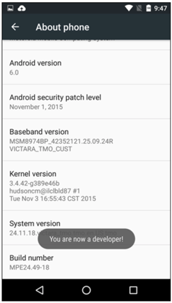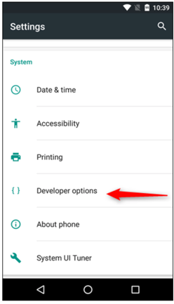

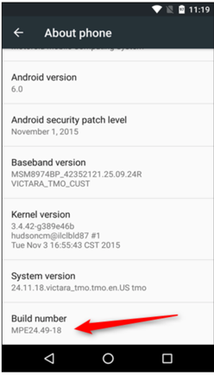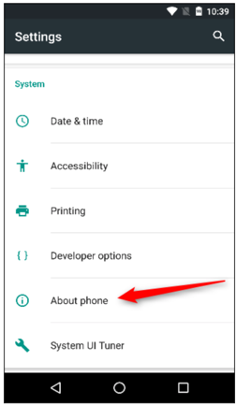

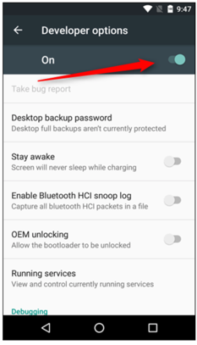

## 3.2 Flash LineageOS to my Smartphone

Since I wanted to deal with the topic LineageOS not only theoretically, but also in a practical way, I decided to install the operating system on my smartphone. On this way I wanted to find out more about the differences to the operating system Android. I organized myself a Smartphone, on which it is possible to use LineageOS. I chose a Samsung Galaxy S5 because a friend gave me his old smartphone. In the following I will first tell you about the beginnings of the installation and then go on with the description of the user interface. I installed the operating system on my smartphone in the classic way, I flashed it from a computer to my smartphone. Since especially older devices are not supported by the LineageOS installer and therefore cannot be supplied with updates, it is necessary to flash the new operating system on these devices on this way to the smartphone.

After I organized the Samsung Galaxy S5 on which I could use the operating system LineageOS 15.1, I started with the installation of the operating system. I relied on a manual from the internet.

For the installation I used my smart device and a computer on which ADB, which means Android Debug Bridge, and Fastboot were installed. The ADB is a software interface for the Android system that can be used to access an Android smartphone from a computer via USB cable and execute commands.[18] A fastboot is a protocol which is needed to overwrite the flash memory of an Android system from a computer via ISB.[19]

As the last step before starting the installation, I unlocked the bootloader of my smartphone. This is a necessary step, because it is not possible to flash the operating system to the smartphone without it. When I installed the ADB and the Fastboot on the computer and I finally unlocked the bootloader on my smartphone, I started to flash the operating system on my smartphone. What the bootloader is and how it is unlocked is describe in step two of the installation.

### 3.2.1 Step One: Get Downloads together and enable Developer Mode:

In a further step I had to download the necessary tools to install LineageOS. A custom recovery must be installed on the PC. To understand what a Custom Recovery is, you have to explain what an Android Stock Recovery is. A Stock recovery is a recovery system that is shipped with all Android devices. This stock recovery is free for any user to access. Android users can access this recovery system and either reset, reboot or restore the system. However, it is not possible to flash third-party ROMs, which is LineageOS, onto the device. Now Custom Recovery comes into play. This is a third-party recovery system that replaces stock recovery when installed on the device.[20]

After downloading Custom Recovery TWRP, I went on to the next step. I downloaded LineageOS version 15.1. I went to the Lineage website and downloaded the operating system version that was compatible with my.[21] As a further step I downloaded Google Apps. Although it was stated here that this is not mandatory for the installation of the operating system, it is otherwise not possible to connect the device to the Google account, unlock all functions of Android and also get access to the Play Store. So I was curious and got the Google Apps Package from the LineageOS website.[22]

Once the download was completed, I moved on to the next step, which was to enable the developer mode and USB debugging on my smartphone, as I did when I activated root access. How I activated the developer mode is explained in the first part of my seminar paper when describing how I enabled root access on my smartphone.

To enable USB debugging you have to click on the activated Developer Options, scroll down to Debugging and enable USB debugging. A further step of the installation of the operating system was accomplished.[23]

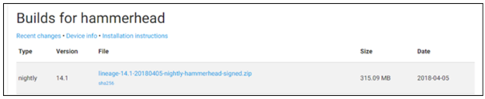

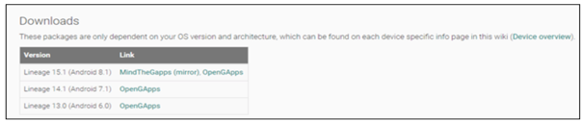

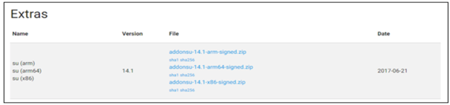

### 3.2.2Step Two: Unlock the Bootloader.

### In another step I unlocked the bootloader on my smartphone. A bootloader is a program that loads an operating system of a smartphone into the main memory and makes the device run.[24]

It is important to back up the smartphone before unlocking the bootloader, otherwise apps may lose their functionality.[25] After I backed up my phone, I connected my phone to my computer via USB. Then I went to the folder where my Fastboot and ADB files were stored. Here it was necessary to open a Powershell window for this folder. Powershell is a programming and scripting language that can be used to automate tasks on operating systems.[26]

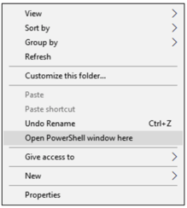

Now I entered adb devices at the prompt and pressed enter. Since my smartphone has never used an ADB before, I had to grant ADB access on the smartphone first. When I had done this as well, a few steps followed in which I had to enter commands into the Powershell. First, I had to enter the command “adb reboot bootloader”. When I sent this command, my smartphone was rebooted into the bootloader. The next command I sent was "fastboot oem unlock", whereupon I had to confirm this command on my smartphone. I had to press the volume key for yes and then the on/off key in order to confirm. After completing this process, I could start flashing the Custom Recovery to my smartphone.[27]

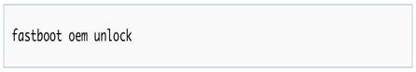

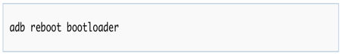

3.2.3 Step three: Flash TWRP

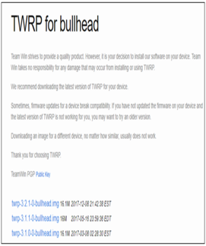In a further step I started to flash the Custom Recovery on my smartphone. Again, I had to open a PowerShell window on my computer and enter the following command: "fastboot flash recovery" <twrp-richard.img>. This step was done pretty quickly, and I was able to move on to the next step.[28]

### 

### 3.2.4 Step Four: Reset/Wipe partitions:

### 

In order to continue with the installation of the operating system, the custom recovery that was just flashed, must first be started. In order to restart it, the user must first use the volume button to search for the recovery function and then confirm it by pressing on/off button in a further step to confirm the restart. As soon as this is done, the custom recovery TWRP is started and you can see the recovery screen. On this screen you first have to select the function “Wipe”. Afterwards the function “Advanced wipe” has to be selected. In a further step, the options that the user does not want on his phone can be selected and deleted. The options Data, System and Cache can be chosen and the deletion process be started. This process takes some time. If the systems are deleted, a restart of the smartphone is necessary to continue with the flashing of the operating system.[29]

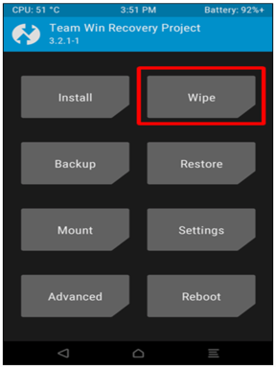

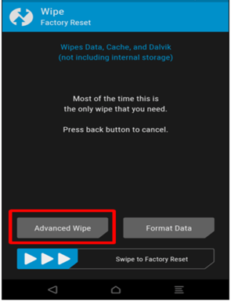

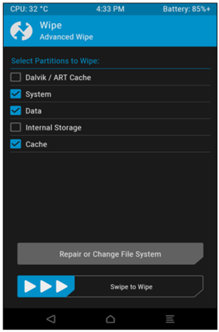

### 

### 3.2.5 Step Five: Flash Lineage, GApps, and SU

After the recovery of the phone and its restart are finished, in a fifth and final step, the SU, the Google Apps and LineageOS can finally be flashed to the phone. While doing this, the user is asked to go back to the PowerShell Window on the computer and enter the following command: "adb push <lineage.zip> /sdcard. Since I also wanted to flash GApps and SU on the smartphone, I had to enter the two commands "adb push <gapps.zip> /sdcard and "adb push <su.zip> / sdcard into the Powershell window. Sdcard means in this case only the local memory of the Smartphone and not that the Smartphone needs a Sdcard. These commands move these three files to the local memory of the smartphone. Now the three files can be installed. First, I installed LineageOS and then GApps and SU. It has to be mentioned that GApps has to be installed before booting the smartphone for the first time. When all of the three files are selected for installation, flashing can begin. This takes some time.[30]





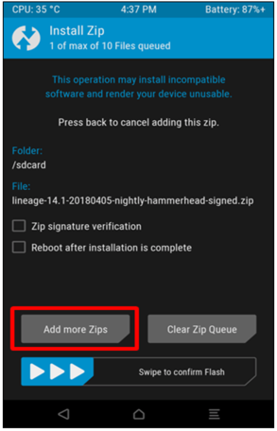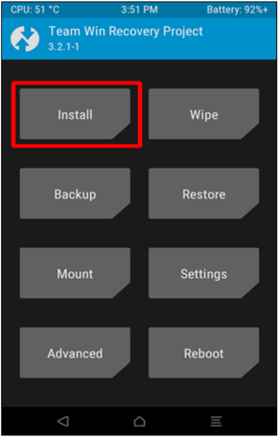

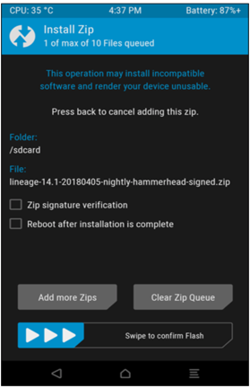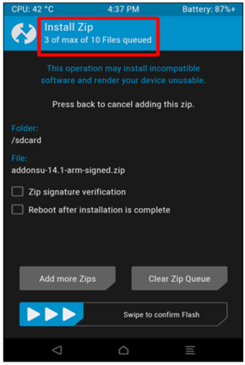

### 

### 3.2.6 Step 6: Boot and Set Up:

When the flash of these three files was completed, I restarted smartphone one last time. When the phone is rebooted, it can be individually configured and personalized according to the user's preferences.[31]

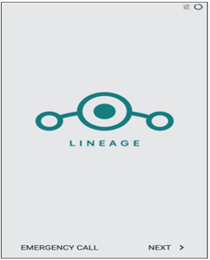

# 4. Market Situation of LineageOS and Outlook for the Future:

## 4.1 Market Situation of LineageOS:

In the following part I will go into detail about different custom ROMs that can be installed for Android. Also, I will draw a comparison to the operating system Lineage OS that I examine in my seminar paper. I look at eleven different Custom ROMs and work out their advantages and disadvantages. At the end of this part I will summarize the results. First, I want to talk about the Custom ROM SlimROM. This operating system was launched in 2015 and is based on the Android Open Source Project Code. It is kept very minimalistic and is user friendly and functional. Like Lineage OS, this operating system has been enhanced to make it more user-friendly for the user. Two aspects to mention are the inclusion of the Slim PIE and the Slim Recents of the operating system. The Slim PIE is a replacement for a navigation bar. This function is particularly useful for the user when using his device in immersive mode. The Slim Recents are used to display the apps not on the whole screen, but only in a small sidebar. This saves space and gives the user a good overview. Further SlimROMs functions are user-defined key locks, a privacy guard and other proograms. The user interface is clear and concise and can be customized like Lineage OS. Compared to LineageOS, however, it does not have so many features and is therefore, despite its pleasantly simple use, not the right operating system for everyone. It is more suitable for less powerful devices for which LineageOS may offer too many features. A positive aspect is that 60 different devices are currently supported by the operating system. These are many supported devices, but Lineage offers support for many more devices. That is why SlimROM has a clear disadvantage in comparison to LineageOS in this regard.[32]

The next Cutom ROM I want to mention is Dirty Unicorns. The Dirty Unicorns project was started in 2012. It offers great device support. Updates are also made regularly on a high frequence. That provides the user with useful features and keeps him up to date. The operating system has a special feature with its function "Omniswitch", which can be defined as an appswitcher, which is arranged at the edge of the screen. It can be used to access all central functions and all open apps of the device with a simple wipe movement. Furthermore, it is easy to adapt through the operating system. In the settings at the option "Dirty Tweaks" the user can adjust many aspects of his device like the lock screen, the system, the navigation bar, the status bar and multitasking functions. It thus offers extensive setting options and represents a good alternative to other custom ROMs.[33]

OmniROM is another Custom ROM that I would like to mention in my seminar paper. It was released in 2016. 80 devices were already supported by OmniROM at this time. Another positive aspect is that the Smartdevice is already equipped with many basic apps and that Omniswitch is used to navigate the apps, which makes it comparable to Dirty Unicorns. OmniROM has summarized its main features in the settings under "Omnigears". Some programs can be adapted there, but Lineage OS and some other CustomROMs offer a higher degree of adaptation than OmniROM. In this respect, the operating system lags behind some of its competitors.

As another operating system I would like to write about Resurrection Remix. In August of 2017, the operating system offered support for about 150 devices, which is a lot. The programs can also be customized and tailored to the preferences of the user. In addition, "Omniswitch" can be integrated into this operating system and a Circle Bar App optimizes the handling of the system. The manufacturers usually provide quick updates so that the user is up to date. Moreover, the operating system with its many customization options is a good alternative for the user. It stands out due to its many features and is therefore more useful for a playful user.[34]

Carbon ROM is another Custom ROM. It is updated frequently and is generally more compact than other custom ROMs. A useful feature can be used for smartphones with OLED display. For this Display Smart Pixels can be used to switch off parts of the pixels and save power. Nonetheless, the Custom ROM does not include large features such as the lineage camera and the Pixel Launcher mod. Carbon is also equipped with a browser called Quark, which is not very powerful and should be replaced by another one. Last but not least it should be noted that Carbon is not supported by many devices. All in all, it is a bit behind the other operating systems.[35]

The developers of the Custom ROM Candy ROM have been inspired by many other Custom ROMs. The interface of the system looks a bit outdated, but it can also be adjusted extensively in the settings. All settings can be found in the settings under "Candy Shop". What is still missing here is the translation of the configuration menu into the German language. There is the ROM for about 30 different devices. Among them are many older Motorola and Nexus devices. So it is a good alternative for users of these devices, who also value a slightly different look of a custom ROM.[36]

crDroid was first released in 2014. The user interface of the operating system is provided with round app icons and a search line is also arranged on the start screen. Also, with crDroid the user can configure almost all programs. Another positive feature is the OTA update, whereby OTA stands for Over The Air. This allows the user to download the latest version and add Google Apps to the system. It is a good alternative to the above-mentioned operating system Resurrection Remix, because the user interface of the Custom ROM is similarly flexible, and the configuration menus are consistent and logical. So, if your smartphone is not supported by Resurecction Remix and you attach a lot of importance to many features of an operating system, crDroid can be considered as a good alternative.

Viper OS is another custom ROM that is based on the AOSP code and has its own mods. It was released at the start of Android Nougat 7.1. Therefore, it is still a young project. It is a clear and simple ROM and does not offer its users as many customization options as Lineage and other ROMs. However, it offers an excellent balance between battery and performance. It has a long battery life, which makes it more attractive. Since it hasn't been on the market that long, not many devices are supported by the ROM.[37]

Also the Custom ROM MIUI is based on the AOSP source code, and primarily supports smartphones of the manufacturer Xiaomi. MIUI is a completely redesigned version of the Android user interface and is more like an iPhone experience with its vibrancy and color. All apps are collected on the start screen as it is also the case with the iPhone. The ROM also features a long battery life and impressive background enhancements. A negative aspect to mention is that the ROM is only available for a few other devices besides Xiaomi. However, if a user is interested in the Chinese iPhone version and owns a Xiaomi smartphone, MIUI is a good alternative that can be considered.[38]

The tenth custom ROM I want to discuss is called AOSP Extended. It is also based on the AOSP code. The ROM offers the user numerous extensions and the possibility of customization. For example, there are options in order to change the status bar and the lock screen. The user of the operating system provided on a regular basis with updates at the beginning of each month, which also speaks for the operating system because the user is always up to date. It is also available for many devices and is supported by Xiaomi, LG, Lenovo, Samsung, HTC and One Plus.

Before I draw the comparison to LineageOS, I would like to take a closer look at the custom ROM Flyme OS. This operating system is mainly represented in China, because it is the official operating system of the Chinese electronics device manufacturer Meizu. Since it was introduced on the market, the Custom ROM has been adapted to support other devices. It is a direct competitor of MIUI and has more or less the same user interface as the operating system of its Chinese competitor. It has some unique features that distinguish it from Lineage and other competitors. Just to mention a few, these include a toolbox equipped with a ruler, a compass and a levelling. It also includes a switch function for various Android settings, which is located in the corner of the screen. To support Flyme OS themes, it also has its own security window. Flyme OS is also a positive alternative for users of custom ROMs for Chinese users.[39]

To put it all in a nutshell, one can say that there are numerous other custom ROMs besides Lineage OS, of which I have now only looked at a small part. LineageOS is supported by about 250 devices. Many of them are smartphones. Therefore, LineageOS can be installed on many more devices than the custom ROMs I have examined. Currently, the system is installed on about 1.8 Million devices.[40]

Unfortunately, there were no exact statistics for the other custom ROMs, so I cannot draw any comparison in this sense. Furthermore, LineageOS offers different versions so that it can be used on old smartphones, such as the classic Samsung Galaxy S2. This makes it very attractive for users who have an older device. However, Lineage also offers its users a current version of its operating system. With Lineage OS 16.0, Lineage introduced a new version of its operating system at the beginning of March. With this update the user of the operating system can use the new functions of the Android version. Although only a few devices are supported by the new version so far, unlike other custom ROMs it offers its users a version based on the latest Android version.

Finally, it can be said that each of the Custom ROMs discussed offer their users certain advantages and disadvantages and that the customer must ultimately decide for himself which components are important for him and whether a suitable version of the Custom ROM is offered for his smartphone at all.

## 4.2 Outlook into the Future of Custom ROMs:

In the following part of my seminar paper I want to grant the reader a look into the future of LineageOS and other Custom ROMs.

The market for Custom ROMs has temporarily become very confusing. There were many suppliers of Android alternatives and it was difficult for the user to find out which one was the right one for him. However, the offer has decreased again. Still, there are big communities for some custom ROMs like LineageOS. With 1.8 million installations, LineageOS is currently the world's most successful custom ROM on the market.

For me the question has arisen: Are Custom ROMs slowly dying out as the suppliers of Stock ROMs continue to adapt and improve their operating systems?

Replacing Android's original system with a Custom ROM makes no sense for an increasing number of users, as smartphones are nowadays less overloaded than in the past and are not sold with so many unnecessary apps anymore. Also, processors have become much faster and memory space has grown, so it is less noticeable when an app or manufacturer-specific feature is pre-installed.

However, it is unlikely that LineageOS and other custom ROMs will die out, as there are always enough users who want to use an Android smartphone freed from Google. Furthermore, there are enough people who like to personalize their smartphone and tinker with it. Custom ROMs are useful for those users who use an older smartphone and for which Android does not provide updates, which means, that users no longer receive security updates. A smartphone with a Custom ROM can therefore be used much longer than the device manufacturer intended. Furthermore, the topic of data protection is becoming more and more relevant today. With a Custom ROM, the consumer gets greater protection in regard to his data. He can be sure that the settings on his smartphone will not be passed on to Google or other third parties.[41]

# Conclusion:

The seminar paper should look at the operating system LineageOS, its historical background and its differences to the Stock ROM Android. Furthermore, it should show the reader its installation on a smartphone in practice. With the help of a detailed examination of the Custom ROM in a theoretical and practical way, the questions of the advantages and disadvantages of the installation of the operating system and how the installation works in practice should be uncovered. In addition, the market situation of LineageOS was analyzed. Eleven other Custom ROMs were examined and their advantages and disadvantages were discussed.

The main advantages of the Custom ROM are the additional functions of the provider and the data protection it offers to its users. Apart from a high adaptability of the user interface and functions like the navigation bar and the apps of the operating system, a large data security is provided to the consumer. The privacy of the user is very important to Lineage, which is why the devices are provided with the program "Trust". With this program the consumer has installed a function on his smartphone, with which he finds many settings for privacy and security. With the Privacy Guard, he has extensive possibilities to protect his apps against phishing attacks and other interventions by third parties. But not everything about the Custom ROM is positive. It also has disadvantages, which can be seen in the fact that the device loses its guarantee as soon as the Custom ROM is installed on it. Furthermore, not every device is supported by LineageOS, which makes it impossible for some smartphone owners to install the operating system.

LineageOS is the most successful custom ROM on the market with approximately 1.8 million installations worldwide. Because it supports so many devices and it provides its users with regular updates, it has a big advantage over some other custom ROMs. Due to its simplicity and clarity, it is very straightforward and therefore especially suitable for users who are satisfied with the most necessary features. Other Custom ROMs, such as Resurrection Remix, have far more features and are therefore more suitable for more playful customers.

In my practical part I first activated root access on my smartphone to get full access to the system. Then I turned to the installation of LineageOS, which I flashed onto my smartphone. This allowed me to put the theory I had learned into practice and to experience what makes the operating system so special.

Finally, it can be said that Lineage0S is above all a good alternative for Android users for who independence and data sovereignty are important. The outgoing data traffic of the system and the apps can be better controlled and also the additional functions of the operating system offer a real enrichment for the user.

# Table of Resources

Anonymweb. (2017). *Anonymweb*. Von Anonymweb: https://anonymweb.de/das-ausmas-der-datensammlung-von-ios-und-android/ abgerufen

Authorless. (1. February 2015). *oneplus*. Von oneplus: https://forums.oneplus.com/threads/backup-before-unlocking-bootloader.258532/ abgerufen

Authorless. (13. October 2018). *droid Wiki*. Von droid Wiki: https://www.droidwiki.org/wiki/Android_Debug_Bridge abgerufen

Authorless. (16. September 2018). *droidWiki*. Von droidWiki: https://www.droidwiki.org/wiki/WebView abgerufen

Authorless. (15. June 2019). *LineageOS Wiki*. Von LineageOS Wiki: https://wiki.lineageos.org/devices/ abgerufen

Authorless. (15. June 2019). *LineageOS Wiki*. Von LineageOS Wiki: https://wiki.lineageos.org/gapps.html abgerufen

Authorless. (12. Juni 2019). *Wikipedia*. Von Wikipedia: https://de.wikipedia.org/wiki/LineageOS abgerufen

Authorless. (12. Juni 2019). *Wikipedia*. Von Wikipedia: https://de.wikipedia.org/wiki/LineageOS abgerufen

Authorless. (16. June 2019). *Wikipedia*. Von Wikipedia: https://de.wikipedia.org/wiki/Google_Assistant abgerufen

Authorless. (14. May 2019). *Wikipedia*. Von Wikipedia: https://de.wikipedia.org/wiki/Resurrection_Remix_OS abgerufen

Authorless. (No Date). *AndroidProfis*. Von AndroidProfis: http://www.android-profis.de/fastboot/ abgerufen

Authorless. (No Date). *Google Play*. Von Google Play: https://play.google.com/store/apps/details?id=com.google.android.apps.nexuslauncher&hl=de_AT abgerufen

Authorless. (No Date). *Techopedia*. Von Techopedia: https://www.techopedia.com/definition/9588/superuser abgerufen

Authorless. (No Date). *WinFuture*. Von WinFuture: https://winfuture.de/news-kommentare,106646.html abgerufen

Becker, J. (5. September 2018). *dr.fone*. Von dr.fone: https://drfone.wondershare.com/de/android/custom-recovery.html abgerufen

Conway, A. (3. March 2019). *XDA*. Von XDA: https://www.xda-developers.com/lineageos-16-android-pie-review/ abgerufen

Czullay, T. (No Date). *areamobile*. Von areamobile: http://www.areamobile.de/specials/42541-lineage-os-das-bessere-android-im-test abgerufen

Czullay, T. (No Date). *areamobile*. Von areamobile: http://www.areamobile.de/specials/42541-lineage-os-das-bessere-android-im-test abgerufen

Czullay, T. (No Date). *areamobile*. Von areamobile: http://www.areamobile.de/specials/42541-lineage-os-das-bessere-android-im-test abgerufen

Czullay, T. (No Date). *areamobile*. Von areamobile: http://www.areamobile.de/specials/42541s2-lineage-os-das-bessere-android-im-test abgerufen

Ferrari-Herrmann, E. (2019). *andoridpit*. Von androidpit: https://www.androidpit.de/die-besten-custom-roms-android-varianten-im-ueberblick abgerufen

Geißler, O., & Ostler, U. (May. 17 2018). *DataCenter Insider*. Von DataCenter Insider: https://www.datacenter-insider.de/was-ist-ein-bootloader-a-712892/ abgerufen

Hitzig, A. (10. August 2017). *COMPUTERWOCHE*. Von COMPUTERWOCHE: https://www.computerwoche.de/a/custom-roms-mit-android-7-im-ueberblick,3331355 abgerufen

Hitzig, A. (23. August 2018). *PC WELT*. Von PC WELT: https://www.pcwelt.de/ratgeber/Custom-ROMs-fuer-Android-7-3981953.html abgerufen

LINEAGEOSTEAM. (1. March 2019). *Lineage*. Von Lineage: https://lineageos.org/Changelog-22/ abgerufen

Luber, S., & Donner, A. (1. August 2018). *IP Insider*. Von IP Insider: https://www.ip-insider.de/was-ist-powershell-a-654718/ abgerufen

Mirchandani, V. (2. July 2018). *Beebom*. Von Beebom: https://beebom.com/best-custom-roms-android-phones/ abgerufen

Mirchandani, V. (2. July 2018). *Beebom*. Von Beebom: https://beebom.com/best-custom-roms-android-phones/ abgerufen

Mirchandani, V. (2. July 2018). *Beebom*. Von Beebom: https://beebom.com/best-custom-roms-android-phones/ abgerufen

Mirchandani, V. (2. July 2018). *Beebom*. Von Beebom: https://beebom.com/best-custom-roms-android-phones/ abgerufen

Ostermaier, S. (14. June 2018). *CASCHYS BLOG*. Von CASCHYS BLOG: https://stadt-bremerhaven.de/trust-interface-lineageos-rueckt-sicherheit-und-privatsphaere-in-den-mittelpunkt/ abgerufen

Schreiber, M. (25. January 2019). *CHIP*. Von CHIP: https://www.chip.de/artikel/Android-rooten-Vorteile-und-Nachteile_131608081.html abgerufen

Schreiber, M. (28. January 2019). *CHIP*. Von CHIP: https://www.chip.de/artikel/Custom-ROMs-fuer-Android-Vorteile-Nachteile-Installation_139935046.html abgerufen

shibaa987. (16. April 2019). *CYANOGENMOD ROM*. Von CYANOGENMOD ROM: https://www.cyanogenmods.org/root-lineageos-15-1-android-oreo-rom/ abgerufen

shibaa987. (16. April 2019). *CYANOGENMOD ROM*. Von CYANOGENMOD ROM: https://www.cyanogenmods.org/root-lineageos-15-1-android-oreo-rom/ abgerufen

Summerson, C. (3. July 2017). *How-To-Geek*. Von How-To-Geek: https://www.howtogeek.com/129728/how-to-access-the-developer-options-menu-and-enable-usb-debugging-on-android-4.2/ abgerufen

Summerson, C. (26. April 2018). *How-To-Geek*. Von How-To-Geek: https://www.howtogeek.com/348545/how-to-install-lineageos-on-android/ abgerufen

Summerson, C. (26. April 2018). *How-To-Geek*. Von How-To-Geek: https://www.howtogeek.com/348545/how-to-install-lineageos-on-android/ abgerufen

Summerson, C. (26. April 2018). *How-To-Geek*. Von How-To-Geek: https://www.howtogeek.com/348545/how-to-install-lineageos-on-android/ abgerufen

Summerson, C. (26. April 2018). *How-To-Geek*. Von How-To-Geek: https://www.howtogeek.com/348545/how-to-install-lineageos-on-android/ abgerufen

Summerson, C. (26. April 2018). *How-To-Geek*. Von How-To-Geek: https://www.howtogeek.com/348545/how-to-install-lineageos-on-android/ abgerufen

Summerson, C. (26. April 2018). *How-To-Geek*. Von How-To-Geek: https://www.howtogeek.com/348545/how-to-install-lineageos-on-android/ abgerufen

Weir, A. (5. July 2017). *Neowin*. Von Neowin: https://www.neowin.net/news/lineageos-gets-a-bunch-of-improvements-including-new-features-in-the-jelly-browser/ abgerufen

1. (Authorless, 2019)
2. (Authorless, Wikipedia, 2019)
3. (Authorless, Google Play, No Date)
4. (Authorless, Wikipedia, 2019)
5. (Czullay, No Date)
6. (Czullay, areamobile, No Date)
7. (Anonymweb, 2017)
8. (Ostermaier, 2018)
9. (Weir, 2017)
10. (Conway, 2019)
11. (Authorless, droidWiki, 2018)
12. (LINEAGEOSTEAM, 2019)
13. (Authorless, LineageOS Wiki, 2019)
14. (Schreiber, 2019)
15. (shibaa987, 2019)
16. (Authorless, Techopedia, No Date)
17. (shibaa987, CYANOGENMOD ROM, 2019)
18. (Authorless, droid Wiki, 2018)
19. (Authorless, AndroidProfis, No Date)
20. (Becker, 2018)
21. (Summerson, 2018)
22. (Authorless, LineageOS Wiki, 2019)
23. (Summerson, How-To-Geek, 2017)
24. (Geißler & Ostler, 2018)
25. (Authorless, oneplus, 2015)
26. (Luber & Donner, 2018)
27. (Summerson, How-To-Geek, 2018)
28. (Summerson, How-To-Geek, 2018)
29. (Summerson, How-To-Geek, 2018)
30. (Summerson, How-To-Geek, 2018)
31. (Summerson, How-To-Geek, 2018)
32. (Mirchandani, 2018)
33. (Hitzig, 2017)
34. (Authorless, Wikipedia, 2019)
35. (Ferrari-Herrmann, 2019)
36. (Hitzig, PC WELT, 2018)
37. (Mirchandani, Beebom, 2018)
38. (Mirchandani, Beebom, 2018)
39. (Mirchandani, Beebom, 2018)
40. (Authorless, WinFuture, No Date)
41. (Schreiber, CHIP, 2019)